Lab Manual for
COMPUTER NETWORKS
(CS408PC)

Academic Year: 2026-2027

II B. TECH II SEMESTER (R25 AUTONOMOUS)



DEPARTMENT OF CSE (Data Science)



ACE
Engineering College
An Autonomous Institution
Ghatkesar, Hyderabad - 501 301, Telangana. Approved by AICTE & Affiliated to JNTUH
NBA Accredited B.Tech Courses, Accorded NACC A-Grade with 3.20 CGPA

INDEX

S.No | Contents | Page No.
1 | Department Vision, Mission, POs and PSOs | 3
2 | Objectives and Course Outcomes of the lab | 4
4 | List of Experiments | 5
7 | Introduction to Lab | 6
8 | Algorithms/Programs with Viva questions | 19
9 | Additional experiments- beyond syllabus | 113
10 | Scheme of Evaluation | 116
11 | References | 116

Institute Vision:
To be a leading Technical Institute to prepare high quality Engineers to cater the needs of the stakeholders in the field of Engineering and Technology with global competence fundamental comprehensive analytical skills, critical reasoning, research aptitude, entrepreneur skills, ethical values and social concern.

Institute Mission:
Imparting Quality Technical Education to young Engineers by providing the state-of-the-art laboratories, quality instructions by qualified and experienced faculty and research facilities to meet the requirements of stakeholders in real time usage and in training them to excel in competitive examinations for higher education and employment to interface globally emerging techno-informative challenges in the growth corridor of techno-excellence.

Department Vision:
To be a centre of excellence in Computer Science and Data Science education by producing competent engineers with strong analytical and research skills, entrepreneurial abilities, ethical values, and the capability to address global technological and societal challenges.

Department Mission:
M1: Provide strong foundations in Computer Science, Data Science, Artificial Intelligence, and Machine Learning through quality teaching–learning processes and modern laboratory facilities.

M2: Develop analytical thinking, problem-solving abilities, and programming skills to address real-world data-driven challenges.

M3: Encourage research, innovation, and entrepreneurship in emerging technologies of data science and computing.

M4: Prepare students for higher education, global careers, and industry requirements through professional training, industry interaction, and lifelong learning.

M5: Promote ethical values, leadership, teamwork, and social responsibility in professional practice.

Course Objectives:
- To understand the working principle of various communication protocols.
- To understand the network simulator environment and visualize a network topology and observe its performance
- To analyze the traffic flow and the contents of protocol frames

Course Outcomes:

- Implement data link layer farming methods
- Analyze error detection and error correction codes.
- Implement and analyze routing and congestion issues in network design.
- Implement Encoding and Decoding techniques used in presentation layer
- To be able to work with different network tools

Requirements:

Softwares required : C/JAVA/Python,Nmap, Wireshark Tool, NS2 Tool, Ubuntu.

List of Experiments:

Computer Networks Experiments:
- Implement the data link layer framing methods such as character, character-stuffing and bit stuffing.
- Write a program to compute CRC code for the polynomials CRC-12, CRC-16 and CRC CCIP
- Develop a simple data link layer that performs the flow control using the sliding window protocol,and loss recovery using the Go-Back-N mechanism.
- Implement Dijsktra’s algorithm to compute the shortest path through a network
- Take an example subnet of hosts and obtain a broadcast tree for the subnet.
- Implement distance vector routing algorithm for obtaining routing tables at each node.
- Implement data encryption and data decryption
- Write a program for congestion control using Leaky bucket algorithm.
- Write a program for frame sorting technique used in buffers.
- Wireshark
  - Packet Capture Using Wire shark
  - Starting Wire shark
  - Viewing Captured Traffic
  - Analysis and Statistics & Filters.
- How to run Nmap scan
- Operating System Detection using Nmap
- Do the following using NS2 Simulator
  - NS2 Simulator-Introduction
  - Simulate to Find the Number of Packets Dropped
  - Simulate to Find the Number of Packets Dropped by TCP/UDP
  - Simulate to Find the Number of Packets Dropped due to Congestion
  - Simulate to Compare Data Rate& Throughput.
  - Simulate to Plot Congestion for Different Source/Destination
  - Simulate to Determine the Performance with respect to Transmission of Packets

Introduction to Lab:

COMPUTER NETWORKS

Definition:
A computer network is a group of computer systems and computing hardware devices that are linked together through communication channels to facilitate communication and resource-sharing among a wide range of users.


Applications:
Major applications of computer networks are:
  - Business Applications
  - Home Applications
  - Mobile Computers

Business Applications:
  - Use of computers in business field to monitor production, inventories, to make payments.
  - Resource sharing is the important purpose of using computer networks.

Home Applications:
Use of computers in home is widespread. Popular uses of computers in home are:
  - Internet access.
  - Personal Communication.
  - Entertainment.
  - Electronic Commerce.

Mobile Computers:
Many users use desktop computers at office and want to be connected to the office network while traveling. This is possible by wireless networks. Wireless networks are used in:
  - Taxis, delivery vehicles and other mobile vehicles for keeping contacts with their office.
  - Geographical Information Systems (GIS).

  - Military applications.
  - Air ports.
  - Banking
  - Weather reporting.

NETWORK TOPOLOGIES
- A network topology is the geometric representation of the all the links and linking devices to one another
- Five types of topologies are commonly used in the network. They are bus, star, ring, mesh and hybrid topology.

Mesh Topology:
- In a mesh network topology, each of the network nodes are interconnected with one another.
- Every node not only sends its own signals but also relays data from other nodes. It is commonly used in wireless networks.
- Flooding or routing technique is used in mesh topology.
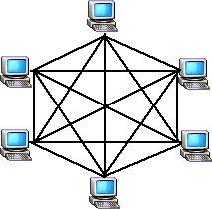

Mesh Topology Diagram
Advantages of Mesh topology:
  - Troubleshooting is easy.
  - Isolation of network failures is easy.

Disadvantages of Mesh topology:
- Difficulty of installation.
- Costly because of maintaining redundant links.
- Difficulty of reconfiguration.

Star Topology:
  - In Star topology, all the components of network are connected to the central device called “hub”.
  - In this topology all the workstations are connected to central device with a point- to-point connection.

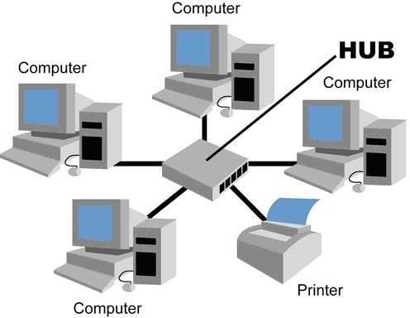

Star Topology Diagram
Advantages of Star Topology:
- In star topology new nodes can be added or removed easily without affecting rest of the network
- Troubleshooting is easy.

Disadvantages of Star Topology:
- If the central hub fails, the whole network fails to operate.
- Each device requires its own cable segment.

Bus Topology:

- Bus Topology is the simplest of network topologies. In this all the nodes are connected to the single cable, by the help of interface connectors.
- This central cable is the backbone of the network.
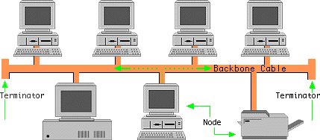

Bus topology diagram

Advantages Bus Topology:
- Easy to use and easy to install.
- Bus topology costs very less.
- Linear Bus network is mostly used in small networks.

Disadvantages Bus Topology:

- It is difficult to detect and troubleshoot fault at individual station.
- Maintenance costs can go higher with time.
- Efficiency of Bus network reduces as the number of devices increases.

Ring Topology:
  - In Ring Topology, all the nodes are connected to each-other in such a way that they make a closed loop.
  - Data travels around the network, in one direction.
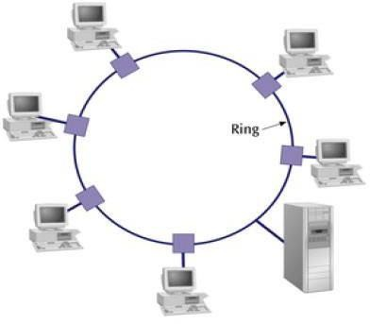

Advantages of Ring Topology:
- Cable failures are easily found.
- Additional components do not affect the performance of network.

Disadvantages of Ring Topology:
- It is difficult to troubleshoot a ring network.
- Cost of cable is more in ring network.

Hybrid Topology:
  - A network can be hybrid. Consider a main star topology with each branch connecting several stations in a bus topology.
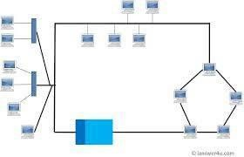

Advantages of Hybrid Topology:
- Unlike other networks, fault detection and troubleshooting is easy in this type of topology.
- It is the combination of two or more topologies.

Disadvantages of Hybrid Topology:
- One of the biggest drawbacks of hybrid topology is its design.
- The hubs used to connect two distinct networks, are very expensive.

NETWORK TYPES

LAN - Local Area Network:
- A LAN connects network devices over a relatively short distance.
- The LAN transmission capacity is more than 1Mbps.
- The geographical coverage of LAN’s is limited to areas less than 5 square kilometers.
- A networked office building, school, or home usually contains a single LAN.
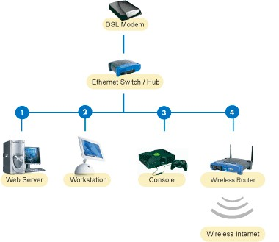

MAN-Metropolitan Area Network:
- A MAN (Metropolitan Area Networks) connects multiple geographically nearby LANs to one another over an area of up to a few kilometers at high speeds.
- Thus, a MAN lets two remote nodes communicate as if they were part of the same local area network.
- A MAN is made from switches or routers connected to one another with high-speed links usually fiber optic cables.
Metropolitan Area Networks
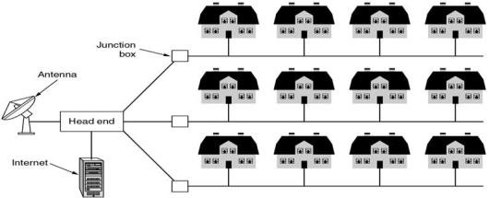
A metropolitan area network based on cable TV.

WAN-Wide Area Network:
A WAN spans a large geographic area, such as a state, province or country. WANs often connect multiple smaller networks, such as local area networks (LAN) or metro area networks (MAN). The world's most popular WAN is the Internet.

Wide Area Networks
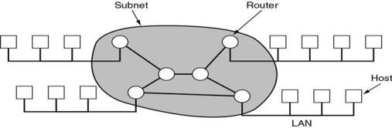

Relation between hosts on LANs and the subnet.

PAN-Personal Area Network:
A personal area network (PAN) is the interconnection of information technology devices within the range of an individual person, typically within a range of 10 meters.


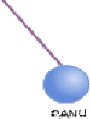
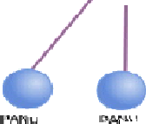
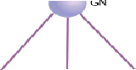



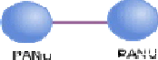

OSI / ISO MODEL
- The International Standards Organization for Standardization (ISO) developed the Open System Interconnection (OSI) reference model. OSI model is most widely used model for networking.
- An Open System is a set of protocols that allows any two different systems to communicate.

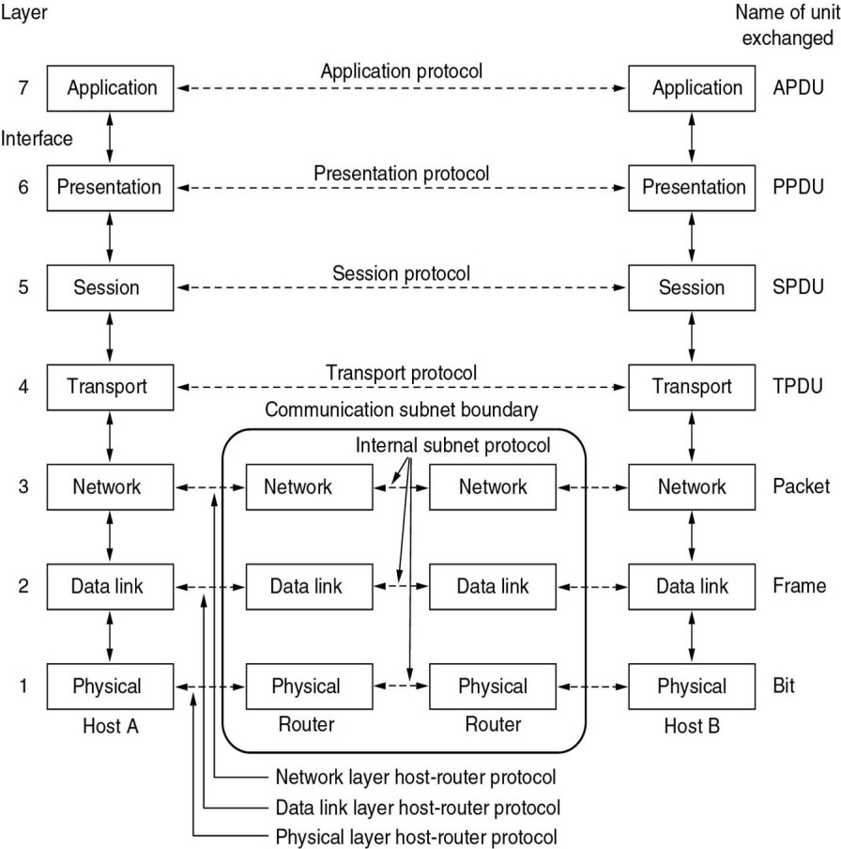
Reference Models

The OSI reference model.

Seven layers of OSI model:
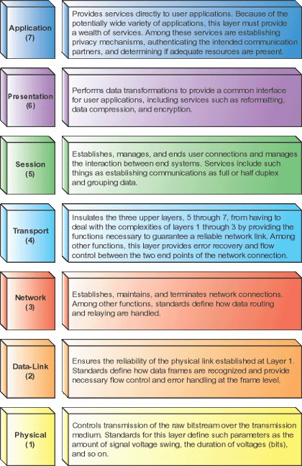

PHYSICAL LAYER:

- Physical layer is the lowest layer of the OSI model.
- The Physical Layer defines the electrical and physical specifications for devices.

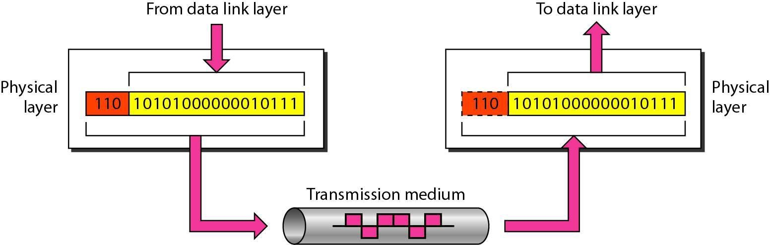

Functions of Physical layer:
  - Physical characteristics of interfaces and media:
    - The physical layer defines the characteristics of the interface between the devices and the transmission medium.
    - It also defines the type of transmission medium.

Representation of bits:
    - The physical layer data consists of a stream of bits (sequence of 0’s or 1’s) with no interpretation.
    - To be transmitted, bits must be encoded into signals electrical or optical. The physical layer defines the type of encoding.

Data rate:
The transmission rate the number of bits sent each second is also defined by the physical layer.

Synchronization of bits:
The sender and receiver not only must use the same bit rate but also must be synchronized at the bit level.

Line configuration:
    - The Physical layer is concerned with the connection devices to the media.
    - In a point-to-point configuration, two devices are connected through a dedicated link. In a multipoint configuration, a link is shared among several devices.

Physical topology:
    - The physical topology defines how devices are connected to make a network.
    - Devices can be connected by using a mesh topology, a star topology, a ring topology, or a hybrid topology.

Transmission mode:
    - The physical layer also defines the direction of transmission between two devices: simplex, half-duplex. Full-duplex.
    - In simplex mode, only one device can send, the other receives. The simplex mode is a one-way communication.
    - In the half-duplex mode, two devices can send and receive, but not at same time.
    - In full-duplex mode, two devices can send and receive at the same time.

DATA LINK LAYER:
    - The data link layer is responsible for transmitting the frames from one node to the next.
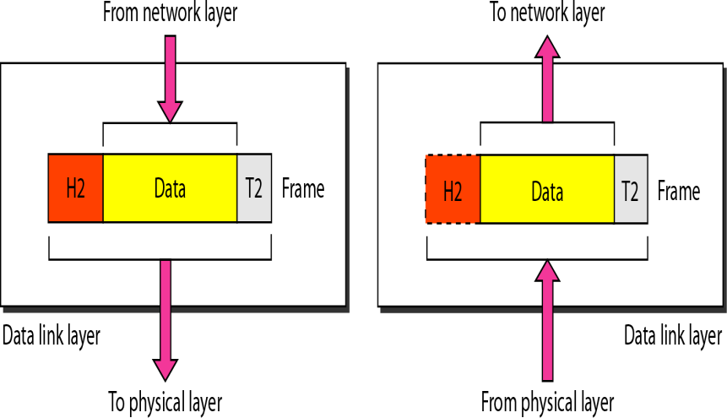
    - It transforms the physical layer to a reliable link making it an error free link to upper layer.

Functions of Data Link Layer:

- Framing:
  - The frames received from network layer are divided intomanageable data units called frames.

Physical addressing:
  - When frames are to be distributed to different systems on the network, the data link layer adds a header to the frame to define the sender and receiver of the frame.
  - If the frame is intended for a system outside the sender’s to the next one.

Flow control:
  - If the rate at which the data are absorbed by the receiver is less than the rate at which data are produced in the sender, the data link layer imposes a flow control mechanism to avoid overwhelming the receiver.

Error control:
  - The data link layer adds reliability to the physical layer by adding mechanisms to detect and retransmit damaged or lost frames. It also uses a mechanism to recognize duplication frames.

  - Error control is normally achieved through a trailer added to the end of the frame.

Access control:
  - When two or more devices are connected to the same link, data link layer protocols are necessary to determine which device has control over the link at any given time.

NETWORK LAYER:
The network layer is responsible for the delivery of packets from the source to destination across multiple networks.
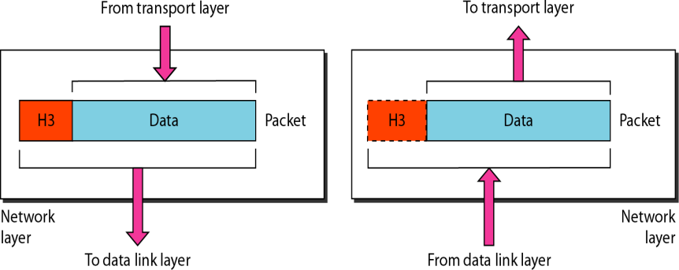

Functions of Network layer:

- Logical addressing:
  - The physical addressing implemented by the data link layer handles the addressing problem locally.
  - If a packet passes the network boundary, we need another addressing system to help distinguish the source and destination systems.

Routing:
  - When independent networks or links are connected to create internet works or a large network, the connecting devices called routers or switches route or switch the packets to their final destination.
  - One of the functions of the network, layer is to provide this mechanism
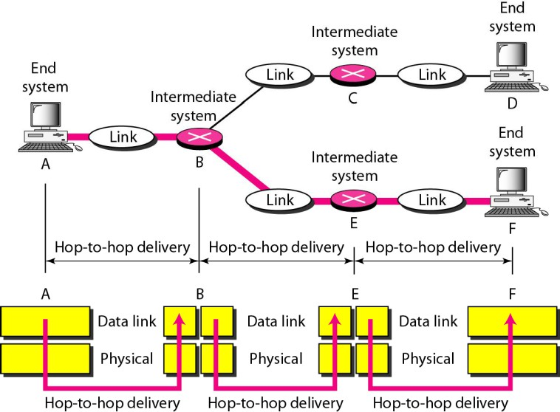

TRANSPORT LAYER:
The transport layer is responsible for process-to-process delivery of the entire message. A process is an application program running on a host.

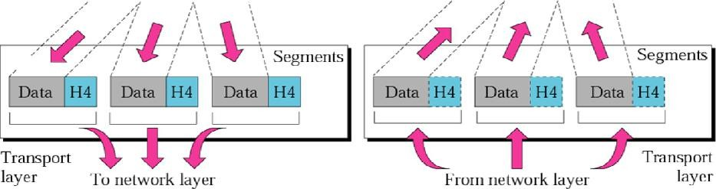

Functions of transport layer:

- Service-point addressing:
  - Computer performs several operations simultaneously. Process-to-process delivery means specific process of one computer must be delivered to specific process on other computer. The transport layer header therefore includes port address.
  - Network layer delivers packet to the desired computer and transport layer, gets message to the correct process on that computer.

Segmentation and reassembly:
  - A message is divided into segments, each segment contains a sequence number which enables transport layer to reassemble at destination.

Connection control:
  - Transport layer performs connectionless or connection oriented services with the destination machine.

Flow control:
  - Transport layer performs end-to-end flow control while data link layer performs it across the link.

Error control:
  - Error control at this layer is performed on end-to-end basis rather than across the link. The transport layer ensures error free transmission.

SESSION LAYER:
The session layer is network dialog controller that is it establishes and synchronizes the interaction between communication systems.
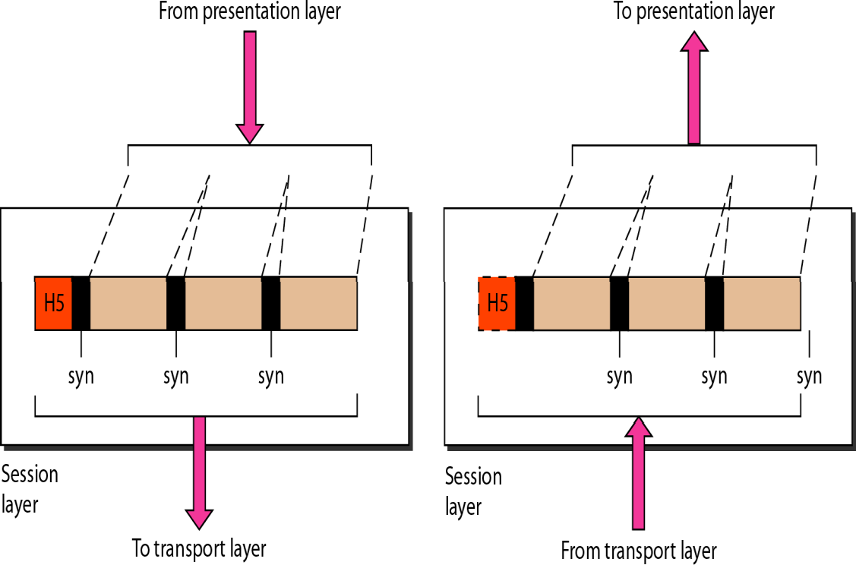

Functions of session layer:

- Dialog control:
  - Communication between two processes takes place in either half duplex or full duplex mode. The session layer manages dialog control for this communication.

Synchronization :
  - Session layer adds synchronization points into stream of data.

PRESENTATION LAYER:
The presentation layer deals with syntax and semantics of the information being exchanged.
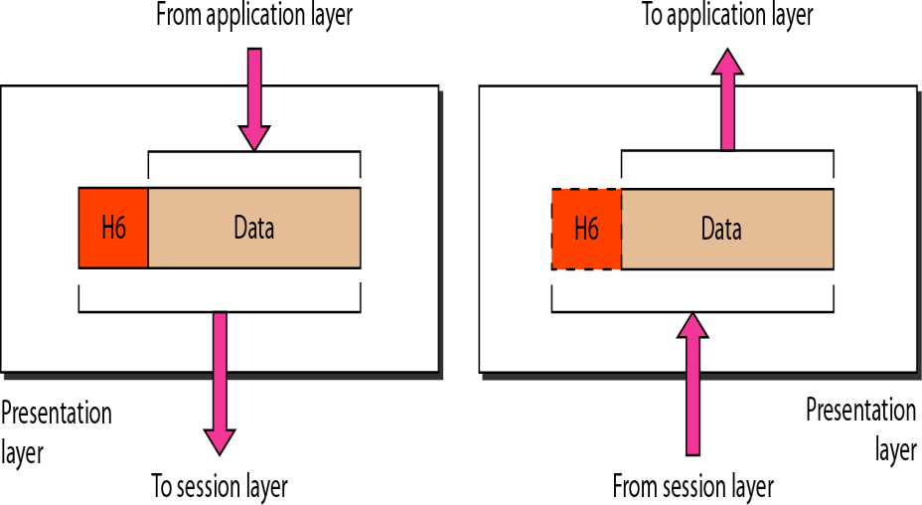

Functions of Presentation Layer:

- Translation:
  - Different computers use different encoding systems. The presentation layer maintains interoperability between the two encoding systems.

Encryption:
  - Encryption is transforming sender information to other form to ensure privacy while transmission. Decryption is a reverse process.

Compression:
  - Compression is a technique of reducing number of bits required to represent the data.

APPLICATION LAYER:
Application layer is responsible for accessing the network by user. It provides user interfaces and other supporting services such as e-mail, remote, file access, file transfer, sharing database, message handling, and directory services.
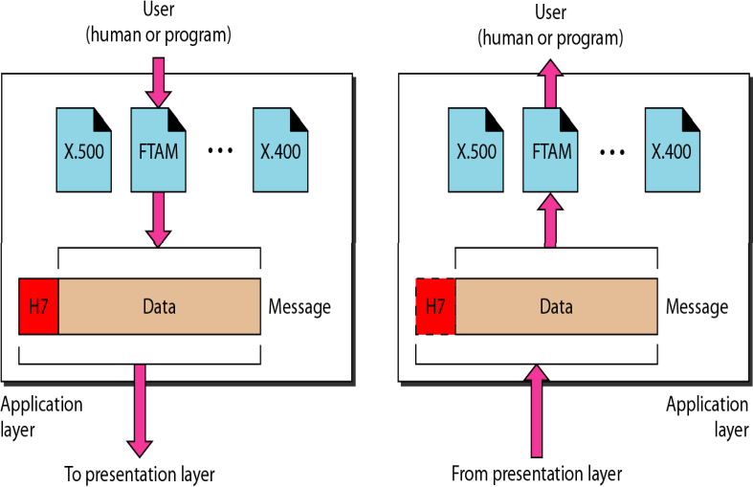

Functions of Application Layer:

- Network Virtual Terminal:
  - It is a software version of physical terminal that allows a user to log onto a remote host.

File Transfer, Access and Management (FTAM):
  - FTAM allows user to access files in remote hosts, to retrieve files and to manage files in remote computer.

Mail Services:
  - E-mail forwarding, storage are the services under this category.

Directory Services:
  - Directory services include access for global information and distributed database.

Computer Networks Programs with Viva questions
PROGRAM-1
Implement the data link layer framing methods such as character, character-stuffing and bit stuffing.
DESCRIPTION:
- To prevent data being interpreted as control information. For example, many frame-based protocols, such as X.25, signal the beginning and end of a frame with six consecutive 1 bits. Therefore, if the actual data being transmitted has six 1 bits in a row, a zero is inserted after the first 5 so that the dat is not interpreted as a frame delimiter. Of course, on the receiving end, the stuffed bits must be discarded.

- For protocols that require a fixed-size frame, bits are sometimes inserted to make the frame size equal to this set size.

- For protocols that required a continuous stream of data, zero bits are sometimes inserted to ensure that the stream is not broken.
1.1 CHARACTER COUNT
DESCRIPTION:
- It is used to count the number characters in the given text and
- To divide the total text in to various parts according to given frame length.
SOURCE CODE:
#include <stdio.h>
#include <string.h>

int main() {
char data[100];
int frame_size;
int i, j, k;
int current_pos = 0;

printf("Enter the data string: ");
scanf("%s", data);

printf("Enter the desired frame size: ");
scanf("%d", &frame_size);
printf("\n The Total number of chars are :%d ",strlen(data));

printf("\nTransmitted Frames:\n");
while (current_pos < strlen(data)) {
int actual_frame_len = 0;
// Calculate the actual frame length, ensuring it doesn't exceed the data string
if ((strlen(data) - current_pos) < frame_size) {
actual_frame_len = strlen(data) - current_pos;
} else {
actual_frame_len = frame_size;
}

// Print the character count for the current frame
printf("%d ", actual_frame_len);

// Print the characters of the current frame
for (k = 0; k < actual_frame_len; k++) {
printf("%c", data[current_pos + k]);
}
printf("\n"); // New line for the next frame
current_pos += actual_frame_len;
}
return 0;
}

OUTPUT:
- Enter the data string: ACECOLLEGE
Enter the desired frame size: 4

The Total number of chars are :10
Transmitted Frames:
4 ACEC
4 OLLE
2 GE

- Enter the data string: CSDDEPARTMENT
Enter the desired frame size: 5

The Total number of chars are :13
Transmitted Frames:
5 CSDDE
5 PARTM
3 ENT

1.2 BYTE STUFFING:

DESCRIPTION:
- In byte stuffing (or character stuffing), a special byte is added to the data section of the frame when there is a character with the same pattern as the flag.
- The data section is stuffed with an extra byte. This byte is usually called the escape character (ESC), which has a predefined bit pattern.
- Whenever the receiver encounters the ESC character, it removes it from the data section and treats the next character as data, not a delimiting flag.
- 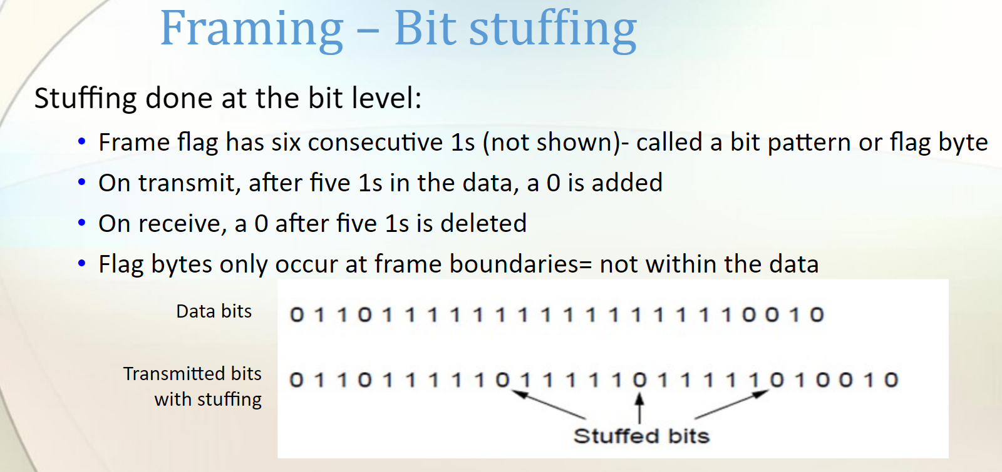

SOURCE CODE:
#include <stdio.h>
#include <string.h>

#define FLAG 'F' // Define Flag character
#define ESC 'E' // Define Escape character

int main() {
char data[100];
char stuffedData[200]; // Array to store stuffed data (larger to accommodate stuffed characters)
int i, j = 0;

printf("Enter the data string: ");
scanf("%s", data);

// Add starting Flag character
stuffedData[j++] = FLAG;

// Iterate through the data and perform stuffing
for (i = 0; i < strlen(data); i++) {
if (data[i] == FLAG || data[i] == ESC) {
stuffedData[j++] = ESC; // Stuff an ESC character
}
stuffedData[j++] = data[i]; // Add the original data character
}

// Add ending Flag character
stuffedData[j++] = FLAG;
stuffedData[j] = '\0'; // Null-terminate the stuffed string

printf("Original Data: %s\n", data);
printf("Stuffed Data: %s\n ", stuffedData);

return 0;
}

OUTPUT:
- Enter the data string: ACE
Original Data: ACE
Stuffed Data: FACEEF

- Enter the data string: CSDESC
Original Data: CSDESC
Stuffed Data: FCSDEESCF

1.3 BIT STUFFING

DESCRIPTION:
- To prevent data being interpreted as control information. For example, many frame-based protocols, such as X.25, signal the beginning and end of a frame with six consecutive 1 bits. Therefore, if the actual data being transmitted has six 1 bits in a row, a zero is inserted after the first 5 so that the dat is not interpreted as a frame delimiter. Of course, on the receiving end, the stuffed bits must be discarded.

- For protocols that require a fixed-size frame, bits are sometimes inserted to make the frame size equal to this set size.

- For protocols that required a continuous stream of data, zero bits are sometimes inserted to ensure that the stream is not broken.

- 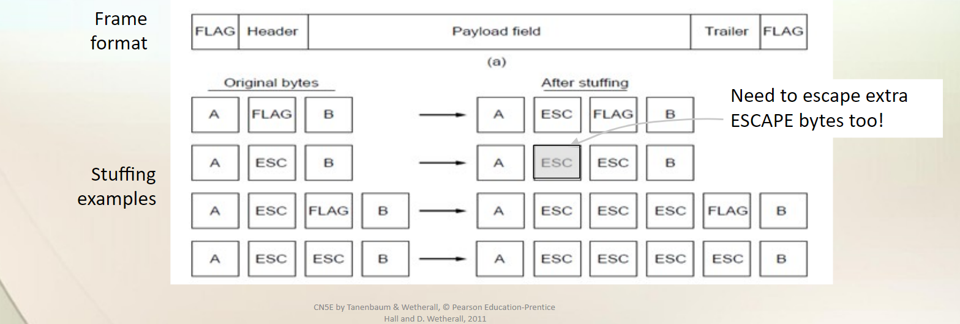

SOURCE CODE:
#include <stdio.h>
#include <string.h>

int main() {
char data[100], stuffedData[200];
int i, count = 0, j = 0;

printf("Enter the data: ");
scanf("%s", data);

for(i = 0; i < strlen(data); i++) {
if(data[i] == '1') {
count++;
stuffedData[j++] = data[i];
} else {
count = 0;
stuffedData[j++] = data[i];
}

if(count == 5) {
count = 0;
stuffedData[j++] = '0';
}
}

stuffedData[j] = '\0';

printf("Data after bit stuffing: %s\n", stuffedData);

return 0;
}

OUTPUT:
- Enter the data: 01111110
Data after bit stuffing: 011111010

- Enter the data: 011111111111111101
Data after bit stuffing: 011111011111011111001

VIVA QUESTIONS FOR PROGRAMS-1

Framing
- Framing is a technique performed by the Data Link layer where data is transmitted as a stream of bits.
- There are two different framing techniques :
  - Fixed size framing
  - Variable size framing
Framing Approaches :
  - Fixed length Approach
  - Variable length Apporach

A frame in a bit Stuffing

- Each frame begins and ends with a special bit pattern called a flag byte [01111110]. {Note this is 7E in hex}
- Whenever sender data link layer encounters five consecutive ones in the data stream, it automatically stuffs a 0 bit into the outgoing stream.
- When the receiver see’s five consecutive incoming ones followed by a 0 bit, it automatically destuffs the 0 bit before sending the data to the network layer.

A frame in a Character Stuffing
- Each frame begins and ends ASCII characters (e.g. DLE STX and DLE ETX ) referred to as character stuffing.
- The problem occurs when these character patterns occur within the “transparent” data.
- Solution: sender stuffs an extra DLE into the data stream just before each occurrence of an ‘accidental’ DLE in the data stream.
- The data link layer on the receiving end un-stuffs the DLE before giving the data to the network layer.
8 16 16 8
Header
Body
CRC
Ending sequence
Beginning sequence

PROGRAM-2
AIM: Write a program to compute CRC code for the polynomials CRC-12, CRC-16 and CRC CCIP
DESCRIPTION:
Cyclic Redundancy Check is a method of detecting accidental changes/errors in the communication channel.
CRC uses Generator Polynomial which is available on both sender and receiver side. An example generator polynomial is of the form like x³ + x + 1. This generator polynomial represents key 1011. Another example is x² + 1 that represents key 101.

n : Number of bits in data to be sent from sender side.
k : Number of bits in the key obtained from generator polynomial.
Sender Side (Generation of Encoded Data from Data and Generator Polynomial (or Key)):
- The binary data is first augmented by adding k-1 zeros in the end of the data
- Use modulo-2 binary division to divide binary data by the key and store remainder of division.
- Append the remainder at the end of the data to form the encoded data and send the same
Receiver Side (Check if there are errors introduced in transmission)
Perform modulo-2 division again and if the remainder is 0, then there are no errors.

SOURCE CODE:
#include <stdio.h>
#include <string.h>
#define MAX_SIZE 100
// Function to compute CRC code
void computeCRC(char data2[], char polynomial2[], int dl, int pl)
{
// Compute CRC
for (int i = 0; i < dl; i++)
{
if (data2[i] == '1')
{
for (int j = 0; j < pl; j++)
{
data2[i + j] = (data2[i + j] == polynomial2[j]) ? '0' : '1';
}
}
}

// Output CRC code
printf("%s", &data2[dl]);
}

int main() {
char data[MAX_SIZE];
char polynomial[] = "1101";
char codedata[MAX_SIZE];
// Input data
printf("Enter data: ");
scanf("%s", data);
printf("Enter Polynomial: ");
scanf("%s", polynomial);
int dl = strlen(data);
int pl = strlen(polynomial);
for (int i = 0; i < pl - 1; i++)
{
data[dl + i] = '0';
}
printf("Data with zeros: %s\n\n", data);
printf("CRC at sender side: ");
computeCRC(data, polynomial, dl,pl);
printf("\n\nEnter codeword (Data + CRC): ");
scanf("%s", codedata);
printf("CRC at receiver side: ");
computeCRC(codedata, polynomial, dl, pl);
}

OUTPUT:

Enter data: 111101
Enter Polynomial: 1101
Data with zeros: 111101000

CRC at sender side: 011

Enter codeword (Data + CRC): 111101011
CRC at receiver side: 000

VIVA – QUESTIONS:
Explain following Error control methods
  - Hamming code

CRC

Checksum
Ans: Networks must be able to transfer data from one device to another with acceptable accuracy. For most applications, a system must guarantee that the data received are identical to the data transmitted.
- Any time data are transmitted from one node to the next, they can become corrupted in passage. Many factors can alter one or more bits of a message. Some applications require a mechanism for detecting and correcting errors.

Types of Errors:
Single-Bit Error:

In a single-bit error, only 1 bit in the data unit has changed.
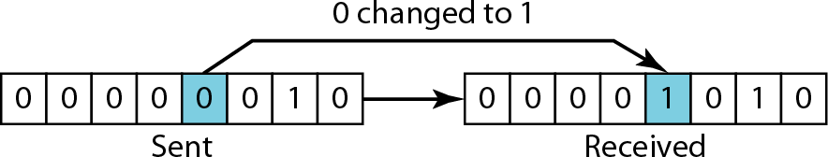

(ASCII STX) (ASCII LF)
Burst Error:

A burst error means that 2 or more bits in the data unit have changed.
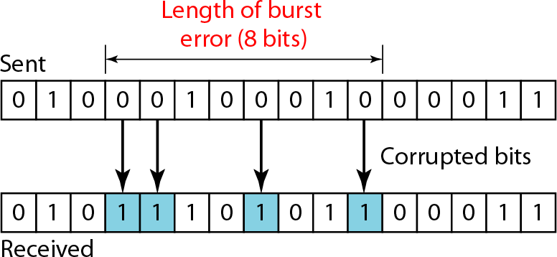

Fig: Burst error of length 8

Redundancy:

To detect or correct errors, we need to send extra (redundant) bits with data.

The structure of encoder and decoder
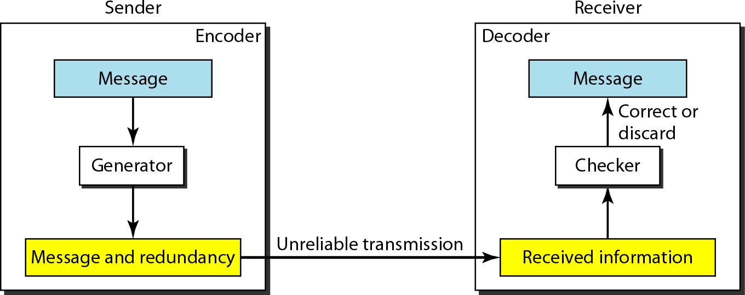
Modular Arithmetic:
- In modular arithmetic, we use only a limited range of integers. We define an upper limit, called a modulus N. We then use only the integers 0 to N - I, inclusive.
- In modulo-N arithmetic, we use only the integers in the range 0 to N - 1, inclusive.
- Addition and subtraction in modulo arithmetic are simple. Modulo-2 Arithmetic:
Of particular interest is modulo-2 arithmetic. In this arithmetic, the modulus N is 2. We can use only 0 and 1. Operations in this arithmetic are very simple. The following shows how we can add or subtract 2 bits.
Adding: Subtracting:
0+0=0 0-0=0
0+1=1 0-1=1
1+0=1 1-0=1
1+1=0 1-1=0
BLOCK CODING:
In block coding, we divide our message into blocks, each of k bits, called data words. We add r redundant bits to each block to make the length n = k + r. The resulting n-bit blocks are called code words.

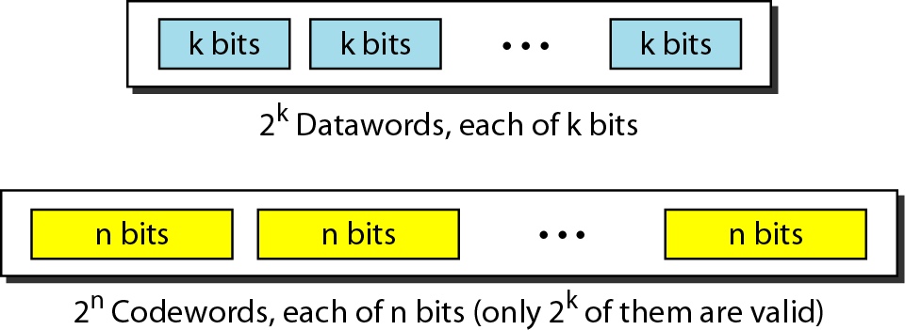
Data words and code words in block coding Hamming code:

The Hamming distance between two words is the number of differences between corresponding bits.

Let us find the Hamming distance between two pairs of words.
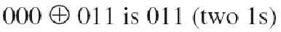
- The Hamming distance d (000, 011) is 2 because
- The Hamming distance d (10101, 11110) is 3 because
  - The minimum Hamming distance is the smallest Hamming distance between all possible pairs in a set of words.
  - To guarantee the detection of up to s errors in all cases, the minimum Hamming distance in a block code must be dmin = s + 1.
  - To guarantee correction of up to t errors in all cases, the minimum Hamming distance in a block code must be dmin = 2t + 1.
CRC:
Cyclic codes are special linear block codes with one extra property. In a cyclic code, if a code word is cyclically shifted (rotated), the result is another code word.
For example,if 1011000 is a code word and we cyclically left-shift, then 0110001 is also a code word.
In this case, if we call the bits in the first word ao to a6' and the bits in the second word b0 to b6, we can shift the bits by using the following:
b1=a0 b2=a1 b3=a2 b4=a3 b5=a4 b6=a5 b0=a6
In the rightmost equation, the last bit of the first word is wrapped around and becomes the first bit of the second word.

A CRC code with C (7, 4)
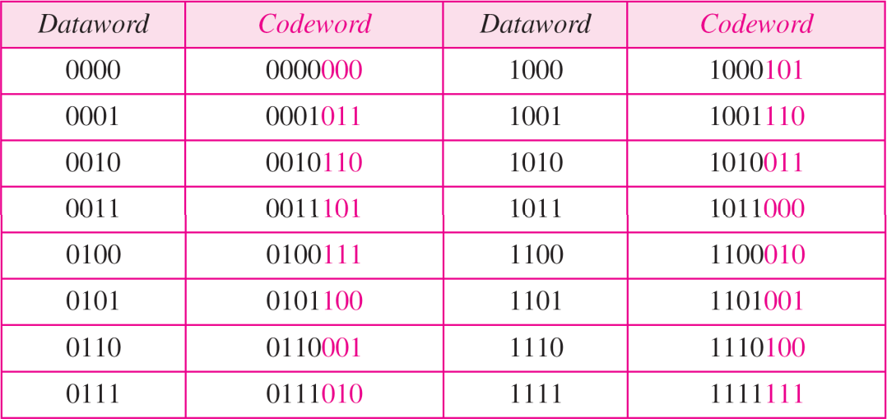

CRC encoder and decoder:

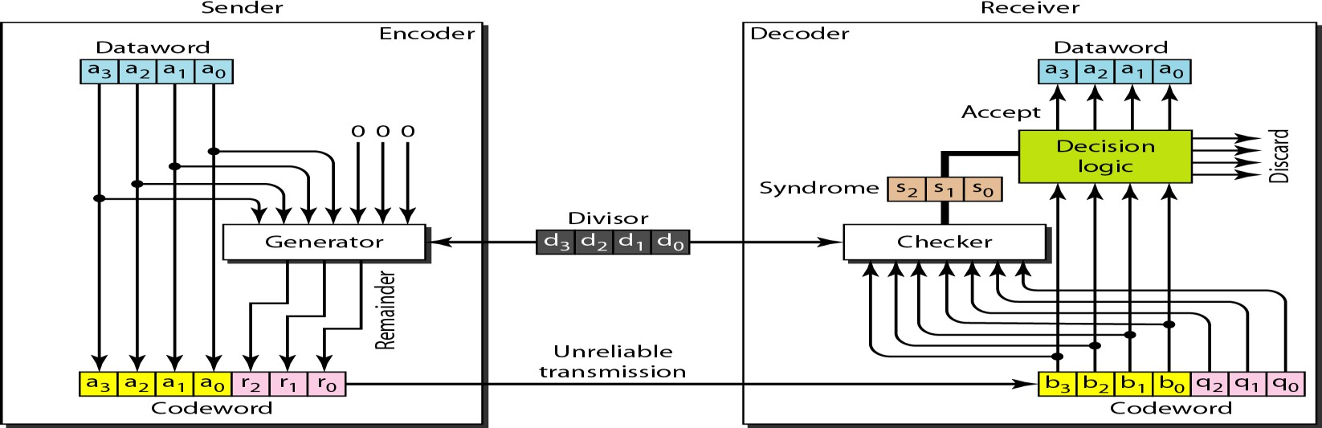

In the encoder, the data word has k bits (4 here); the code word has n bits (7 here).
The size of the data word is augmented by adding n - k (3 here) 0s to the right-hand side of the word. The n-bit result is fed into the generator. The generator uses a divisor of size n - k + I (4 here), predefined and agreed upon. The generator divides the augmented data word by the divisor (modulo-2 division). The quotient of the division is discarded; the remainder (r2rl ro) is appended to the data word to create the code word.
The decoder receives the possibly corrupted code word. A copy of all n bits is fed to the checker which is a replica of the generator. The remainder produced by the checkeris a syndrome of n - k (3 here) bits, which is fed to the decision logic analyzer. The analyzer has a simple function. If the syndrome bits are all as, the 4 leftmost bits of the code word are accepted as the data word (interpreted as no error); otherwise, the 4 bits are discarded (error).

Encoder
Let us take a closer look at the encoder. The encoder takes the data word and augments it with n - k number of as. It then divides the augmented data word by the divisor, as shown in Figure.
Division in CRC encoder:
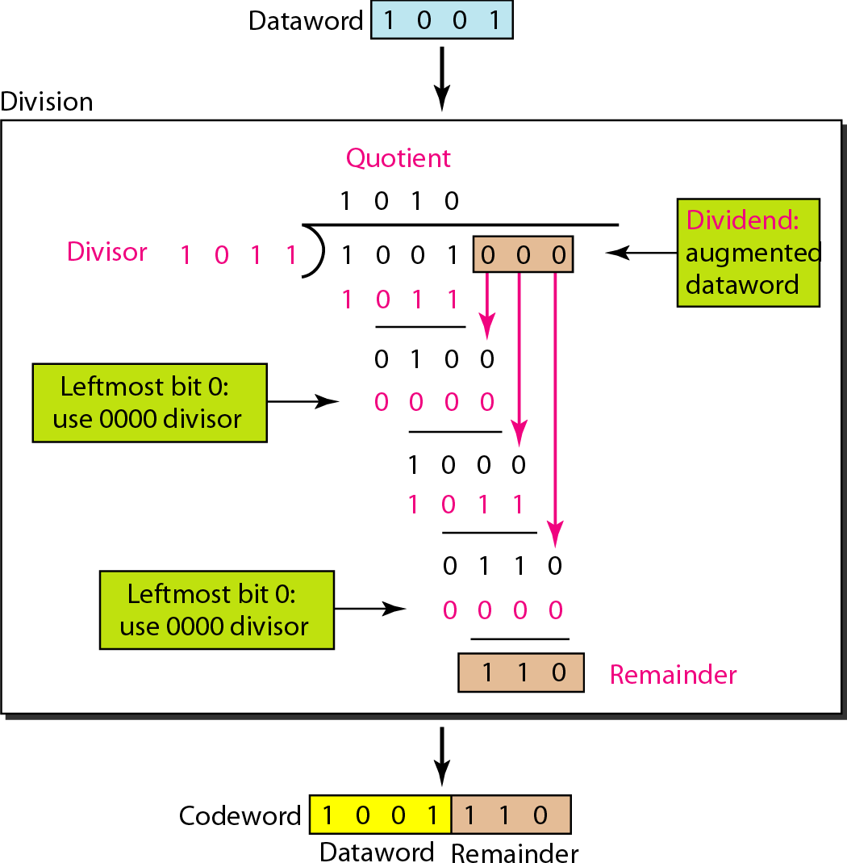

Decoder
The code word can change during transmission. The decoder does the same division process as the encoder. The remainder of the division is the syndrome. If the syndrome is all 0s, there is no error; the data word is separated from the received code word and accepted. Otherwise, everything is discarded. Figure 10.16 shows two cases: The left hand figure shows the value of syndrome when no error has occurred; the syndrome is 000. The right-hand part of the figure shows the case in which there is one single error. The syndrome is not all 0s (it is OIl).

Division in the CRC decoder for two cases:
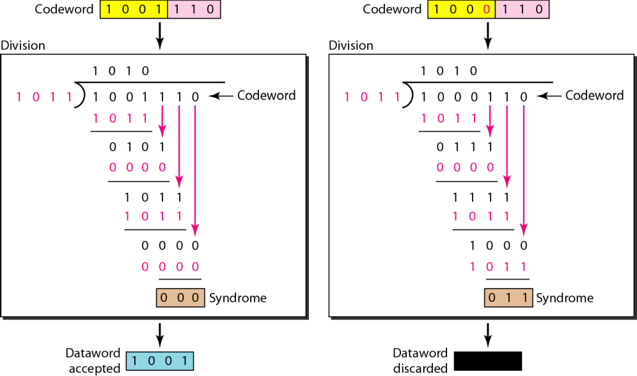

Augmented Dataword
In our paper-and-pencil division process in Figure 10.15, we show the augmented data word as fixed in position with the divisor bits shifting to the right, 1 bit in each step.
The divisor bits are aligned with the appropriate part of the augmented data word. Now that our divisor is fixed, we need instead to shift the bits of the augmented data word to the left (opposite direction) to align the divisor bits with the appropriate part. There is no need to store the augmented data word bits.
Remainder
In our previous example, the remainder is 3 bits (n - k bits in general) in length. We can use three registers (single-bit storage devices) to hold these bits. To find the final remainder of the division, we need to modify our division process. The following is the step-by-step process that can be used to simulate the division process in hardware (or even in software).
- We assume that the remainder is originally all 0s (000 in our example).
- At each time click (arrival of 1 bit from an augmented data word), we repeat the following two actions:
  - We use the leftmost bit to make a decision about the divisor (011 or 000).
  - The other 2 bits of the remainder and the next bit from the augmented data word (total of 3 bits) are XORed with the 3-bit divisor to create the next remainder.

Simulation of division in CRC encoder:
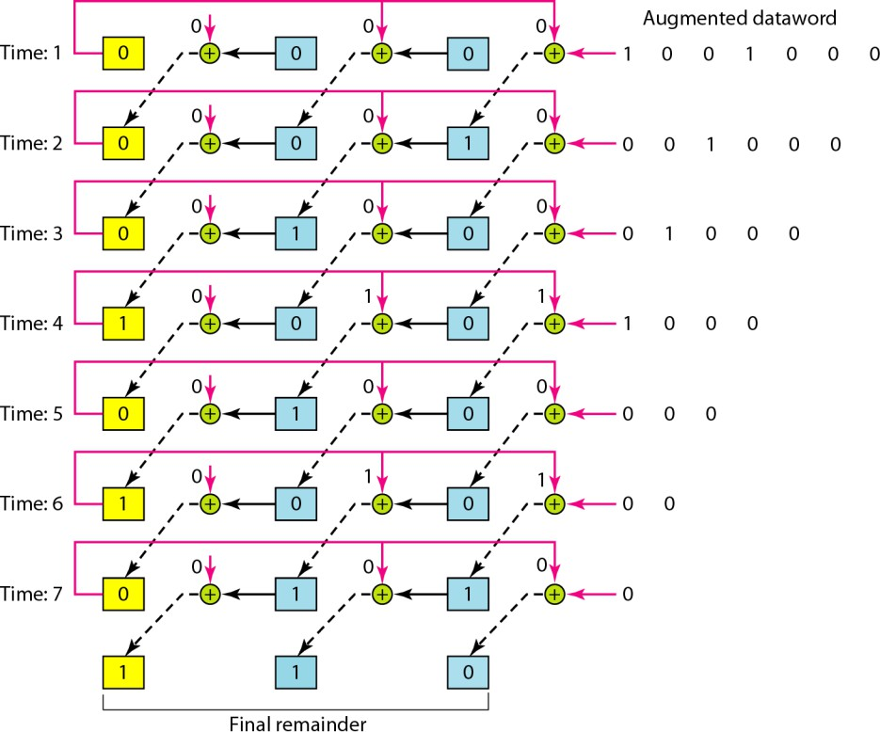

CHECKSUM:
The checksum is used in the Internet by several protocols although not at the data link layer.
Implementation of checksum:
The sender initializes the checksum to 0 and adds all data items and the checksum. 36 cannot be expressed in 4 bits. The extra two bits are wrapped and added with the sum to create the wrapped sum value 6.
The sum is then complemented, resulting in the checksum value 9 (15 − 6 = 9).
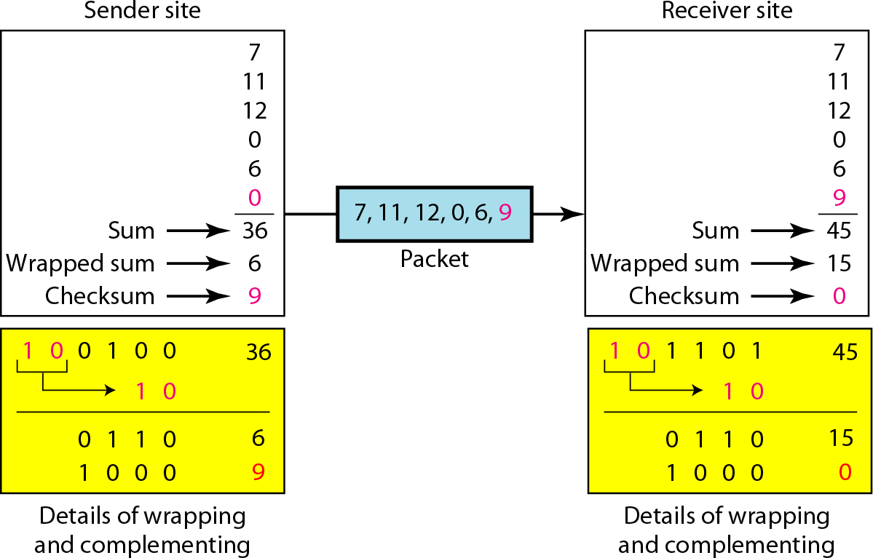

Example:
Suppose the following block of 16 bits is to be sent using a checksum of 8 bits. 10101001 00111001
The numbers are added using one’s complement

10101001 | 00111001
Sum | 11100010
Checksum | 00011101
The pattern sent is 10101001 00111001 00011101
Now suppose the receiver receives the pattern sent in Example 7 and there is no error. 10101001 00111001 00011101
When the receiver adds the three sections, it will get all 1s, which, after complementing, is all 0s and shows that there is no error.
10101001
00111001
00011101
Sum 11111111
Complement 00000000 means that the pattern is OK.
Now suppose there is a burst error of length 5 that affects 4 bits.
10101111 11111001 00011101
When the receiver adds the three sections, it gets
10101111
11111001
00011101

Partial Sum 1 11000101
Carry 1
Sum 11000110
Complement 00111001 the pattern is corrupted.

Internet Checksum:
Sender site:
- The message is divided into 16-bit words.
- The value of the checksum word is set to 0.
- All words including the checksum are added using one’s complement addition.
- The sum is complemented and becomes the checksum.
- The checksum is sent with the data.
Receiver site:
- The message (including checksum) is divided into 16-bit words.
- All words are added using one’s complement addition.
- The sum is complemented and becomes the new checksum.
- If the value of checksum is 0, the message is accepted; otherwise, it is rejected.
Example:
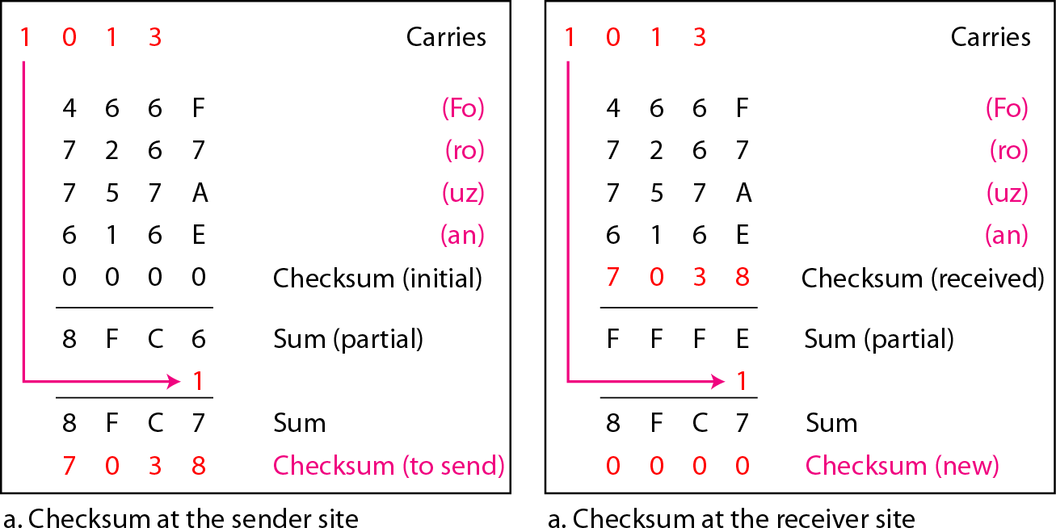

PROGRAM-3
AIM: Develop a simple data link layer that performs the flow control using the sliding window protocol, and loss recovery using the Go-Back-N mechanism.

DESCRIPTION:
Suppose there are a sender and a receiver, and let's assume that there are 12 frames to be sent. These frames are represented as 0,1,2,3,4,5,6,7,8,9,10,11 and these are the sequence numbers of the frames.

Let's consider the window size as 4, which means that the four frames can be sent at a time before expecting the acknowledgment of the first frame.

Firstly, the sender will send the first four frames to the receiver, i.e., 0,1,2,3, and now the sender is expected to receive the acknowledgment of the 0th frame.

Let's assume that the receiver has sent the acknowledgment for the 0 frame.
The sender will then send the next frame, i.e., 4, and the window slides containing four frames (1,2,3,4).

The receiver will then send the acknowledgment for the frame no 1. After receiving the acknowledgment, the sender will send the next frame, i.e., frame no 5, and the window will slide having four frames (2,3,4,5).

Now, let's assume that the receiver is not acknowledging the frame no 2, either the frame is lost, or the acknowledgment is lost. Instead of sending the frame no 6, the sender Go-Back to 2, which is the first frame of the current window, retransmits all the frames in the current window, i.e., 2,3,4,5.

SOURCE CODE:
#include<stdio.h>
int main()
{
int frames,windowsize,ack=0,i;
printf("enter no.of frames\n");
scanf("%d",&frames);
printf("enter window size\n");
scanf("%d",&windowsize);

left:
while(ack<frames)
{
for( i = ack; i < windowsize+ack; i++)
{
printf("Frame %d has been transmitted.\n",i);
if(i==frames-1)
{
break;
}
}
printf("\nPlease enter the Acknowledgement number: ");
scanf("%d",&ack);
if(ack>i)
{
if(ack==(frames))
{
printf("Total frames were sent");
}
else
{
printf("invalid and resending the frame\n");
ack=i-windowsize;
}
}
else if(ack <frames)
{
goto left;
}
else
break;
}
return 0;
}

OUTPUT:

enter no.of frames
12
enter window size
4
Frame 0 has been transmitted.
Frame 1 has been transmitted.
Frame 2 has been transmitted.
Frame 3 has been transmitted.

Please enter the Acknowledgement number: 1
Frame 1 has been transmitted.
Frame 2 has been transmitted.
Frame 3 has been transmitted.
Frame 4 has been transmitted.

Please enter the Acknowledgement number: 2
Frame 2 has been transmitted.
Frame 3 has been transmitted.
Frame 4 has been transmitted.
Frame 5 has been transmitted.

VIVA – QUESTIONS:

Explain flow and error control protocols of noisy channels?

Taxonomy of protocols discussed in this chapter

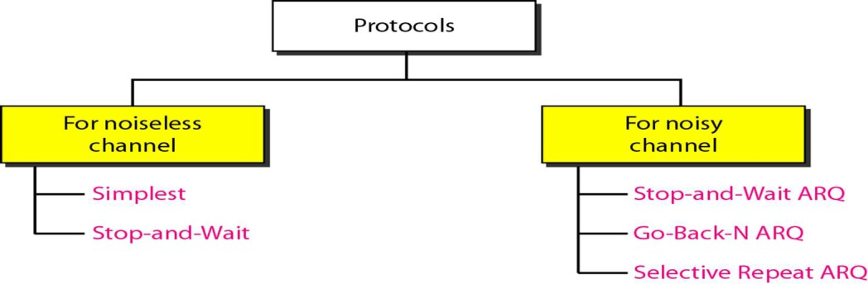

Stop-and-Wait Automatic Repeat Request:

Our first protocol, called the Stop-and-Wait Automatic Repeat Request (Stop-andWait ARQ), adds a simple error control mechanism to the Stop-and-Wait Protocol.
Let us see how this protocol detects and corrects errors.
To detect and correct corrupted frames, we need to add redundancy bits to our data frame .When the frame arrives at the receiver site, it is checked and if
it is corrupted, it is silently discarded. The detection of errors in this protocol is manifested by the silence of the receiver.

Lost frames are more difficult to handle than corrupted ones. In other protocols there was no way to identify a frame. The received frame could be the correct one, or a duplicate, or a frame out of order. The solution is to number the frames. When the receiver receives a data frame that is out of order, this means that frames were either lost or duplicated.
The comlpted and lost frames need to be resent in this protocol error, At the same time, it starts a timer. If the timer expires and there is no ACK for the sent frame, the frame is resent, the copy is held, and the timer is restarted. Since the protocol uses the stop-and-wait mechanism, there is only one specific frame that needs an ACK even though several copies of
the same frame can be in the network.

Error correction in Stop-and-Wait ARQ is done by keeping a copy of the sent frame and retransmitting of the frame when the timer expires.
Since an ACK frame can also be corrupted and lost, it too needs redundancy bits and a sequence number. The ACK frame for this protocol has a sequence number field.
In this protocol, the sender simply discards a corrupted ACK frame or ignores an out-of-order one.

Sequence Numbers:
The protocol specifies that frames need to be numbered. This is done
by using sequence numbers. A field is added to the data frame to hold the sequence number of that frame.
One important consideration is the range of the sequence numbers. Since we want to minimize the frame size, we look for the smallest range that provides unambiguous communication. The sequence numbers of course can wrap around.
assume that the sender has sent the frame numbered x. Three things can happen.
- The frame arrives safe and sound at the receiver site; the receiver sends an acknowledgment.
The acknowledgment arrives at the sender site, causing the sender to send the next frame numbered x + 1.
- The frame arrives safe and sound at the receiver site; the receiver sends an acknowledgment, but the acknowledgment is corrupted or lost. The sender resends the frame (numbered x) after the time- out. Note that the frame here is a duplicate. The receiver
can recognize this fact because it expects frame x + I but frame x was received.
- The frame is corrupted or never arrives at the receiver site; the sender resends the frame (numbered x) after the time-out.

Acknowledgment Numbers

The acknowledgment numbers always announce the sequence
number of the next frame expected by the receiver. For example, if frame 0 has arrived safe and sound, the receiver sends an ACK frame with acknowledgment 1 (meaning frame 1 is expected next). If frame 1 has arrived safe and sound, the receiver sends an
ACK frame with acknowledgment 0 (meaning frame 0 is expected).

Design
The sending device keeps a copy of the last frame transmitted until it receives an acknowledgment for that frame. A data frames uses a seqNo (sequence number); an ACK frame uses an ackNo (acknowledgment number). The sender has a control variable, which we call Sn (sender, next frame to send), that holds the sequence number for the next frame to be sent (0 or 1).

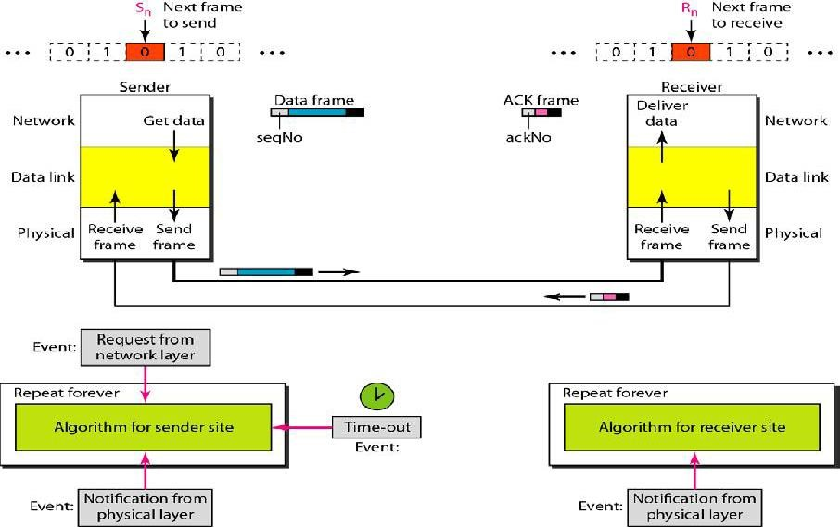
The receiver has a control variable, which we call Rn (receiver, next frame expected),
that holds the number of the next frame expected. When a frame is sent, the value of Sn is incremented (modulo-2), which means if it is 0, it becomes 1 and vice versa. When a frame is received, the value of Rn is incremented (modulo-2), which means if it is 0, it becomes 1 and vice versa. Three events can happen at the sender site; one event can happen at the receiver site.
Variable Sn points to the slot that matches the sequence
number of the frame that has been sent, but not acknowledged; Rn points to the slot that matches the sequence number of the expected frame.

Pipelining
In networking and in other areas, a task is often begun before the previous task has ended.
This is known as pipelining. There is no pipelining in Stop-and-Wait ARQ because we need to wait for a frame to reach the destination and be acknowledged before the next
frame can be sent. However, pipelining does apply to our next two protocols because several frames can be sent before we receive news about the previous frames. Pipelining
improves the efficiency of the transmission if the number of bits in transition is large with respect to the bandwidth-delay product.

Go-Back-N Automatic Repeat Request
To improve the efficiency of transmission (filling the pipe), multiple frames must be in transition while waiting for acknowledgment. In other words, we need to let more than

one frame be outstanding to keep the channel busy while the sender is waiting for acknowledgment.
The first is called Go-Back-N Automatic Repeat Request (the rationale for the name will become clear later). In this protocol we can send several frames before receiving acknowledgments; we keep a copy of these frames until the acknowledgments arrive.

Sliding Window:

In this protocol ,the sliding window defines the range of sequence numbers that is the concern of the sender and receiver
The sender and receiver need to deal with only part of the possible sequence numbers. The range which is the concern of the sender is called the send sliding window; the range that is the concern of the receiver is called the receive sliding window.
The send window is an imaginary box covering the sequence numbers of the data frames which can be in transit. In each window position, some of these sequence numbers
define the frames that have been sent; others define those that can be sent. The maximum size of the window is 2m – 1.
Figure shows a sliding window of size 15 (m =4).
The window at any time divides the possible sequence numbers into four regions.
The first region, from the far left to the left wall of the window, defines the sequence numbers belonging to frames that are already acknowledged. The sender does not worry about these frames and keeps no copies of them. The second region defines the range of sequence numbers belonging to the frames that are sent and have an unknown status. The sender needs to wait to find out if these frames have been received or were lost. We call these outstanding frames. The third range, white in the figure, defines the range of sequence numbers for frames that can be sent; however, the corresponding data packets have not yet been received from the network
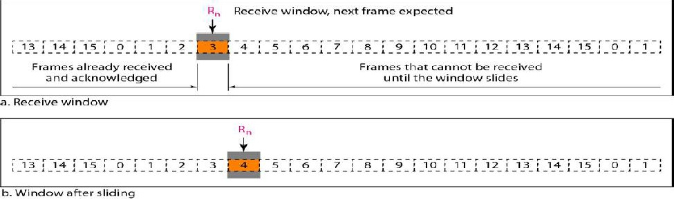
The receive window is an abstract concept defining an imaginary box of size 1 with one single variable Rn• The window slides when a correct frame has arrived; sliding occurs one slot at a time. we need only one variable Rn (receive window, next frame expected) to define this abstraction. The sequence numbers to the left of the window belong to the frames already received and acknowledged; the sequence numbers to the right of this
window define the frames that cannot be received. Any received frame with a sequence number in these two regions is discarded. Only a frame with a sequence number matching the value of Rn is accepted and acknowledged.

The receive window also slides, but only one slot at a time. When a correct frame is received (and a frame is received only one at a time), the window slides.

Timers

Although there can be a timer for each frame that is sent, in our protocol we use only one. The reason is that the timer for the first outstanding frame always expires first; we send all outstanding frames when this timer expires.
Acknowledgment
The receiver sends a positive acknowledgment if a frame has arrived safe and sound and in order. If a frame is damaged or is received out of order, the receiver is silent and will discard all subsequent frames until layer. Finally, the fourth region defines sequence numbers that cannot be used until the window slides

Selective Repeat Automatic Repeat Request:

Go-Back-N ARQ simplifies the process at the receiver site. The receiver keeps track of only one variable, and there is no need to buffer out-of-order frames; they are simply discarded. However, this protocol is very inefficient for a noisy link. In a noisy link a frame has a higher probability of damage, which means the resending of multiple frames.
This resending uses up the bandwidth and slows down the transmission. For noisy links, there is another mechanism that does not resend N frames when just one frame is damaged; only the damaged frame is resent. This mechanism is called Selective RepeatARQ.

Windows :

The Selective Repeat Protocol also uses two windows: a send window and a receive window. However, there are differences between the windows in this protocol and the ones in Go-Back-N. First, the size of the send window is much smaller; it is 2m- I . The reason for this will be discussed later. Second, the receive window is the same size as the send window. The send window maximum size can be 2m- I . For example, if m = 4, the sequence numbers go from 0 to 15, but the size of the window is just 8 (it is 15 in the Go-Back-N Protocol). The smaller window size means less efficiency in filling the pipe, but the fact that there are fewer duplicate frames can compensate for this.
The protocol uses the same variables as we discussed for Go-Back-N.

Selective Repeat Automatic Repeat Request:-

Go-Back-N ARQ simplifies the process at the receiver site. The receiver keeps track of only one variable, and there is no need to buffer out-of-order frames; they are simply discarded. However, this protocol is very inefficient for a noisy link. In a noisy link a frame has a higher probability of damage, which means the resending of multiple frames.

This resending uses up the bandwidth and slows down the transmission. For noisy links, there is another mechanism that does not resend N frames when just one frame is damaged; only the damaged frame is resent. This mechanism is called Selective RepeatARQ.
It is more efficient for noisy links, but the processing at the receiver is more complex.

Windows
The Selective Repeat Protocol also uses two windows: a send window and a receive window. However, there are differences between the windows in this protocol and the ones in Go-Back-N. First, the size of the send window is much smaller; it is 2m- I . The reason for this will be discussed later. Second, the receive window is the same size as the send window.
The send window maximum size can be 2m- I . For example, if m = 4, the
sequence numbers go from 0 to 15, but the size of the window is just 8 (it is 15 in the Go-Back-N Protocol). The smaller window size means less efficiency in filling the pipe, but the fact that there are fewer duplicate frames can compensate for this.
The protocol uses the same variables as we discussed for Go-Back-N. We show the Selective Repeat send window in Figure to emphasize the size.
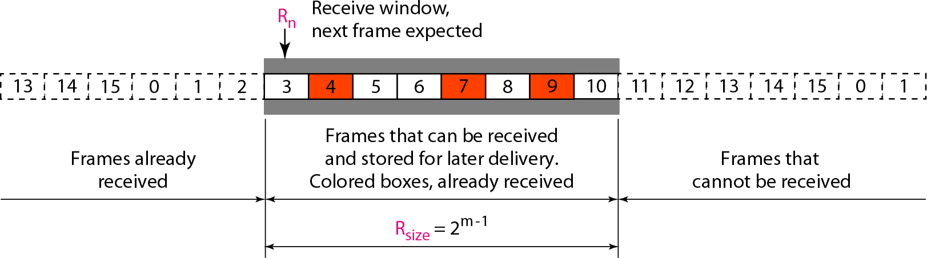
Sending:
Receiving:
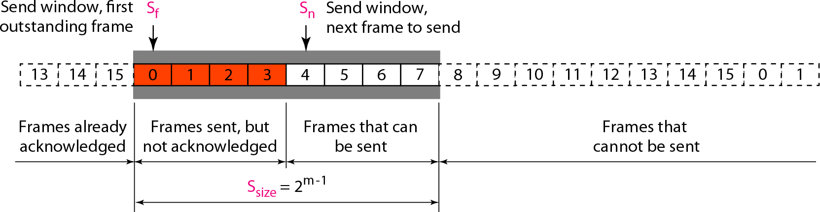

PROGRAM-4
AIM: Implement Dijsktra’s algorithm to compute the shortest path through a network.

DESCRIPTION:
One algorithm for finding the shortest path from a starting node to a target node in a weighted graph is Dijkstra’s algorithm.

The algorithm creates a tree of shortest paths from the starting vertex, the source, to all other points in the graph. The graph can either be directed or undirected.

The algorithm exists in many variants. Dijkstra's original algorithm found the shortest path between two given nodes, but a more common variant fixes a single node as the "source" node and finds shortest paths from the source to all other nodes in the graph, producing a shortest-path tree.

SOURCE CODE:

// importing the standard I/O header file
#include <stdio.h>

// defining some constants
#define INF 9999
#define MAX 10

// defining the function for Dijkstra's Algorithm
void DijkstraAlgorithm(int Graph[MAX][MAX], int size, int start)
{
int cost[MAX][MAX], distance[MAX], previous[MAX];
int visited_nodes[MAX], counter, minimum_distance, next_node, i, j;

// creating cost matrix
for (i = 0; i < size; i++)
for (j = 0; j < size; j++)
if (Graph[i][j] == 0)
cost[i][j] = INF;
else
cost[i][j] = Graph[i][j];

for (i = 0; i < size; i++)
{
distance[i] = cost[start][i];
previous[i] = start;
visited_nodes[i] = 0;
}

distance[start] = 0;
visited_nodes[start] = 1;
counter = 1;

while (counter < size - 1)
{
minimum_distance = INF;

for (i = 0; i < size; i++)
if (distance[i] < minimum_distance && !visited_nodes[i])
{
minimum_distance = distance[i];
next_node = i;
}

visited_nodes[next_node] = 1;
for (i = 0; i < size; i++)
if (!visited_nodes[i])
if (minimum_distance + cost[next_node][i] < distance[i])
{
distance[i] = minimum_distance + cost[next_node][i];
previous[i] = next_node;
}
counter++;
}

// printing the distance
for (i = 0; i < size; i++)
{
printf("\nDistance from node %d to %d: %d", start,i, distance[i]);
}
}

// main function
int main() {
// defining variables
int Graph[MAX][MAX], i, j, size, source;
// declaring the size of the matrix
size = 7;
/*for(i=0;i<size;i++)
{
for(j=0;j<size;j++)
{
scanf("%d",&Graph[i][j]);
}
}*/

// declaring the nodes of graph
Graph[0][0] = 0;
Graph[0][1] = 4;
Graph[0][2] = 0;
Graph[0][3] = 0;
Graph[0][4] = 0;
Graph[0][5] = 8;
Graph[0][6] = 0;

Graph[1][0] = 4;
Graph[1][1] = 0;
Graph[1][2] = 8;
Graph[1][3] = 0;
Graph[1][4] = 0;
Graph[1][5] = 11;
Graph[1][6] = 0;

Graph[2][0] = 0;
Graph[2][1] = 8;
Graph[2][2] = 0;
Graph[2][3] = 7;
Graph[2][4] = 0;
Graph[2][5] = 4;
Graph[2][6] = 0;

Graph[3][0] = 0;
Graph[3][1] = 0;
Graph[3][2] = 7;
Graph[3][3] = 0;
Graph[3][4] = 9;
Graph[3][5] = 14;
Graph[3][6] = 0;

Graph[4][0] = 0;
Graph[4][1] = 0;
Graph[4][2] = 0;
Graph[4][3] = 9;
Graph[4][4] = 0;
Graph[4][5] = 10;
Graph[4][6] = 2;

Graph[5][0] = 0;
Graph[5][1] = 0;
Graph[5][2] = 4;
Graph[5][3] = 14;
Graph[5][4] = 10;
Graph[5][5] = 0;
Graph[5][6] = 2;

Graph[6][0] = 0;
Graph[6][1] = 0;
Graph[6][2] = 0;
Graph[6][3] = 0;
Graph[6][4] = 2;
Graph[6][5] = 0;
Graph[6][6] = 0;

printf("Enter the Source node: ");
scanf("%d",&source);

// calling the DijkstraAlgorithm() function by passing the Graph, the number of nodes and the source node
DijkstraAlgorithm(Graph, size, source);

return 0;
}

OUTPUT:

Distance from node 1 to 0: 4
Distance from node 1 to 1: 0
Distance from node 1 to 2: 8
Distance from node 1 to 3: 15
Distance from node 1 to 4: 15
Distance from node 1 to 5: 11
Distance from node 1 to 6: 13

PROGRAM-5
AIM: Take an example subnet of hosts and obtain a broadcast tree for the subnet

DESCRIPTION:
This technique is widely used because it is simple and easy to understand. The idea of this algorithm is to build a graph of the subnet with each node of the graph representing a router and each arc of the graph representing a communication line.

To choose a route between a given pair of routers the algorithm just finds the broadcast between them on the graph.

Simply we can say Broadcast routing is a mechanism in which a router sends the packet to all the routers in the graph.

This can be implemented in 5 ways
- Point to point transmission
- Flooding
- Multi destination routing
- Reverse path routing
- Spanning tree

SOURCE CODE:
#include <stdio.h>
#define INF 9999
#define MAX 10

int main() {
int n; // Number of hosts
int cost[MAX][MAX];
int visited[MAX] = {0};
int i, j, edges = 1, a, b;
int min, total_cost = 0;

printf("=== Computer Network Simulation ===\n");
printf("Broadcast Tree Construction using Spanning Tree Algorithm\n\n");

printf("Enter number of hosts (nodes) in the subnet: ");
scanf("%d", &n);

printf("\nEnter the cost adjacency matrix (Enter 9999 if no direct link):\n");
for (i = 0; i < n; i++) {
for (j = 0; j < n; j++) {
scanf("%d", &cost[i][j]);
}
}
visited[0] = 1; // Start simulation from Host 1
printf("\nSimulating Broadcast Tree Formation...\n");
printf("----------------------------------------\n");

while (edges < n) {
min = INF;

for (i = 0; i < n; i++) {
if (visited[i]) {
for (j = 0; j < n; j++) {
if (!visited[j] && cost[i][j] < min) {
min = cost[i][j];
a = i;
b = j;
}
}
}
}

printf("Step %d: Connect Host %d --> Host %d | Link Cost = %d\n",
edges, a + 1, b + 1, min);

total_cost += min;
visited[b] = 1;
edges++;
}

printf("----------------------------------------\n");
printf("Total Cost of Broadcast Tree = %d\n", total_cost);
printf("Simulation Complete: Broadcast Tree Formed Successfully.\n");

return 0;
}

OUTPUT :
=== Computer Network Simulation ===
Broadcast Tree Construction using Spanning Tree Algorithm

Enter number of hosts (nodes) in the subnet: 4

Enter the cost adjacency matrix (Enter 9999 if no direct link):
0 10 7 9999
10 0 9999 5
7 9999 0 6
9999 5 6 0

Simulating Broadcast Tree Formation...
----------------------------------------
Step 1: Connect Host 1 --> Host 3 | Link Cost = 7
Step 2: Connect Host 3 --> Host 4 | Link Cost = 6
Step 3: Connect Host 4 --> Host 2 | Link Cost = 5
----------------------------------------
Total Cost of Broadcast Tree = 18
Simulation Complete: Broadcast Tree Formed Successfully.

PROGRAM-6
AIM: Implement distance vector routing algorithm for obtaining routing tables at each node.

DESCRIPTION:
Distance Vector Routing is a method used by routers to find the best path for data to travel across a network. Each router keeps a table that shows the shortest distance to every other router, based on the number of hops (or steps) needed to reach them. Routers share this information with their neighbors, allowing them to update their tables and find the most efficient routes. This protocol helps ensure that data moves quickly and smoothly.
SOURCE CODE:
#include<stdio.h>
int dist[50][50],temp[50][50],n,i,j,k,x;
void dvr();
int main()
{
printf("\nEnter the number of nodes : ");
scanf("%d",&n);
printf("\nEnter the distance matrix :\n");
for(i=0;i<n;i++)
{
for(j=0;j<n;j++)
{
printf("Enter cost of %d-%d: ",i+1,j+1);
scanf("%d",&dist[i][j]);
dist[i][i]=0;
temp[i][j]=j;
}
printf("\n");
}
dvr();
printf("To update further enter nodes numbers: ");
scanf("%d",&i);
scanf("%d",&j);
printf("After update\n\n");
dvr();
return 0;
}
void dvr()
{
for (i = 0; i < n; i++)
for (j = 0; j < n; j++)
for (k = 0; k < n; k++)
if (dist[i][k] + dist[k][j] < dist[i][j])
{
dist[i][j] = dist[i][k] + dist[k][j];
temp[i][j] = k;
}
for(i=0;i<n;i++)
{
printf("\n\nRouting Table for Router:: %d is \n",i+1);
printf("To\tCost\tNext\n");
for(j=0;j<n;j++)
{
if ((temp[i][j]+1)==(j+1))
printf("\n%d\t %d\t --",j+1,dist[i][j]);
else
printf("\n%d\t %d\t %d",j+1,dist[i][j],temp[i][j]+1);
}
}
printf("\n\n");
}
OUTPUT:
Enter the number of nodes : 4
Enter the distance matrix :
Enter cost of 1-1: 0
Enter cost of 1-2: 12
Enter cost of 1-3: 9
Enter cost of 1-4: 4

Enter cost of 2-1: 12
Enter cost of 2-2: 0
Enter cost of 2-3: 1
Enter cost of 2-4: 99

Enter cost of 3-1: 9
Enter cost of 3-2: 1
Enter cost of 3-3: 0
Enter cost of 3-4: 2

Enter cost of 4-1: 4
Enter cost of 4-2: 99
Enter cost of 4-3: 2
Enter cost of 4-4: 0

Routing Table for Router:: 1 is
To Cost Next
1 0 --
2 10 3
3 6 4
4 4 --

Routing Table for Router:: 2 is
To Cost Next
1 10 3
2 0 --
3 1 --
4 3 3

Routing Table for Router:: 3 is
To Cost Next
1 6 4
2 1 --
3 0 --
4 2 --

Routing Table for Router:: 4 is
To Cost Next
1 4 --
2 3 3
3 2 --
4 0 --

To update further enter nodes numbers: 1, 2

After update
Routing Table for Router:: 1 is
To Cost Next
1 0 --
2 7 3
3 6 4
4 4 --

Routing Table for Router:: 2 is
To Cost Next
1 7 4
2 0 --
3 5 4
4 3 3
Routing Table for Router:: 3 is
To Cost Next
1 6 4
2 1 --
3 0 --
4 2 --

Routing Table for Router:: 4 is
To Cost Next
1 4 --
2 3 3
3 2 --
4 0 --

VIVA – QUESTIONS FOR PROGRAMS 4-6:

WITH NEAT DIAGRAMS DISCUSS ABOUT THE 3 UNICAST ROUTING PROTOCOLS?
ANS. UNICAST ROUTING PROTOCOLS
- A routing protocol is a combination of rules and procedures that let routers in the internet inform each other of changes. It allows routers to share whatever they know about the internet or their neighborhood.
- The routing protocols also include procedures for combining information received from other routers.
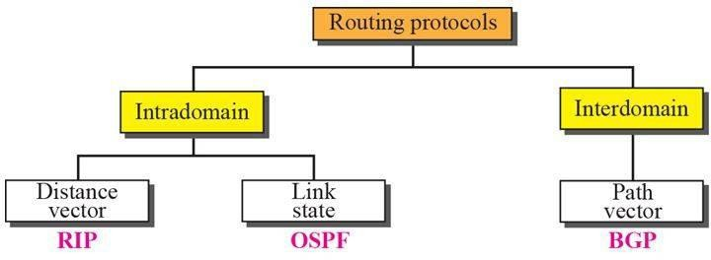

Intra- and Interdomain Routing

- Today, an internet can be so large that one routing protocol cannot handle the task of updating the routing tables of all routers. For this reason, an internet is divided into autonomous systems.
- An autonomous system (AS) is a group of networks and routers under the authority of a single administration.
- 1. Routing inside an autonomous system is referred to as intradomain routing.
2. Routing between autonomous systems is referred to as interdomain routing.

Distance Vector Routing

- Each node maintains a vector (table) of minimum distances to every node.
- The table at each node also guides the packets to the desired node by showing the next stop in the route (next-hop routing).
- We can think of nodes as the cities in an area and the lines as the roads connecting them. A table can show a tourist the minimum distance between cities.
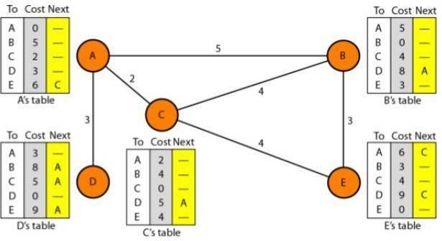
- The table for node A shows how we can reach any node from this node. For example, our least cost to reach node E is 6. The route passes through C.

Initialization
- The tables in Figure 22.14 are stable; each node knows how to reach any other node and the cost.
- At the beginning, however, this is not the case. Each node can know only the distance between itself and its immediate neighbors, those directly connected to it.
- So for the moment, we assume that each node can send a message to the immediate neighbors and find the distance between itself and these neighbors.
- The distance for any entry that is not a neighbor is marked as infinite (unreachable).

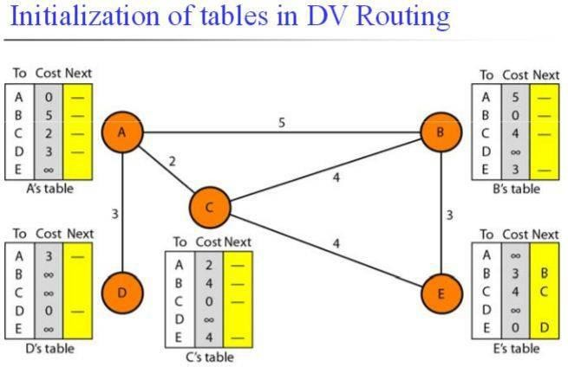
Sharing
- The whole idea of distance vector routing is the sharing of information between neighbors.
- Although node A does not know about node E, node C does. So if node C shares its routing table with A, node A can also know how to reach node E.
- On the other hand, node C does not know how to reach node D, but node A does.
- In other words, nodes A and C, as immediate neighbors, can improve their routing tables if they help each other.
- There is only one problem. How much of the table must be shared with each neighbor?
- The best solution for each node is to send its entire table to the neighbor and let the neighbor decide what part to use and what part to discard.
- Sharing here means sharing only the first two columns.
- If any of the rows can be used, the next node is the sender of the table.

Updating
When a node receives a two-column table from a neighbor, it needs to update its routing table. Updating takes three steps:
- The receiving node needs to add the cost between itself and the sending node to each value in the second column.
- The receiving node needs to add the name of the sending node to each row as the third column if the receiving node uses information from any row.
- The receiving node needs to compare each row of its old table with the corresponding row of the modified version of the received table.
  - If the next-node entry is different, the receiving node chooses the row with the smaller cost. If there is a tie, the old one is kept.
  - If the next-node entry is the same, the receiving node chooses the new row.

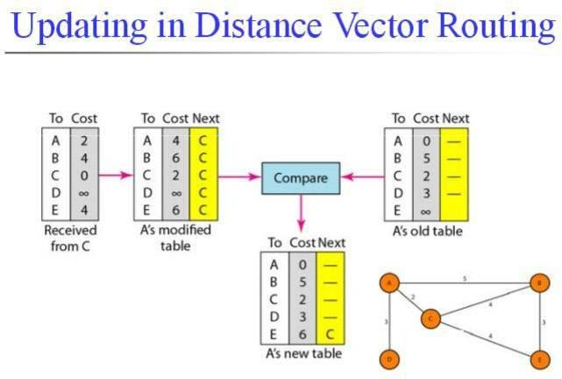
When to Share
- The table is sent both periodically and when there is a change in the table.
- 1. Periodic Update: A node sends its routing table, normally every 30 s, in a periodic update. The period depends on the protocol that is using distance vector routing.
2.Triggered Update: A node sends its two-column routing table to its neighbors anytime there is a change in its routing table. This is called a triggered update. The change can result from the following.
  - A node receives a table from a neighbor, resulting in changes in its own table after updating.
  - A node detects some failure in the neighboring links which results in a distance change to infinity.
Two-Node Loop Instability
- A problem with distance vector routing is network instability.

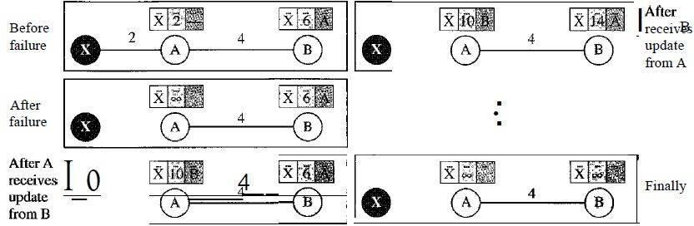
- At the beginning, both nodes A and B know how to reach node X.
- But suddenly, the link between A and X fails. Node A changes its table. If A can send its table to B immediately, everything is fine.
- However, the system becomes unstable if B sends its routing table to A before receiving A's routing table.
- Based on the triggered update strategy, A sends its new update to B. Now B thinks that something has been changed around A and updates its routing table.
- The cost of reaching X increases gradually until it reaches infinity.
- Node A thinks that the route to X is via B; node B thinks that the route to X is via A.

- If A receives a packet destined for X, it goes to B and then comes back to A. Similarly, if B receives a packet destined for X, it goes to A and comes back to B. Packets bounce between A and B, creating a two-node loop problem.
- A few solutions have been proposed for instability of this kind.

- Defining Infinity:
  - The first obvious solution is to redefine infinity to a smaller number, such as 100.
  - As a matter of fact, most implementations of the distance vector protocol define the distance between each node to be I and define 16 as infinity.
- Split Horizon:
  - Instead of flooding the table through each interface.
  - If, according to its table, node B thinks that the optimum route to reach X is via A, it does not need to advertise this piece of information to A; the information has corne from A (A already knows).
  - Node A keeps the value of infinity as the distance to X. Later when node A sends its routing table to B, node B also corrects its routing table.
  - The system becomes stable after the first update: both node A and B know that X is not reachable.
- Split Horizon and Poison Reverse:
  - Normally, the distance vector protocol uses a timer, and if there is no news about a route, the node deletes the route from its table.
  - When node B in the previous scenario eliminates the route to X from its advertisement to A, node A cannot guess that this is due to the split horizon strategy (the source of information was A) or because B has not received any news about X recently.
  - The split horizon strategy can be combined with the poison reverse strategy.
  - Node B can still advertise the value for X, but if the source of information is A, it can replace the distance with infinity as a warning: "Do not use this value; what I know about this route comes from you."

Three-Node Instability
  - If the instability is between three nodes, stability cannot be guaranteed.
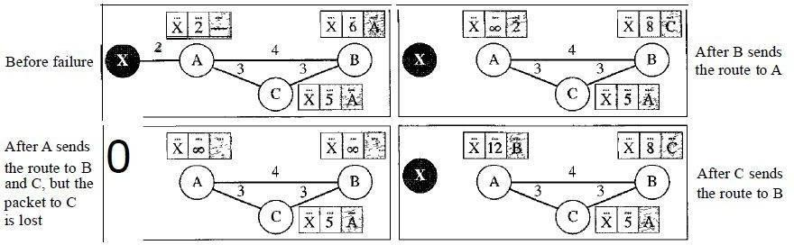
  - After finding that X is not reachable, node A sends a packet to Band C.
  - Node B immediately updates its table, but the packet to C is lost in the network and never reaches C.

  - Node C still thinks that there is a route to X via A with a distance of 5.
  - After a while, node C sends to Bits routing table, which includes the route to X. Node B is totally fooled here.
  - Node B updates its table, showing the route to X via C with a cost of 8.
  - So after awhile node B may advertise this route to A.
  - Now A is fooled and updates its table to show that A can reach X via B with a cost of 12. The loop continues leading to three-node instability.

RIP
  - The Routing Information Protocol (RIP) is an intradomain routing protocol used inside an autonomous system based on distance vector routing.
  - RIP implements distance vector routing directly with some considerations:
    - In an autonomous system, we are dealing with routers and networks (links). The routers have routing tables; networks do not.
    - The destination in a routing table is a network, which means the first column defines a network address.
    - The metric in RIP is called a hop count. The distance is defined as the number of links (networks) to reach the destination.
    - Infinity is defined as 16, which means that any route in an autonomous system using RIP cannot have more than 15 hops.
    - The next-node column defines the address of the router to which the packet is to be sent to reach its destination.
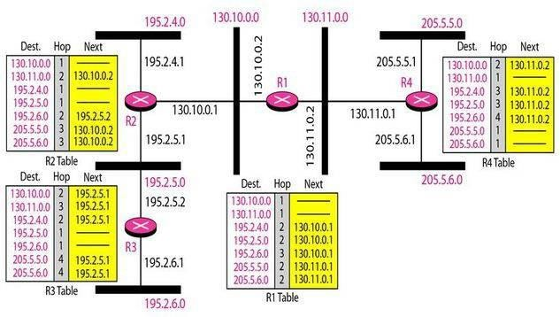
  - To send a packet to one of the three networks at the far left, router Rl needs to deliver the packet to R2. The next-node entry for these three networks is the interface of router R2 with IP address 130.10.0.1.
  - To send a packet to the two networks at the far right, router Rl needs to send the packet to the interface of router R4 with IP address 130.11.0.1.

Link State Routing
  - In link state routing, if each node in the domain has the entire topology of the domain the list of nodes and links, how they are connected including the type, cost (metric), and condition of the links (up or down)-the node can use Dijkstra's algorithm to build a routing table.
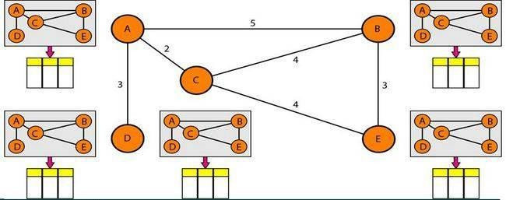
  - Each node in the domain has the entire topology of the domain.
  - Each node uses the same topology to create the routing tables.
  - The topology must be dynamic, representing the latest state of each node and each link.
  - How can a common topology be dynamic and stored in each node? No node can know the topology at the beginning or after a change somewhere in the network.
  - Link state routing is based on the assumption that, although the global knowledge about the topology is not clear, each node has partial knowledge: it knows the state (type, condition, and cost) of its links.
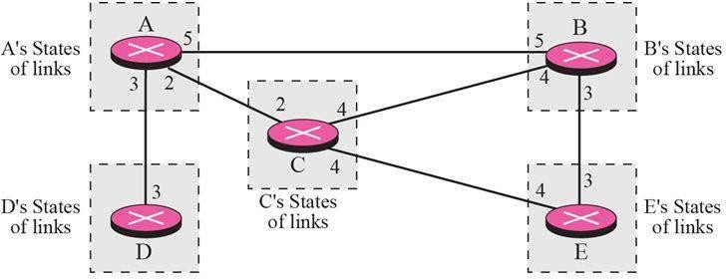
  - Node A knows that it is connected to node B with metric 5, to node C with metric 2, and so on.

Building Routing Tables

In link state routing, four sets of actions are required to ensure that each node has the routing table showing the least-cost node to every other node.
- Creation of the states of the links by each node, called the link state packet (LSP).
- Dissemination of LSPs to every other router, called flooding, in an efficient and reliable way.
- Formation of a shortest path tree for each node.

- Calculation of a routing table based on the shortest path tree.

Creation of Link State Packet (LSP)

  - A link state packet can carry a some amount of information: the node identity, the list of links, a sequence number, and age.
  - The first two, node identity and the list of links, are needed to make the topology.
  - The third, sequence number, facilitates flooding and distinguishes new LSPs from old ones.
  - The fourth, age, prevents old LSPs from remaining in the domain for a long time.
  - LSPs are generated on two occasions:
    - When there is a change in the topology of the domain.
    - On a periodic basis: A longer period ensures that flooding does not create too much traffic on the network.
Flooding of LSPs
  - After a node has prepared an LSP, it must be disseminated to all other nodes, not only to its neighbors called flooding which is based on the following:
    - The creating node sends a copy of the LSP out of each interface.
    - If the newly arrived LSP is older than the one it has (found by checking the sequence number), it discards the LSP. If it is newer, the node does the following:
      - It discards the old LSP and keeps the new one.
      - It sends a copy of it out of each interface except the one from which the packet arrived. This guarantees that flooding stops somewhere in the domain.

Formation of Shortest Path Tree: Dijkstra Algorithm

  - A shortest path tree is a tree in which the path between the root and every other node is the shortest.
  - The Dijkstra algorithm creates a shortest path tree from a graph.
  - The algorithm divides the nodes into two sets: tentative and permanent.
  - It finds the neighbors of a current node, makes them tentative, examines them, and if they pass the criteria, makes them permanent.

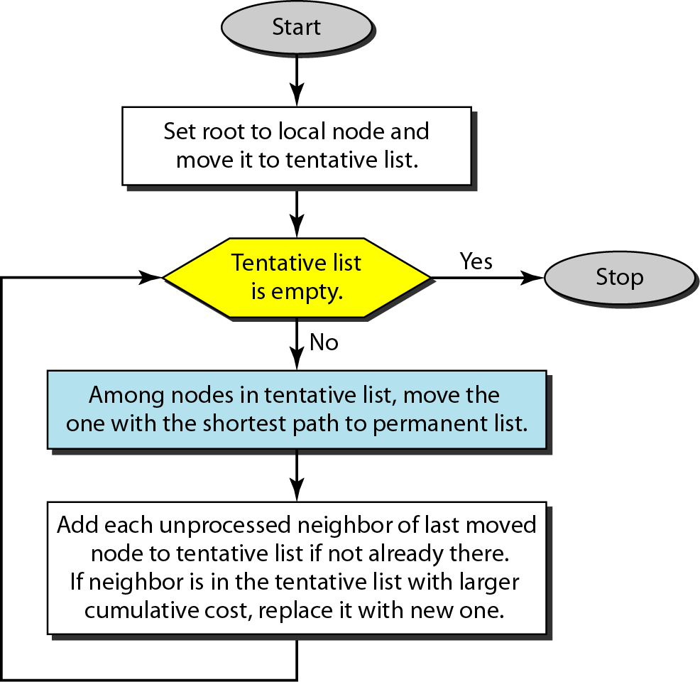

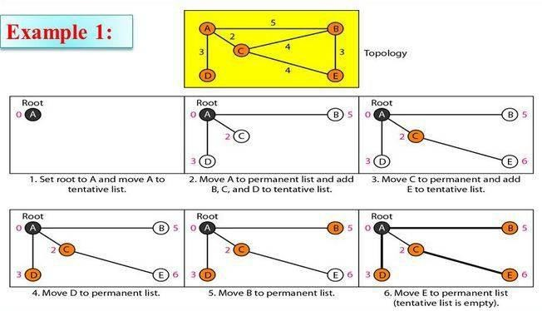
  - Example of formation of shortest path tree:

    - Permanent list: empty Tentative list: A(O)
    - Permanent list: A(O) Tentative list: B(5), C(2), D(3)
    - Permanent list: A(O), C(2) Tentative list: B(5), 0(3), E(6)
    - Permanent list: A(O), C(2), D(3) Tentative list: B(5), E(6)
    - Permanent list: A(O), B(5), C(2), D(3) Tentative list: E(6)
    - Permanent list: A(O), B(5), C(2), D(3), E(6) Tentative list: empty Calculation of Routing Table from Shortest Path Tree

  - Each node uses the shortest path tree protocol to construct its routing table which shows the cost of reaching each node from the root.
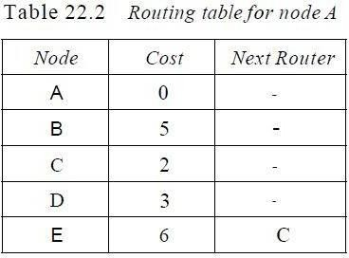

OSPF
  - The Open Shortest Path First or OSPF protocol is an intradomain routing protocol based on link state routing.
Areas
  - An area is a collection of networks, hosts, and routers all contained within an autonomous system.
  - Routers inside an area flood the area with routing information. At the border of an area, special routers called area border routers summarize the information about the area and send it to other areas.
  - All the areas inside an autonomous system must be connected to the backbone.
  - The routers inside the backbone are called the backbone routers.
  - A virtual link between routers must be created by an administrator to allow continuity of the functions of the backbone as the primary area if the connectivity fails.
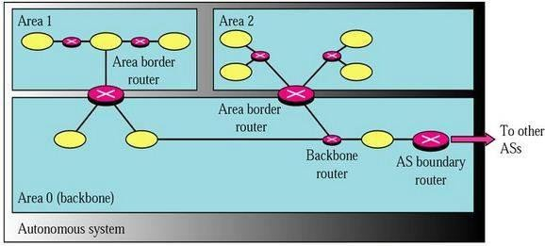
Metric: Type of Service

Types of Links:
  - In OSPF terminology, a connection is called a link.

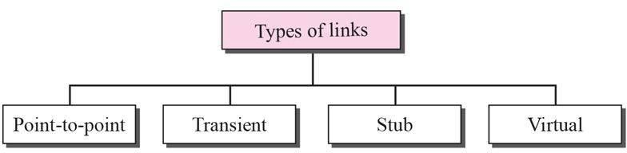

- A point-to-point link connects two routers without any other host or router in between. Example: two routers connected by a telephone line or a T line.
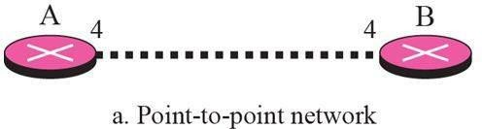
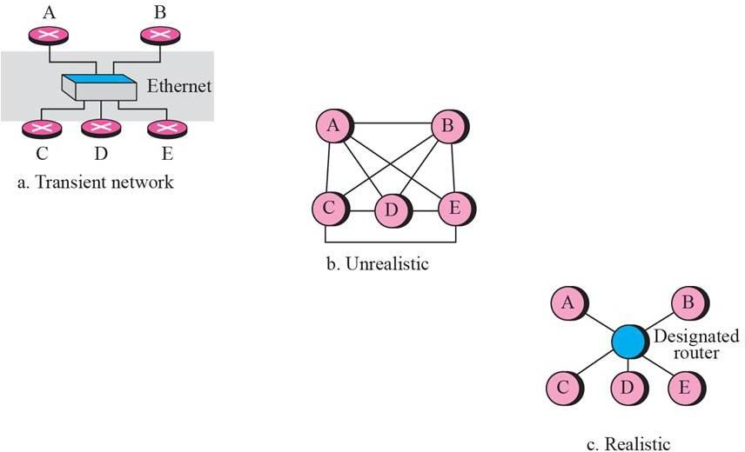
- A transient link is a network with several routers attached to it. The data can enter through any of the routers and leave through any router. consider the Ethernet in Figure 22.27a. Router A has routers B, C, D, and E as neighbors. Router B has routers A, C, D, and E as neighbors. If we want to show the neighborhood relationship in this situation, we have the graph shown in Figure 22.27b.

- Stub link: The data packets enter the network through a single router and leave the network through the same router. The link is only one-directional.
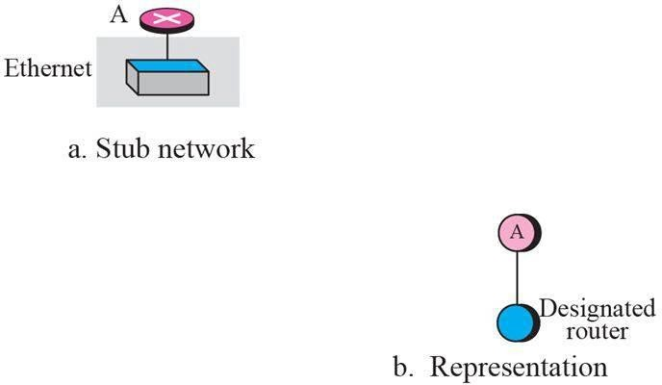

Graphical Representation
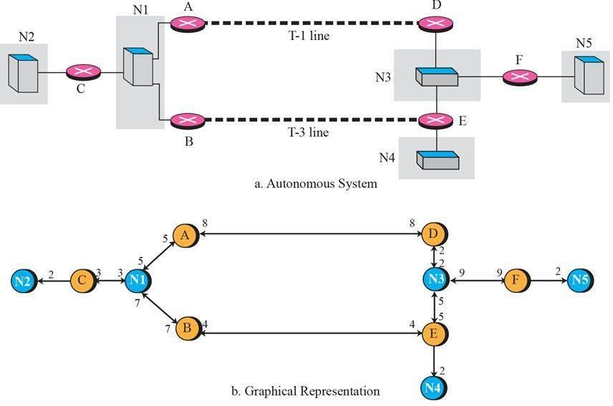
Path Vector Routing
  - Path vector routing is an inter-domain routing protocol.
  - We assume that there is one node (there can be more, but one is enough for our conceptual discussion) in each autonomous system that acts on behalf of the entire autonomous system. Let us call it the speaker node.
  - The speaker node in an AS creates a routing table and advertises it to speaker nodes in the neighboring ASs.
Initialization
  - At the beginning, each speaker node can know only the reachability of nodes inside its autonomous system.
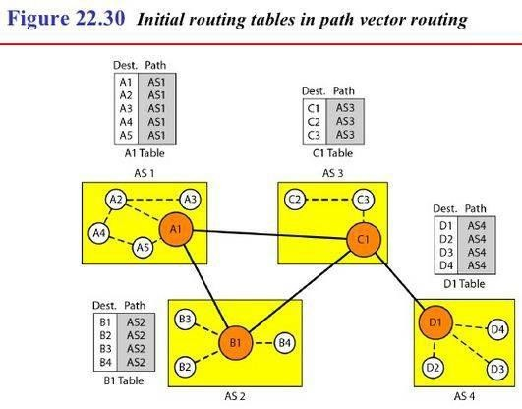
Sharing
  - A speaker in an autonomous system shares its table with immediate neighbors.
Updating

  - When a speaker node receives a two-column table from a neighbor, it updates its own table by adding the nodes that are not in its routing table and adding its own autonomous system and the autonomous system that sent the table.
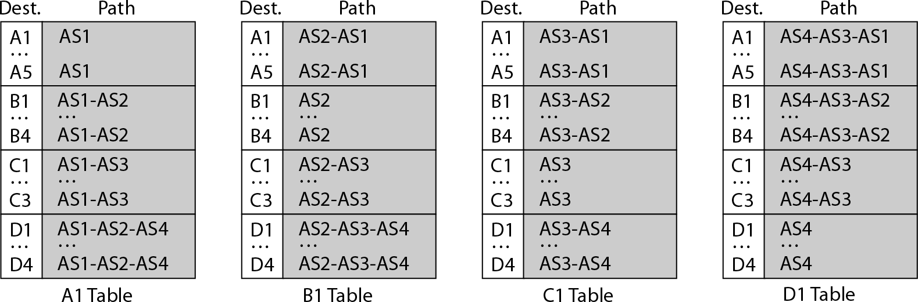

BGP
- Loop prevention:
When a router receives a message, it checks to see if its autonomous system is in the path list to the destination. If it is, looping is involved and the message is ignored.

Policy routing:
When a router receives a message, it can check the path. If one of the autonomous systems listed in the path is against its policy, it can ignore that path and that destination.

Optimum path:
The optimum path is the path that fits the organization like smaller number of autonomous systems.
Other criteria, such as security, safety, and reliability, can also be applied.

  - Border Gateway Protocol (BGP) is an interdomain routing protocol using path vector routing.
Types of Autonomous Systems:

We can divide autonomous systems into three categories: stub, multihomed, and transit.
  - Stub AS: A stub AS has only one connection to another AS. Data traffic, however, cannot pass through a stub AS. A stub AS is either a source or a sink. A good example of a stub AS is a small corporation or a small local ISP.
  - Multihomed AS: A multihomed AS has more than one connection to other ASs, but it is still only a source or sink for data traffic. It does not allow transient traffic. A good example of a multihomed AS is a large corporation that is connected to more than one regional or national AS that does not allow transient traffic.
  - Transit AS: A transit AS is a multihomed AS that also allows transient traffic. Good examples of transit ASs are national and international ISPs.
Path Attributes
  - The list of attributes helps the receiving router make a more-informed decision when applying its policy.
  - Attributes are divided into two broad categories: well known and optional. A well-known

Attribute is one that every BGP router must recognize. An optional attribute is one that needs not be recognized by every router.
  - Well-known attributes are themselves divided into two categories: mandatory and discretionary. A well-known mandatory attribute is one that must appear in the description of a route. Ex: ORIGIN, AS_PATH. A well-known discretionary attribute is one that must be recognized by each router, but is not required to be included in every update message.
  - The optional attributes can also be subdivided into two categories: transitive and non transitive. An optional transitive attribute is one that must be passed to the next
router by the router that has not implemented this attribute. An optional nontransitive attribute is one that must be discarded if the receiving router has not implemented it.
BGP Sessions
  - A session is a connection that is established between two BGP routers only for the sake of exchanging routing information.
  - A session at the BGP level, as an application program, is a connection at the TCP level.
  - BGP sessions are sometimes referred to as semi permanent connections.
External and Internal BGP:
  - BGP can have two types of sessions: external BGP (E-BGP) and internal BGP (I-BGP) sessions.
  - The E-BGP session is used to exchange information between two speaker nodes belonging to two different autonomous systems.
  - The I-BGP session, on the other hand, is used to exchange routing information between two routers inside an autonomous system.
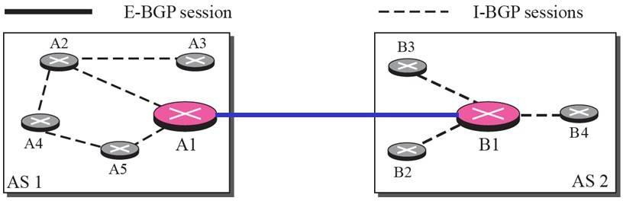

    - The session established between AS1 and AS2 is an E-BOP session.
    - Two speaker routers need to collect information from other routers in the autonomous systems. This is done using I-BOP sessions.

PROGRAM-7
AIM: Implementation of data encryption and data decryption

DESCRIPTION:

ENCRYPTION: Encryption is a process that transforms plain text into Cipher Text (Un-understandable format of data), which appears to be random and meaningless.

DECRYPTION: The process of converting ciphertext back to plaintext is called decryption. (This plain text is also known as Decipher Text)

For both the processes we need a key.

SOURCE CODE:

#include <stdio.h>
#include <string.h>
#include <ctype.h>

void encrypt(char text[], int key) {
for (int i = 0; text[i] != '\0'; ++i) {
char ch = text[i];
if (isalpha(ch)) {
char base = islower(ch) ? 'a' : 'A';
ch = (ch - base + key) % 26 + base;
}
text[i] = ch;
}
}

void decrypt(char text[], int key) {
for (int i = 0; text[i] != '\0'; ++i) {
char ch = text[i];
if (isalpha(ch)) {
char base = islower(ch) ? 'a' : 'A';
ch = (ch - base - key + 26) % 26 + base;
}
text[i] = ch;
}
}

int main() {
char text[100];
int key, choice;
char cont;

printf("=== Data Encryption and Decryption Simulation ===\n\n");

printf("Enter a message: ");
fgets(text, sizeof(text), stdin);
text[strcspn(text, "\n")] = '\0'; // Remove newline

printf("Enter encryption key (integer): ");
scanf("%d", &key);

do {
printf("\n----------- MENU -----------\n");
printf("1. Encrypt the Message\n");
printf("2. Decrypt the Message\n");
printf("3. Exit\n");
printf("-----------------------------\n");
printf("Enter your choice: ");
scanf("%d", &choice);

switch (choice) {
case 1:
encrypt(text, key);
printf("\nEncrypted Text (Ciphertext): %s\n", text);
break;

case 2:
decrypt(text, key);
printf("\nDecrypted Text (Plaintext): %s\n", text);
break;

case 3:
printf("\nExiting the program...\n");
return 0;

default:
printf("\nInvalid choice! Please enter 1, 2, or 3.\n");
}
} while (1);

return 0;
}
OUTPUT:
=== Data Encryption and Decryption Simulation ===
Enter a message: ACE COLLEGE
Enter encryption key (integer): 3
----------- MENU -----------
1. Encrypt the Message
2. Decrypt the Message
3. Exit
-----------------------------
Enter your choice: 1
Encrypted Text (Ciphertext): DFH FROOHJH
----------- MENU -----------
1. Encrypt the Message
2. Decrypt the Message
3. Exit
-----------------------------
Enter your choice: 2
Decrypted Text (Plaintext): ACE COLLEGE
----------- MENU -----------
1. Encrypt the Message
2. Decrypt the Message
3. Exit
-----------------------------
Enter your choice: 3
Exiting the program...

VIVA – QUESTIONS:
- Define Security and Authentication?
- Define encryption and Decryption?
- What are the various public key encryption Algorithms?
3. What are the various private key encryption Algorithms?

PROGRAM-8
AIM: Write a program for congestion control using Leaky bucket algorithm

DESCRIPTION:
- This algorithm is a congestion control algorithm used to control the rate at which traffic is sent to the network and shape the burst traffic to a steady traffic stream.
- The disadvantages compared with the leaky-bucket algorithm are the inefficient use of available network resources.
- The large area of network resources such as bandwidth is not being used effectively.
Let us consider an example to understand Imagine a bucket with a small hole in the bottom. No matter at what rate water enters the bucket, the outflow is at constant rate. When the bucket is full with water additional water entering spills over the sides and is lost.

SOURCE CODE:
#include <stdio.h>
int main() {
int bucket_size, output_rate, n, i;
int incoming_packet_size, bucket_content = 0;

printf("Enter bucket capacity: ");
scanf("%d", &bucket_size);

printf("Enter output rate: ");
scanf("%d", &output_rate);

printf("Enter number of packets: ");
scanf("%d", &n);

for (i = 1; i <= n; i++) {
printf("\n--- Packet %d ---\n", i);
printf("Enter packet size: ");
scanf("%d", &incoming_packet_size);

// Check bucket space
if (bucket_content + incoming_packet_size > bucket_size) {
printf("❌ Packet of size %d is dropped (Bucket overflow!)\n", incoming_packet_size);
} else {
bucket_content += incoming_packet_size;
printf("✅ Packet of size %d added to bucket\n", incoming_packet_size);
}

// Transmit data (leak)
if (bucket_content > 0) {
int leaked = (bucket_content < output_rate) ? bucket_content : output_rate;
bucket_content -= leaked;
printf("📤 Transmitted %d units\n", leaked);
} else {
printf("📤 Nothing to transmit\n");
}

printf("🪣 Bucket content after transmission: %d\n", bucket_content);
}

// Empty remaining bucket content
while (bucket_content > 0) {
int leaked = (bucket_content < output_rate) ? bucket_content : output_rate;
bucket_content -= leaked;
printf("\n📤 Transmitted %d units (Final flush)\n", leaked);
printf("🪣 Bucket content now: %d\n", bucket_content);
}

printf("\n✅ All packets processed and bucket is empty.\n");
return 0;
}

NOTE:
Bucket size = Maximum data it can hold.
Incoming packets try to enter the bucket.
If total data exceeds capacity → packet is dropped.
Data leaves (is transmitted) at a fixed output rate.
Remaining data is leaked until the bucket is empty.

OUTPUT-1:
Enter bucket capacity: 10
Enter output rate: 3
Enter number of packets: 5

--- Packet 1 ---
Enter packet size: 20
❌ Packet of size 20 is dropped (Bucket overflow!)
📤 Nothing to transmit
🪣 Bucket content after transmission: 0

--- Packet 2 ---
Enter packet size: 5
✅ Packet of size 5 added to bucket
📤 Transmitted 3 units
🪣 Bucket content after transmission: 2

--- Packet 3 ---
Enter packet size: 1
✅ Packet of size 1 added to bucket
📤 Transmitted 3 units
🪣 Bucket content after transmission: 0

--- Packet 4 ---
Enter packet size: 7
✅ Packet of size 7 added to bucket
📤 Transmitted 3 units
🪣 Bucket content after transmission: 4

--- Packet 5 ---
Enter packet size: 4
✅ Packet of size 4 added to bucket
📤 Transmitted 3 units
🪣 Bucket content after transmission: 5

📤 Transmitted 3 units (Final flush)
🪣 Bucket content now: 2

📤 Transmitted 2 units (Final flush)
🪣 Bucket content now: 0

✅ All packets processed and bucket is empty.

OUTPUT-2:
Enter bucket capacity: 15
Enter output rate: 5
Enter number of packets: 4

--- Packet 1 ---
Enter packet size: 8
✅ Packet of size 8 added to bucket
📤 Transmitted 5 units
🪣 Bucket content after transmission: 3

--- Packet 2 ---
Enter packet size: 6
✅ Packet of size 6 added to bucket
📤 Transmitted 5 units
🪣 Bucket content after transmission: 4

--- Packet 3 ---
Enter packet size: 4
✅ Packet of size 4 added to bucket
📤 Transmitted 5 units
🪣 Bucket content after transmission: 3

--- Packet 4 ---
Enter packet size: 3
✅ Packet of size 3 added to bucket
📤 Transmitted 5 units
🪣 Bucket content after transmission: 1

📤 Transmitted 1 units (Final flush)
🪣 Bucket content now: 0

✅ All packets processed and bucket is empty.

VIVA – QUESTIONS:

How to improve Quality of Service. Explain Integrated Services and Differentiated Services?

QUALITY OF SERVICE:
Quality of service (QoS) is an internetworking issue that has been discussed more than defined. We can informally define quality of service as something a flow seeks to attain.

TECHNIQUES TO IMPROVE QoS:
The four common methods to improve the Quality of Service:
  - Scheduling
  - Traffic shaping
  - Admission control
  - Resource reservation.

SCHEDULING:
Packets from different flows arrive at a switch or router for processing. A good scheduling technique treats the different flows in a fair and appropriate manner. Several scheduling techniques are designed to improve the quality of service. We discuss three of them here:
- FIFO queuing
- Priority queuing and
- Weighted fair queuing.

FIFO Queuing:
In first-in, first-out (FIFO) queuing, packets wait in a buffer (queue) until the node (router or switch) is ready to process them. If the average arrival rate is higher than the average processing rate, the queue will fill up and new packets will be discarded. A FIFO queue is familiar to those who have had to wait for a bus at a bus stop.
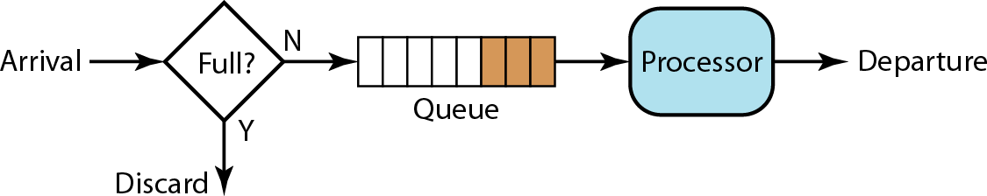

Conceptual view of FIFO queue

Priority queue:
In priority queuing, packets are first assigned to a priority class. Each priority class has its own queue. The packets in the highest-priority queue are processed first. Packets in the lowest-priority queue are processed last. Note that the system
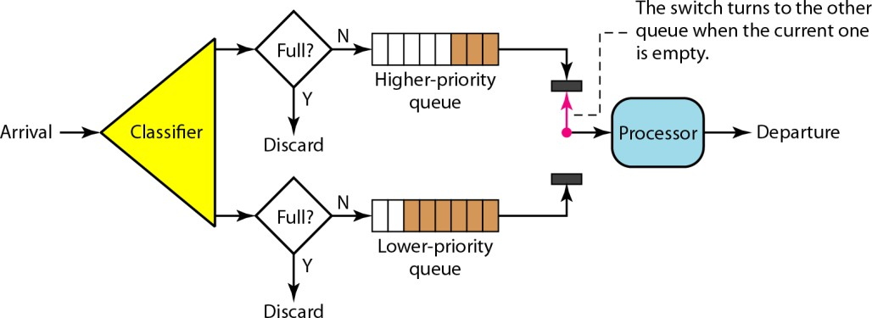

Priority queuing
does not stop serving a queue until it is empty. A priority queue can provide better QoS than the FIFO queue because higher- priority traffic, such as multimedia, can reach the destination with less delay. However, there is a potential drawback. If there is a continuous flow in a high-priority queue, the packets in the lower-priority queues will never have a chance to be processed. This is a condition called starvation.

Weighted Fair Queuing:
A better scheduling method is weighted fair queuing. In this technique, the packets are still assigned to different classes and admitted to different queues. The queues, how- ever, are weighted based on the priority of the queues; higher priority means a higher weight. The system processes packets in each queue in a round-robin fashion with the number of packets selected from each queue based on the corresponding weight. For example, if the weights are 3, 2, and 1, three packets are processed from the first queue, two from the second queue, and one from the third queue. If the system does

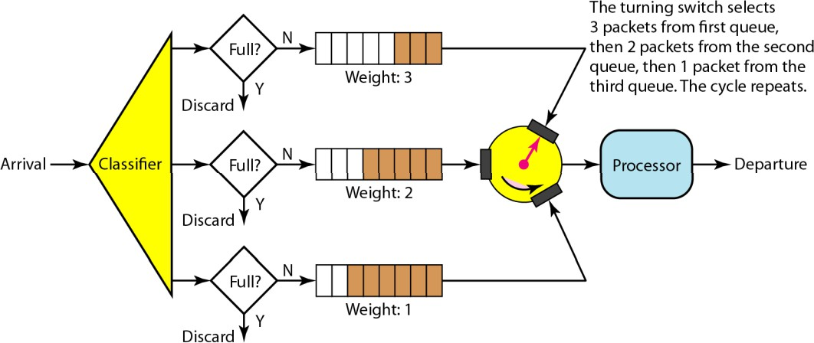
not impose priority on the classes, all weights can be equal. In this way, we have fair queuing with

priority.
Weighted fair queuing

TRAFFIC SHAPING:
Traffic shaping is a mechanism to control the amount and the rate of the traffic sent to the network. Two techniques can shape traffic:
- Leaky bucket and
- Token bucket.
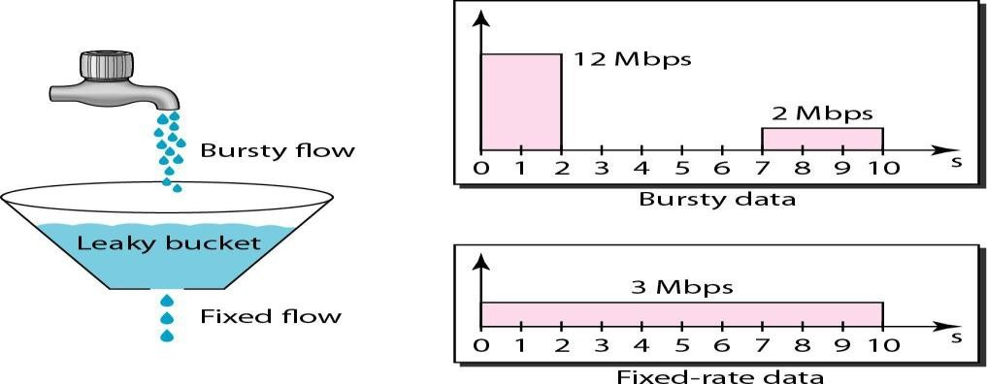

Leaky Bucket:
If a bucket has a small hole at the bottom, the water leaks from the bucket at a constant rate as long as there is water in the bucket. The rate at which the water leaks does not depend on the rate at which the water is input to the bucket unless the bucket is empty. The input rate can vary, but the output rate remains constant. Similarly, in networking, a technique called leaky bucket can smooth out burst traffic. Bursty chunks are stored in the bucket and sent out at an average rate. In the figure, we assume that the network has committed a bandwidth of 3 Mbps for a host. The use of the leaky bucket shapes the input traffic to make it conform to this commitment. In Figure, the host sends a burst of data at a rate of 12 Mbps for 2 s, for a total of 24 Mbits of data. The host is silent for 5 s and then sends data at a rate of 2 Mbps for 3 s, for a total of 6 Mbits of data. In all, the host has sent 30 Mbits of data in 10s. The leaky bucket smooths the traffic by sending out data at a rate of3 Mbps during the same 10 s. Without the leaky bucket, the beginning burst may have hurt the network by consuming more bandwidth than is set aside for this host. We can also see that the leaky bucket may

prevent congestion. As an analogy, consider the freeway during rush hour (bursty traffic). If, instead, commuters could stagger their working hours, congestion on our freeways could be avoided.
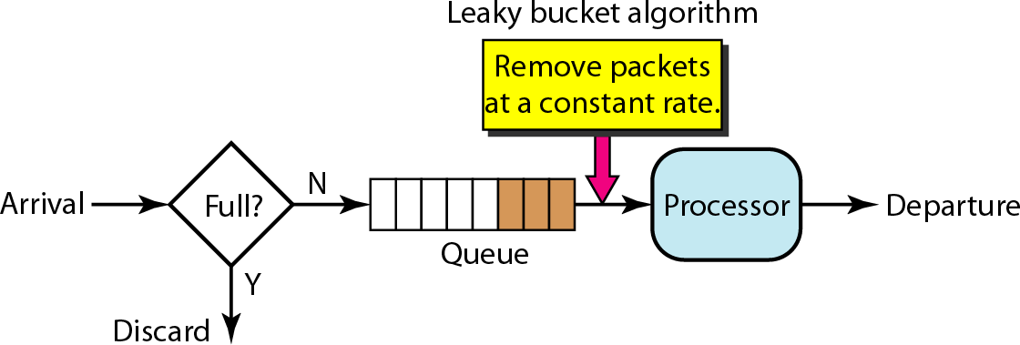

A FIFO queue holds the packets. If the traffic consists of fixed-size packets (e.g., cells in ATM networks), the process removes a fixed number of packets from the queue at each tick of the clock. If the traffic consists of variable-length packets, the fixed output rate must be based on the number of bytes or bits. The following is an algorithm for variable-length packets:
- Initialize a counter to n at the tick of the clock.
- If n is greater than the size of the packet, send the packet and decrement the counter by the packet size. Repeat this step until n is smaller than the packet size.
- Reset the counter and go to step1.
A leaky bucket algorithm shapes bursty traffic into fixed-rate traffic by averaging the data rate. It may drop the packets if the bucket is full.

Token Bucket:
The leaky bucket is very restrictive. It does not credit an idle host. For example, if a host is not sending for a while, its bucket becomes empty. Now if the host has bursty data, the leaky bucket allows only an average rate. The time when the host was idle is not taken into account. On the other hand, the token bucket algorithm allows idle hosts to accumulate credit for the future in the form of tokens. For each tick of the clock, the system sends n tokens to the bucket. The system removes one token for every cell (or byte) of data sent. For example, if n is 100 and the host is idle for 100 ticks, the bucket collects 10,000 tokens. Now the host can consume all these tokens in one tick with 10,000 cells, or the host takes 1000 ticks with 10 cells per tick. In other words, the host can send bursty data as long as the bucket is not empty. The token bucket can easily be implemented with a counter. The token is initialized to zero. Each time a token is added, the counter is incremented by 1. Each time a unit of data is sent, the counter is decremented by 1. When the counter is zero, the host cannot send data.
The token bucket allows bursty traffic at a regulated maximum rate.

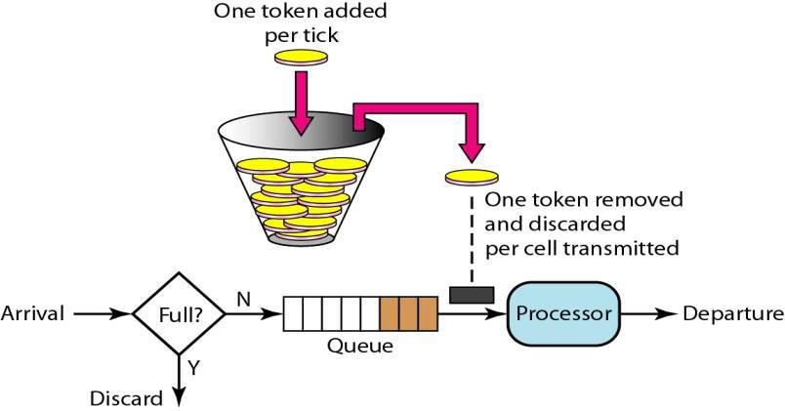
Token bucket

Combining Token Bucket and Leaky Bucket:
The two techniques can be combined to credit an idle host and at the same time regulate the traffic. The leaky bucket is applied after the token bucket; the rate of the leaky bucket needs to be higher than the rate of tokens dropped in the bucket.

RESOURCE RESERVATION:
A flow of data needs resources such as a buffer, bandwidth, CPU time, and so on. The quality of service is improved if these resources are reserved beforehand. We discuss in this section one QoS model called Integrated Services, which depends heavily on resource reservation to improve the quality of service.

ADMISSIONCONTROL:
Admission control refers to the mechanism used by a router, or a switch, to accept or reject a flow based on predefined parameters called flow specifications. Before a router accepts a flow for processing, it checks the flow specifications to see if its capacity (in terms of bandwidth, buffer size, CPU speed, etc.) and its previous commitments to other flows can handle the new flow.
Based on characteristics and techniques of Quality of Service two models have been designed to provide quality of service in the Internet:
- Integrated Services and
- Differentiated Services.
Both models emphasize the use of quality of service at the network layer (IP), although the model can also be used in other layers such as the data link. IP was originally designed for best-effort delivery. This means that every user receives the same level of services. This type of delivery does not guarantee the minimum of a service, such as bandwidth, to applications such as real-time audio and video. If such an application accidentally gets extra bandwidth, it may be detrimental to other applications, resulting in congestion.

INTEGRATED SERVICES:
Integrated Services, sometimes called IntServ, is a flow-based QoS model, which means that a user needs to create a flow, a kind of virtual circuit, from the source to the destination and inform all routers of the resource requirement.
Integrated Services is a flow-based QoS model designed for IP.

Signaling:
To implement a flow-based model over a connectionless protocol signaling is used. Signaling protocol is to run over IP that provides the signaling mechanism for making a reservation. This protocol is called Resource Reservation Protocol (RSVP).

Flow Specification:
When a source makes a reservation, it needs to define a flow specification. A flow specification has two parts: Rspec( resource specification )and Tspec(traffic specification). Rspec defines the resource that the flow needs to reserve (buffer, bandwidth, etc.). Tspec defines the traffic characterization of the flow.

Admission:
After a router receives the flow specification from an application, it decides to admit or deny the service. The decision is based on the previous commitments of the router and the current availability of the resource.

Service Classes:
Two classes of services have been defined for Integrated Services: guaranteed service and controlled- load service.

Guaranteed Service Class:
This type of service is designed for real-time traffic that needs a guaranteed minimum end-to-end delay. The end-to-end delay is the sum of the delays in the routers, the propagation delay in the media, and the setup mechanism. Only the first, the sum of the delays in the routers, can be guaranteed by the router. This type of service guarantees that the packets will arrive within a certain delivery time and are not discarded if flow traffic stays within the boundary of Tspec. We can say that guaranteed services are quantitative services, in which the amount of end-to-end delay and the data rate must be defined by the application.

Controlled-Load Service Class:
This type of service is designed for applications that can accept some delays, but are sensitive to an overloaded network and to the danger of losing packets. Good examples of these types of applications are file transfer, e-mail, and Internet access. The controlled- load service is a qualitative type of service in that the application requests the possibility of low-loss or no-loss packets.

RSVP:
In the Integrated Services model, an application program needs resource reservation. As we learned in the discussion of the IntServ model, the resource reservation is for a flow. This means that if we want to use IntServ at the IP level, we need to create a flow, a kind of virtual-circuit network, out of the IP, which was originally designed as a datagram packet-switched network. A virtual-circuit network needs a signaling system to set up the virtual circuit before data traffic can start. The Resource Reservation Protocol (RSVP) is a signaling protocol to help IP create a flow and consequently make a resource reservation. Before discussing RSVP, we need to mention that it is an independent protocol separate from the Integrated Services model. It may be used in other models in the future.

Multicast Trees:
RSVP is different from some other signaling systems we have seen before in that it is a signaling system designed for multicasting. However, RSVP can be also used for unicasting because unicasting is just a special case of multicasting with only one member in the multicast group. The reason for this design is to enable RSVP to provide resource reservations for all kinds of traffic including multimedia which often uses multicasting.

Receiver-Based Reservation:
In RSVP, the receivers, not the sender, make the reservation. This strategy matches the other multicasting protocols. For example, in multicast routing protocols, the receivers, not the sender, make a decision to join or leave a multicast group.

RSVP Messages:
RSVP has several types of messages. Two of them: Path and Resv.

Path Messages :
Recall that the receivers in a flow make the reservation in RSVP. However, the receivers do not know the path traveled by packets before the reservation is made. The path is needed for the reservation. To solve the problem, RSVP uses Path messages. A Path message travels from the sender and reaches all receivers in the multi- cast path. On the way, a Path message stores the necessary information for the receivers. A Path message is sent in a multicast environment; a new message is created when the path diverges.
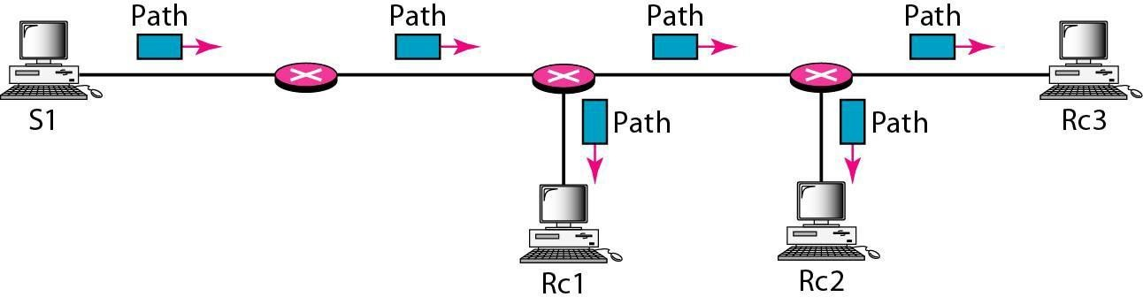

Resv Messages:
After a receiver has received a Path message, it sends a Resv message. The Resv message travels toward the sender (upstream) and makes a resource reservation on the routers that support RSVP. If a router does not support RSVP on the path, it routes the packet based on the best-effort delivery methods.
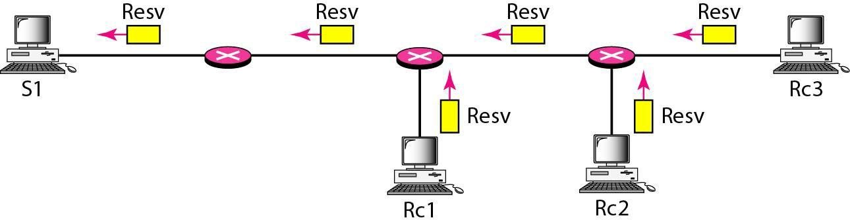

Reservation Merging:
In RSVP, the resources are not reserved for each receiver in a flow; the reservation is merged. In Figure, Rc3 requests a 2-Mbps bandwidth while Rc2 requests a I-Mbps bandwidth. Router R3, which needs to make a bandwidth reservation, merges the two requests. The reservation is made for 2 Mbps, the larger of the two, because a 2-Mbps input reservation can handle both requests. The same situation is true for R2. The reader may ask why Rc2 and Rc3, both belonging to one single flow, request different amounts of bandwidth. The answer is that, in a multimedia environment, different receivers may handle different grades of quality. For example, Rc2 may be able' to receive video only at 1 Mbps (lower quality), while Rc3 may be able to receive video at 2 Mbps (higher quality)
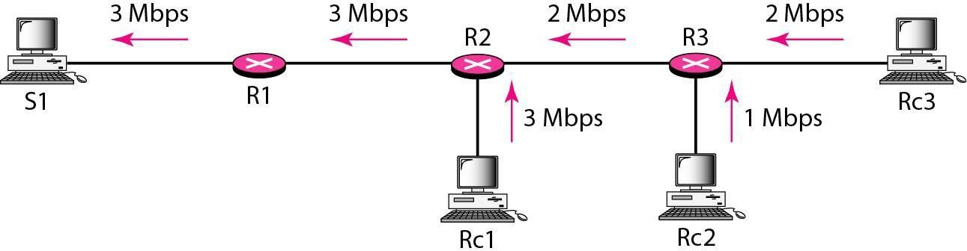

Reservation Styles:
When there is more than one flow, the router needs to make a reservation to accommodate all of them. RSVP defines three types of reservation styles.
. 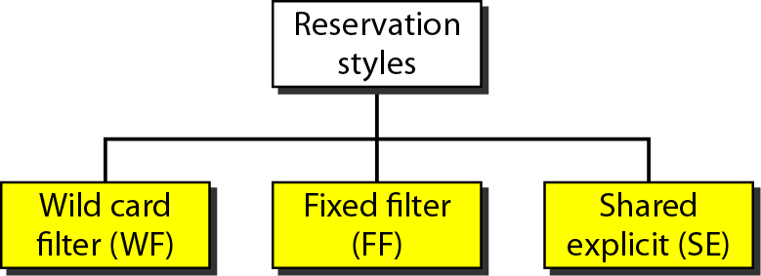

Wild Card Filter Style: In this style, the router creates a single reservation for all senders. The reservation is based on the largest request. This type of style is used when the flows from different senders do not occur at the same time.
Fixed Filter Style: In this style, the router creates a distinct reservation for each flow. This means that if there are n flows, n different reservations are made. This type of style is used when there is a high probability that flows from different senders will occur at the same time.
Shared Explicit Style: In this style, the router creates a single reservation which can be shared by a set of flows.

Soft State:
The reservation information (state) stored in every node for a flow needs to be refreshed periodically. This is referred to as a soft state as compared to the hard state used in other virtual- circuit protocols such as ATM or Frame Relay, where the information about the flow is maintained until it is erased. The default interval for refreshing is currently 30 s.

Problems with Integrated Services:
There are at least two problems with Integrated Services that may prevent its full implementation in the Internet: scalability and service-type limitation.

Scalability:
The Integrated Services model requires that each router keep information for each flow. As the Internet is growing every day, this is a serious problem.

Service-Type Limitation:
The Integrated Services model provides only two types of services, guaranteed and control-load. Those opposing this model argue that applications may need more than these two types of services.

DIFFERENTIATED SERVICES:
Differentiated Services (DS or Diffserv) was introduced by the IETF (Internet Engineering Task Force) to handle the shortcomings of Integrated Services. Two fundamental changes were made:
- The main processing was moved from the core of the network to the edge of the network. This solves the scalability problem. The routers do not have to store information about flows. The applications, or hosts, define the type of service they need each time they send a packet.
- The per-flow service is changed to per-class service. The router routes the packet based on the class of service defined in the packet, not the flow. This solves the service-type limitation problem. We can define different types of classes based on the needs of applications.
Differentiated Services is a class-based QoS model designed for IP.

DS Field:
In Diffserv, each packet contains a field called the DS field. The value of this field is set at the boundary of the network by the host or the first router designated as the boundary router. IETF proposes to replace the existing TOS (type of service) field in IPv4 or the class field in IPv6 by the DS field.
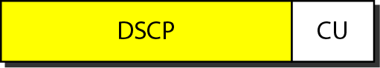
The DS field contains two subfields: DSCP and CU. The DSCP (Differentiated Services Code Point) is a 6- bit subfield that defines the per-hop behavior (PHB). The 2-bit CU (currently unused) subfield is not currently used. The Diffserv capable node (router) uses the DSCP 6 bits as an index to a table defining the packet-handling mechanism for the current packet being processed.

Per-Hop Behavior:
The Diffserv model defines per-hop behaviors (PHBs) for each node that receives a packet. So far three PHBs are defined: DE PHB, EF PHB, and AF PHB.
DE PHB: The DE PHB (default PHB) is the same as best-effort delivery, which is compatible with TOS.
EF PHB: The EF PHB (expedited forwarding PHB) provides the following services:
- Low loss
- Low latency
- Ensured bandwidth
This is the same as having a virtual connection between the source and destination.
AF PHB: The AF PHB (assured forwarding PHB) delivers the packet with a high assurance as long as the class traffic does not exceed the traffic profile of the node. The users of the network need to be aware that some packets may be discarded.

Traffic Conditioner:
To implement Diffserv, the OS node uses traffic conditioners such as meters, markers, shapers, and droppers.
Meters: The meter checks to see if the incoming flow matches the negotiated traffic profile. The meter also sends this result to other components. The meter can use several tools such as a token bucket to check the profile.
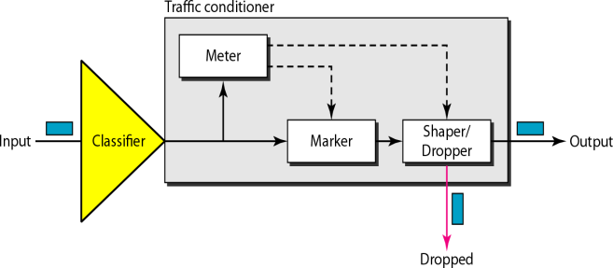

Marker: A marker can remark a packet that is using best-effort delivery (OSCP: 000000) or down- mark a packet based on information received from the meter. Down- marking (lowering the class of the flow) occurs if the flow does not match the profile. A marker does not up-mark (promote the class) a packet.
Shaper: A shaper uses the information received from the meter to reshape the traffic if it is not compliant with the negotiated profile.
Dropper: A dropper, which works as a shaper with no buffer, discards packets if the flow severely violates negotiated profile.

PROGRAM-9
AIM: Write a program for frame sorting techniques used in buffers.

DESCRIPTION:

In some data transfer techniques (UDP) the frames may be delivered unorderly (frame numbers may not be as per sequence numbers). The receiver has to arrange these unordered frames in order (as per the sequence) to get the meaning correctly. This program illustrates the same.

SOURCE CODE:
#include <stdio.h>
#include <string.h>

int main() {
int option, n, i, j;
char temp_str[100];
int temp_int;

printf("Choose frame type:\n");
printf("1. Numeric Frames\n");
printf("2. Text Frames\n");
printf("Enter your choice (1 or 2): ");
scanf("%d", &option);

printf("Enter number of frames: ");
scanf("%d", &n);

if (option == 1) {
int frames[50];

printf("Enter the frame numbers (in any order):\n");
for (i = 0; i < n; i++) {
scanf("%d", &frames[i]);
}

// Bubble Sort
for (i = 0; i < n - 1; i++) {
for (j = 0; j < n - i - 1; j++) {
if (frames[j] > frames[j + 1]) {
temp_int = frames[j];
frames[j] = frames[j + 1];
frames[j + 1] = temp_int;
}
}
}

printf("\nSorted Numeric Frames:\n");
for (i = 0; i < n; i++) {
printf("Line %d: Frame %d\n", i + 1, frames[i]);
}

} else if (option == 2) {
char frames[50][100];

printf("Enter the text frames (in any order):\n");
for (i = 0; i < n; i++) {
scanf(" %[^\n]", frames[i]); // Reads multi-word strings
}

// Bubble Sort for strings
for (i = 0; i < n - 1; i++) {
for (j = 0; j < n - i - 1; j++) {
if (strcmp(frames[j], frames[j + 1]) > 0) {
strcpy(temp_str, frames[j]);
strcpy(frames[j], frames[j + 1]);
strcpy(frames[j + 1], temp_str);
}
}
}

printf("\nSorted Text Frames:\n");
for (i = 0; i < n; i++) {
printf("Line %d: %s\n", i + 1, frames[i]);
}

} else {
printf("Invalid choice! Please run the program again.\n");
}

return 0;
}

OUTPUT-1:
Choose frame type:
1. Numeric Frames
2. Text Frames
Enter your choice (1 or 2): 1
Enter number of frames: 4
Enter the frame numbers (in any order):
3
2
4
1

Sorted Numeric Frames:
Line 1: Frame 1
Line 2: Frame 2
Line 3: Frame 3
Line 4: Frame 4

OUTPUT-2:
Choose frame type:
1. Numeric Frames
2. Text Frames
Enter your choice (1 or 2): 2
Enter number of frames: 4
Enter the text frames (in any order):
Ace
engineering
college
CSD

Sorted Text Frames:
Line 1: Ace
Line 2: CSD
Line 3: College
Line 4: Engineering

VIVA – QUESTIONS:
- What are the various Frame sorting Techniques used in the networks explain each with examples?

PROGRAM-10
AIM: WORK WITH WIRESHARK TOOL FOR
i. PACKET CAPTURE USING WIRE SHARK
ii. STARTING WIRE SHARK
iii. VIEWING CAPTURED TRAFFIC
iv. ANALYSIS AND STATISTICS & FILTERS.

DESCRIPTION:
Wireshark is a network protocol analyzer — a powerful tool used to capture, inspect, and analyze network traffic in real time.
It helps students, network engineers, and cybersecurity experts understand what’s happening on a network at a very detailed level.

What is Wireshark?
Wireshark is an open-source packet analyzer that allows you to see what’s happening on your network — packet by packet.
It’s often used for:
  - Network troubleshooting
  - Protocol development
  - Network security analysis
  - Learning network concepts
- Features of Wireshark
- Captures live network data from Ethernet, Wi-Fi, Bluetooth, etc.
- Displays packet details like source, destination, protocol, and payload.
- Supports hundreds of protocols (TCP, UDP, HTTP, DNS, ICMP, etc.).
- Filters traffic using powerful display filters.
- Provides statistical analysis of network performance.
- Cross-platform support (Windows, Linux, macOS).
- Graphical and Command-line modes (wireshark GUI, tshark CLI).

Wireshark Architecture
+ +
| User Interface (GUI) |
+ +
| Packet Analyzer |
+ +
| Capture Engine (libpcap) |
+ +
| Network Interface |
+ +
  - Capture Engine: Collects live packets from the network using libraries like libpcap
(Linux) or WinPcap (Windows).
  - Packet Analyzer: Decodes packets and shows detailed information.
  - User Interface: Displays packets, filters, and statistics visually.

PACKET CAPTURE USING WIRESHARK
  - Open Wireshark application on your system.
  - The main interface will show a list of available network interfaces (e.g., Ethernet, Wi-Fi).
  - Select the interface connected to the internet.
  - Click on “Start Capturing Packets” (blue shark fin icon).
  - Perform some network activity (e.g., open a website, ping a server).
  - Wireshark will capture live packets transmitted and received by your system.
  - Click Stop (Red Square button) to end the capture session.
- Output: A list of captured packets will appear with columns like No., Time, Source, Destination, Protocol, and Info.

STARTING WIRESHARK

  - Launch Wireshark from the Start Menu or Terminal.
    - Windows: Start → Wireshark
    - Linux: $ sudo wireshark
  - Choose your desired network adapter (e.g., Wi-Fi 0, eth0, etc.).
  - Once selected, packet capturing begins automatically.
  - You can pause or stop capturing at any time.
  - Save the capture file using File → Save As → .pcap format.
- Note: Administrative (root) privileges are required to capture live packets.

VIEWING CAPTURED TRAFFIC

The Wireshark window is divided into three panes:

Pane | Description
Packet List Pane (Top) | Displays summary of all captured packets with number, time, source, destination, protocol, and info.
Packet Details Pane (Middle) | Shows detailed protocol hierarchy of the selected packet (Ethernet → IP  → TCP/UDP → Data).
Packet Bytes Pane (Bottom) | Displays the actual raw data of the packet in hexadecimal and ASCII formats.

You can click on any packet to expand its protocol layers and inspect its details such as:
- Source and Destination IP address
- TCP flags, ports, and sequence numbers
- HTTP request or DNS query details

ANALYSIS AND STATISTICS & FILTERS

Applying Filters
Wireshark provides Display Filters to focus on specific traffic types.

Filter | Description
ip | Show all IP packets
tcp | Show only TCP packets
udp | Show only UDP packets
icmp | Show ping packets
http | Show HTTP request/response packets
ip.addr == 192.168.1.1 | Show packets from/to specific IP
tcp.port == 80 | Show packets using port 80

Example:
Type http in the filter bar and press Enter — Wireshark will only display HTTP packets.

Viewing Statistics
Wireshark provides multiple built-in statistical analysis tools:

Menu Path | Function
Statistics → Protocol Hierarchy | Shows percentage of each protocol used.
Statistics → Conversations | Displays communication between pairs of hosts.
Statistics → Endpoints | Lists all source and destination IPs.
Statistics → IO Graphs | Graphical view of traffic over time.

These tools help in understanding network utilization, protocol distribution, and traffic patterns.

RESULT / OUTPUT:
Successfully captured, viewed, and analyzed network packets using Wireshark. Students were able to:
  - Start Wireshark and capture packets in real time.
  - View and decode various network protocols.
  - Apply filters to focus on specific traffic.
  - Analyze statistics and visualize network performance.
  - PACKET CAPTURE USING WIRE SHARK

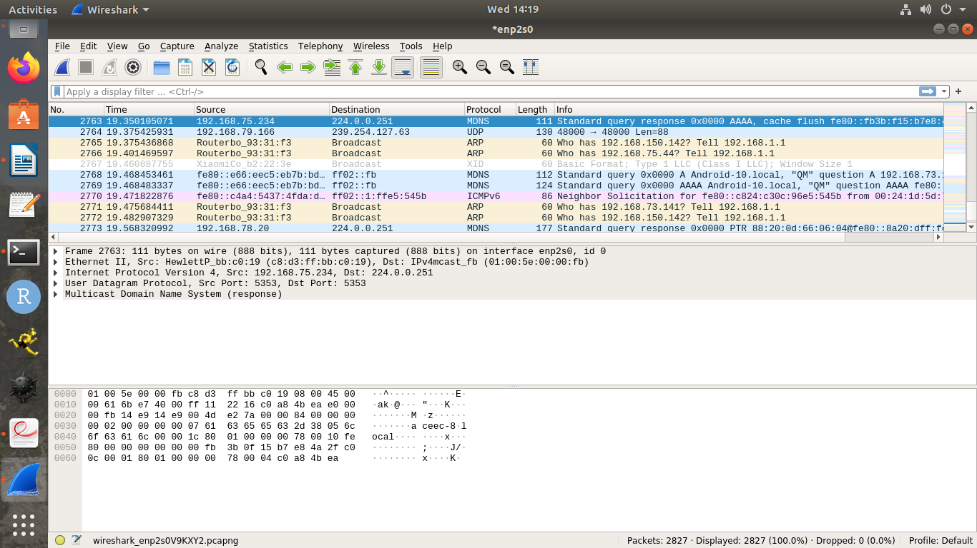

  - STARTING WIRE SHARK

  - VIEWING CAPTURED TRAFFIC
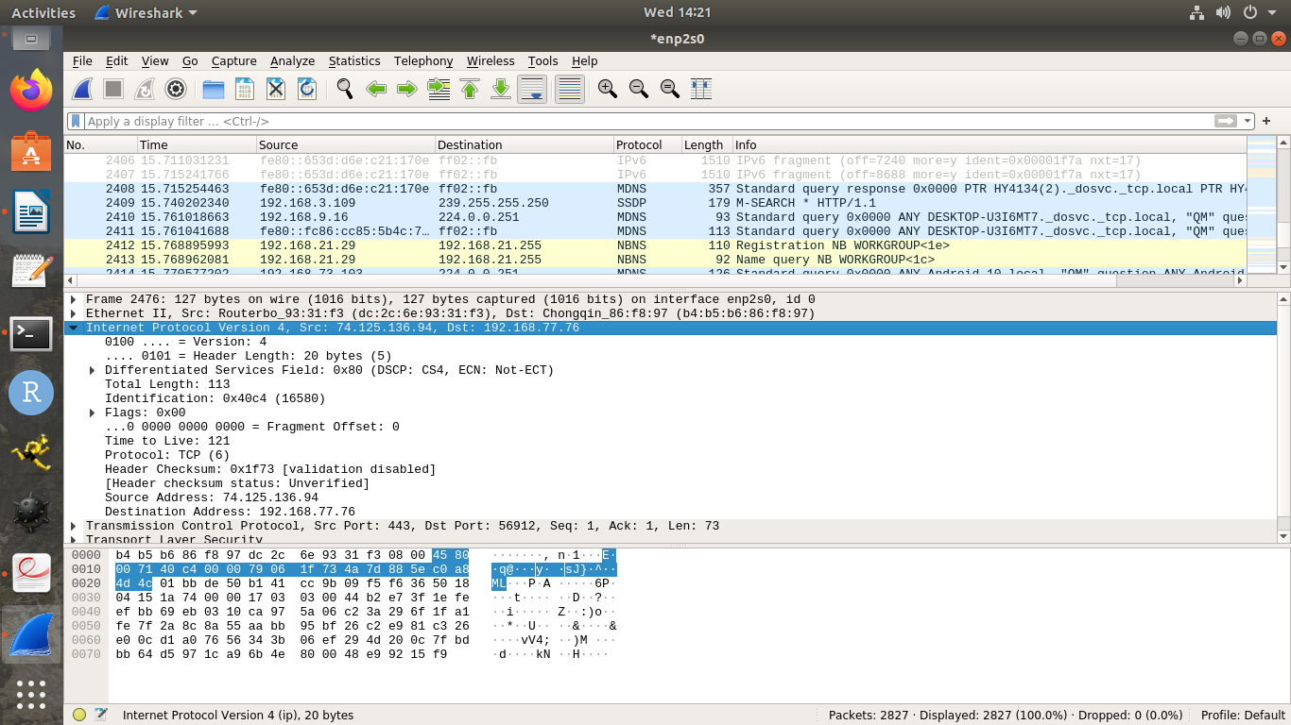

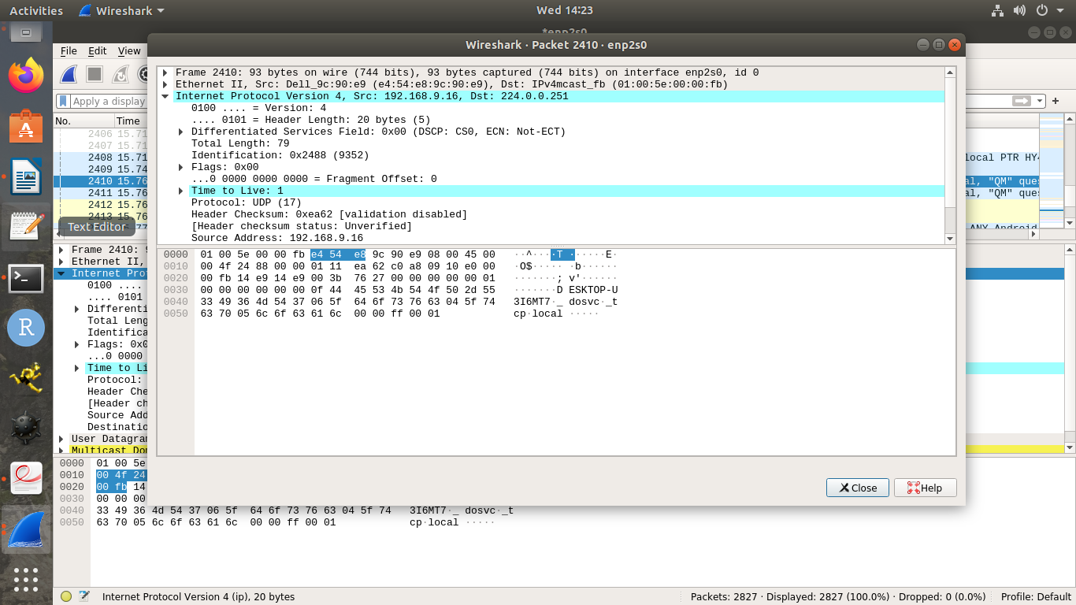
4.1 ANALYSIS AND STATISTICS

4.2 FILTER
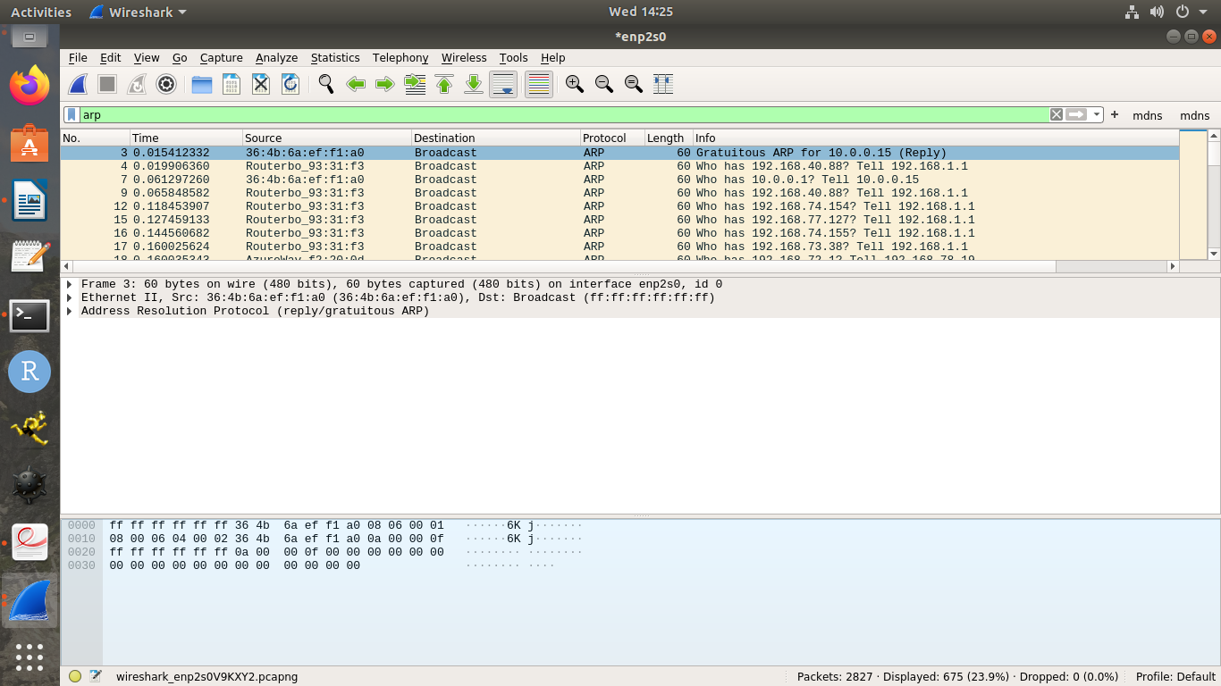

PROGRAM-11
AIM:WITH COMMANDS SHOW HOW TO RUN NMAP SCAN AND OPERATING SYSTEM DETECTION USING NMAP

DESCRIPTION:
Nmap stands for Network Mapper.
It is an open-source network scanning tool used to discover hosts, detect open ports, identify services, and find vulnerabilities in a computer network.
Nmap is widely used by network administrators, ethical hackers, and security analysts for:
  - Network inventory
  - Managing service upgrades
  - Monitoring host or service uptime
  - Security auditing

What is Nmap?
Nmap is a command-line network scanner that sends specially crafted packets to target hosts and analyzes their responses to determine:
- Which hosts are up and running
- Which ports are open, closed, or filtered
- What services and versions are running
- Which operating system (OS) the target is using
- Main Functions of Nmap

Function | Description
Host Discovery | Finds active devices (hosts) on a network.
Port Scanning | Identifies open/closed/filtered ports.
Service Detection | Detects the running service and its version on a port.
Operating System Detection | Identifies the OS based on packet responses.

Common Nmap Commands and Examples

Command | Purpose
nmap 192.168.1.1 | Scan a single host.
nmap 192.168.1.0/24 | Scan an entire subnet (all 256 IPs).
nmap -p 80 192.168.1.1 | Scan specific port 80 on a host.
nmap -p 1-1000 192.168.1.1 | Scan port range 1–1000.
nmap -sP 192.168.1.0/24 | Ping scan to list active hosts.
nmap -sS 192.168.1.1 | Stealth (SYN) scan for faster scanning.
nmap -sV 192.168.1.1 | Detect version of services on open ports.
nmap -O 192.168.1.1 | Detect operating system.
nmap --script vuln 192.168.1.1 | Run vulnerability detection scripts.
- Working Steps (Procedure)

  - Open Terminal / Command Prompt
    - For Linux: Ctrl + Alt + T
    - For Windows (after installing Nmap): open Nmap Command Line.

Scan a Host or Network
    - Type: nmap <IP address> or nmap <network range>

Observe the Output
    - Displays:
      - Host status (Up/Down)
      - Open ports (e.g., 22, 80, 443)
      - Protocol used (TCP/UDP)
      - Service running (HTTP, SSH, DNS, etc.)
      - Version information

Analyze the Results
    - Identify open or vulnerable ports.
    - Check unnecessary running services.
    - Document results for network security reports.

Advantages of Nmap
- Free and open-source
- Cross-platform (Windows, Linux, macOS)
- Detects live hosts and open ports efficiently
- Helps identify vulnerabilities
- Scriptable and customizable

Example Output
Nmap scan report for 192.168.1.10 Host is up (0.0020s latency).
Not shown: 996 closed ports
PORT STATE SERVICE VERSION
22/tcp open ssh OpenSSH 7.4 80/tcp open http Apache httpd 2.4.6 139/tcp open netbios-ssn
445/tcp open microsoft-ds
MAC Address: 00:0C:29:3E:5F:6B (VMware)
Device type: general purpose Running: Linux 4.X

Interpretation:
- The host is active.
- Ports 22, 80, 139, 445 are open.
- It’s likely a Linux system running SSH and Apache HTTP server.
sudo nmap 192.168.67.123
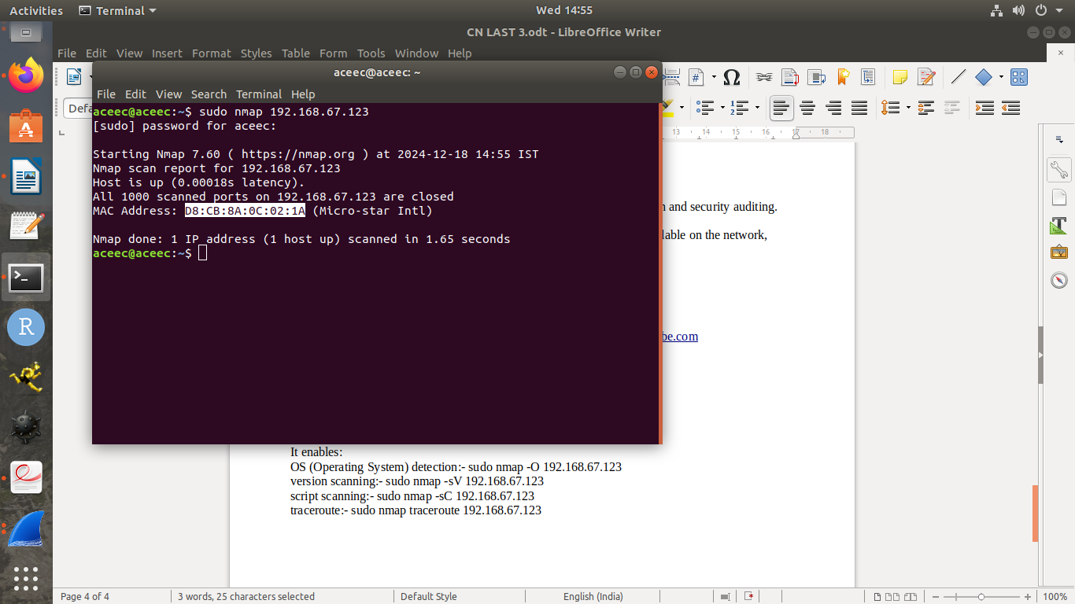

sudo nmap -A 192.168.67.123
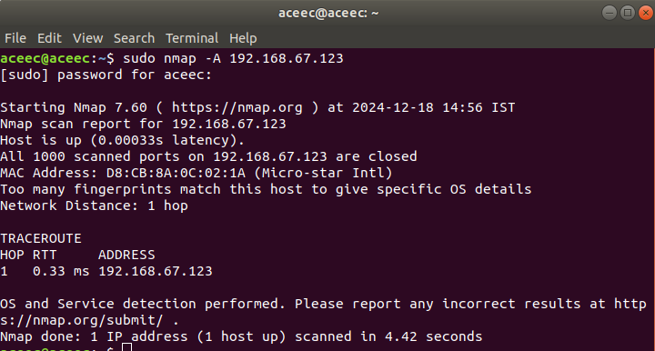

sudo nmap -p 80, 192.168.67.123
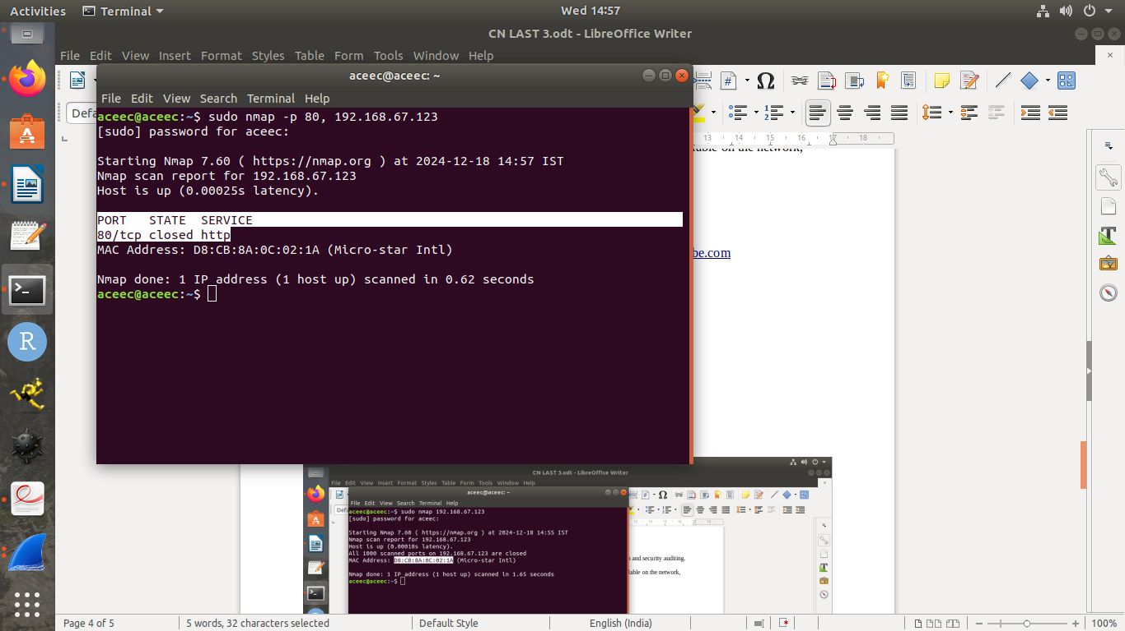

sudo nmap traceroute 192.168.67.123
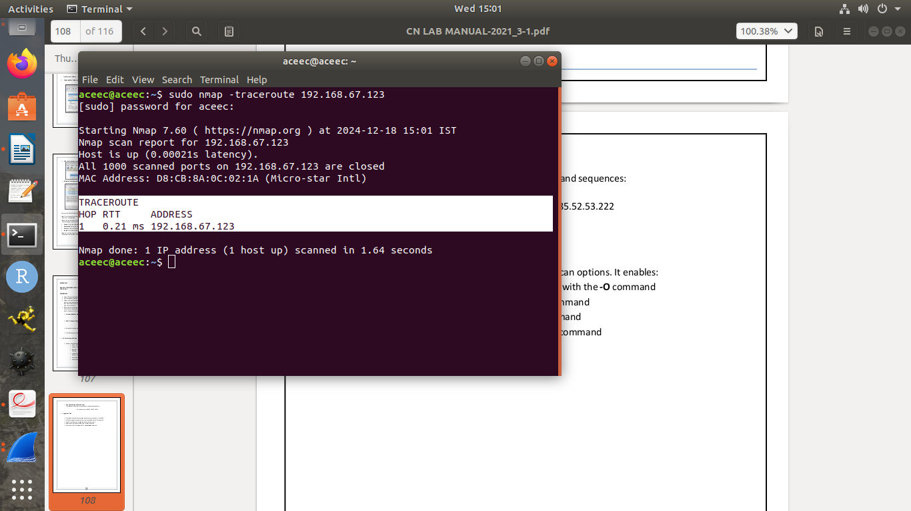

PROGRAM-12
AIM: DO THE FOLLOWING USING NS2 SIMULATOR
- NS2 SIMULATOR-INTRODUCTION
- SIMULATE TO FIND THE NUMBER OF PACKETS DROPPED
- SIMULATE TO FIND THE NUMBER OF PACKETS DROPPED BY TCP/UDP
- SIMULATE TO FIND THE NUMBER OF PACKETS DROPPED DUE TO CONGESTION
- SIMULATE TO COMPARE DATA RATE & THROUGHPUT.
- SIMULATE TO PLOT CONGESTION FOR DIFFERENT SOURCE/DESTINATION
- SIMULATE TO DETERMINE THE PERFORMANCE WITH RESPECT TO TRANSMISSION OF PACKETS.

NS2 Simulator Introduction

Introduction
NS2 stands for Network Simulator version 2.
It is an open-source, event-driven network simulation tool used to study and analyze the performance of wired and wireless networks.
It helps students and researchers understand how different network protocols (like TCP, UDP, routing, and MAC layer protocols) behave under various network conditions.

Purpose
  - To simulate real-time network scenarios (without actual hardware).
  - To analyze packet flow, packet drop, delay, and throughput.
  - To test and compare network protocols (e.g., TCP vs UDP).
  - To study network performance metrics such as delay, jitter, and congestion.

Features of NS2
- Supports both wired and wireless networks.
- Works with various protocols — TCP, UDP, FTP, HTTP, DSR, AODV, etc.
- Provides NAM (Network Animator) for graphical visualization.
- Simulation scripts are written in TCL (Tool Command Language).
- Produces trace files (.tr) for analysis.
- Advantages of NS2
- Open-source and free to use
- Simulates both wired and wireless networks
- Provides visual analysis via NAM
- Useful for protocol and performance evaluation

PROCEDURE:
- Install NS2 (in Ubuntu: sudo apt install ns2).
- Open a terminal and create a TCL simulation script (e.g., intro.tcl).
- Define nodes, links, and agents in the script.
- Run the simulation:
- $ ns intro.tcl
- View the NAM animation:
- $ nam intro.nam
- Observe how packets are transmitted between nodes.

NAM (Network Animator) Introduction
NAM (Network Animator) is a visualization tool that comes with NS2.
It allows you to view the simulation graphically, showing nodes, links, packet movement, and packet drops.

Purpose
  - To visually represent the network topology and packet flow.
  - To observe communication between nodes (sending, receiving, dropping packets).
  - To understand protocol behavior easily through animation.

Features of NAM
- Displays nodes and links graphically.
- Shows packet movement and packet drops during the simulation.
- Allows playback, pause, and zoom in simulation playback.
- Reads simulation results from .nam files generated by NS2.

TCL (Tool Command Language) Introduction
TCL is the scripting language used to write simulation scripts in NS2.
Every simulation in NS2 is defined by a TCL script (.tcl file).

Purpose
  - To define the network topology (nodes, links).
  - To configure agents and applications (TCP, UDP, FTP, etc.).
  - To set simulation parameters (start time, stop time).

To record trace and NAM output files.
- Structure of an NS2 TCL Script
A typical TCL program for NS2 has these steps:

Step | Description
1. | Create simulator object (set ns [new Simulator])
2. | Open trace and NAM files
3. | Create network nodes
4. | Connect nodes using duplex links
5. | Define agents (TCP, UDP) and attach to nodes
6. | Attach applications (FTP, CBR) to agents
7. | Schedule events (start, stop time)
8. | Run the simulation
9. | Execute NAM for visualization

Example TCL Script
# Create Simulator Object set ns [new Simulator]
# Open Trace File
set tracefile [open out.tr w]
$ns trace-all $tracefile

# Open NAM File
set namfile [open out.nam w]
$ns namtrace-all $namfile

# Create Nodes set n0 [$ns node] set n1 [$ns node]

# Create Link
$ns duplex-link $n0 $n1 1Mb 10ms DropTail
# Create Agents
set tcp [new Agent/TCP]
$ns attach-agent $n0 $tcp

set sink [new Agent/TCPSink]
$ns attach-agent $n1 $sink
$ns connect $tcp $sink # Create Application
set ftp [new Application/FTP]
$ftp attach-agent $tcp
$ns at 0.5 "$ftp start"
$ns at 4.0 "$ftp stop"
# Finish Simulation
$ns at 5.0 "finish" proc finish {} {
global ns tracefile namfile
$ns flush-trace close $tracefile close $namfile
exec nam out.nam & exit 0
}
$ns run

- Simulate to Find the Number of Packets Dropped

Experiment – Simulation to Find the Number of Packets Dropped using NS2

Save this file as packetdrop.tcl

# ==========================
# Program: Packet Drop Simulation in NS2 # ==========================

# Step 1: Create a Simulator object set ns [new Simulator]
# Step 2: Open Trace and NAM files set tracefile [open packetdrop.tr w]
$ns trace-all $tracefile

set namfile [open packetdrop.nam w]
$ns namtrace-all $namfile
# Step 3: Define a 'finish' procedure proc finish {} {
global ns tracefile namfile
$ns flush-trace close $tracefile close $namfile
exec nam packetdrop.nam & exit 0
}

# Step 4: Create network nodes set n0 [$ns node]
set n1 [$ns node] set n2 [$ns node]

# Step 5: Create links between nodes
# Format: $ns duplex-link <node1> <node2> <bandwidth> <delay> <queue_type>
$ns duplex-link $n0 $n1 1Mb 10ms DropTail
$ns duplex-link $n1 $n2 0.5Mb 20ms DropTail # Step 6: Set queue limit to induce packet drops

$ns queue-limit $n1 $n2 5
# Step 7: Create TCP agent and attach to node n0 set tcp [new Agent/TCP]
$ns attach-agent $n0 $tcp
# Step 8: Create sink agent and attach to node n2 set sink [new Agent/TCPSink]
$ns attach-agent $n2 $sink

# Step 9: Connect TCP source and sink
$ns connect $tcp $sink
# Step 10: Create FTP application over TCP set ftp [new Application/FTP]
$ftp attach-agent $tcp

# Step 11: Schedule the simulation
$ns at 0.5 "$ftp start"
$ns at 4.5 "$ftp stop"
$ns at 5.0 "finish"

# Step 12: Run the simulation
$ns run

OUTPUT FILES GENERATED:

- packetdrop.tr – Trace file (records all send/receive/drop events)
- packetdrop.nam – NAM animation file

TO RUN THE PROGRAM (in Linux terminal):
$ ns packetdrop.tcl
$ nam packetdrop.nam

TO FIND NUMBER OF PACKETS DROPPED

After simulation, use this command in terminal:
$ grep -c "d" packetdrop.tr

- Simulate to Find the Number of Packets Dropped by TCP/UDP

PROGRAM CODE: Save this file tcp_udp_drop.tcl
# ==========================================
# Title: NS2 Program to Find Packet Drops by TCP and UDP # ==========================================
# Step 1: Create simulator object set ns [new Simulator]

# Step 2: Open Trace and NAM files set tracefile [open tcp_udp_drop.tr w]
$ns trace-all $tracefile
set namfile [open tcp_udp_drop.nam w]
$ns namtrace-all $namfile

# Step 3: Define finish procedure proc finish {} {
global ns tracefile namfile
$ns flush-trace close $tracefile close $namfile
exec nam tcp_udp_drop.nam & exit 0
}
# Step 4: Create network nodes set n0 [$ns node]
set n1 [$ns node] set n2 [$ns node] set n3 [$ns node]
# Step 5: Create duplex links between nodes
$ns duplex-link $n0 $n2 1Mb 10ms DropTail
$ns duplex-link $n1 $n2 1Mb 10ms DropTail
$ns duplex-link $n2 $n3 0.5Mb 20ms DropTail

# Step 6: Set queue limit (to create congestion and packet drops)
$ns queue-limit $n2 $n3 5
# Step 7: Setup TCP agent at n0 and sink at n3 set tcp [new Agent/TCP]
$ns attach-agent $n0 $tcp
set sink1 [new Agent/TCPSink]
$ns attach-agent $n3 $sink1
$ns connect $tcp $sink1

# Step 8: Attach FTP application over TCP set ftp [new Application/FTP]
$ftp attach-agent $tcp
# Step 9: Setup UDP agent at n1 and Null sink at n3 set udp [new Agent/UDP]
$ns attach-agent $n1 $udp
set null [new Agent/Null]
$ns attach-agent $n3 $null
$ns connect $udp $null

# Step 10: Attach CBR traffic generator to UDP set cbr [new Application/Traffic/CBR]
$cbr set packetSize_ 500
$cbr set rate_ 1Mb
$cbr attach-agent $udp
# Step 11: Schedule traffic
$ns at 0.5 "$ftp start"
$ns at 1.0 "$cbr start"
$ns at 4.5 "$ftp stop"
$ns at 5.0 "$cbr stop"
$ns at 5.5 "finish"

# Step 12: Run the simulation
$ns run

OUTPUT FILES GENERATED:
- tcp_udp_drop.tr – Trace file (contains event logs of packets sent, received, and dropped)
- tcp_udp_drop.nam – NAM animation (for visualization)
TO RUN THE PROGRAM:
$ ns tcp_udp_drop.tcl
$ nam tcp_udp_drop.nam

TO FIND NUMBER OF PACKETS DROPPED:
After running the simulation, execute the following commands:

(a) For Total Packet Drops
grep -c "d" tcp_udp_drop.tr

(b) For TCP Packet Drops
grep "d" tcp_udp_drop.tr | grep "tcp" | wc -l

(c) For UDP Packet Drops
grep "d" tcp_udp_drop.tr | grep "cbr" | wc -l

- Simulate to Find the Number of Packets Dropped due to Congestion

Experiment: Simulate to Find the Number of Packets Dropped Due to Congestion
PROGRAM CODE — Save file as congestion_drop.tcl

# ======================================================
# Title: Packet Drop due to Congestion in NS2
# ======================================================
# Step 1: Create a Simulator object set ns [new Simulator]
# Step 2: Open trace and NAM files
set tracefile [open congestion_drop.tr w]
$ns trace-all $tracefile
set namfile [open congestion_drop.nam w]
$ns namtrace-all $namfile
# Step 3: Define finish procedure proc finish {} {
global ns tracefile namfile
$ns flush-trace close $tracefile close $namfile
exec nam congestion_drop.nam & exit 0
}
# Step 4: Create network nodes set n0 [$ns node]
set n1 [$ns node] set n2 [$ns node] set n3 [$ns node]
# Step 5: Create links between nodes
# Format: $ns duplex-link <node1> <node2> <bandwidth> <delay> <queue_type>
$ns duplex-link $n0 $n2 1Mb 10ms DropTail
$ns duplex-link $n1 $n2 1Mb 10ms DropTail
$ns duplex-link $n2 $n3 0.5Mb 20ms DropTail ;# Bottleneck link

# Step 6: Set queue limit (to cause congestion)
$ns queue-limit $n2 $n3 5

# Step 7: Create TCP agent at n0 set tcp [new Agent/TCP]
$ns attach-agent $n0 $tcp

# Step 8: Create TCP sink at n3 set sink [new Agent/TCPSink]
$ns attach-agent $n3 $sink

# Step 9: Connect TCP and sink
$ns connect $tcp $sink

# Step 10: Create UDP agent at n1 set udp [new Agent/UDP]
$ns attach-agent $n1 $udp
set null [new Agent/Null]
$ns attach-agent $n3 $null
$ns connect $udp $null

# Step 11: Create traffic sources set ftp [new Application/FTP]
$ftp attach-agent $tcp
set cbr [new Application/Traffic/CBR]
$cbr set packetSize_ 500
$cbr set rate_ 1Mb
$cbr attach-agent $udp

# Step 12: Schedule events
$ns at 0.5 "$ftp start"
$ns at 1.0 "$cbr start"
$ns at 4.5 "$ftp stop"
$ns at 5.0 "$cbr stop"
$ns at 5.5 "finish"
# Step 13: Run simulation
$ns run

OUTPUT FILES GENERATED

After running the above TCL program, two files are created:
- congestion_drop.tr → Trace file (records events like send, receive, drop)
- congestion_drop.nam → Network Animator file (visual animation)

TO RUN THE PROGRAM (in Terminal):
$ ns congestion_drop.tcl
$ nam congestion_drop.nam

TO FIND NUMBER OF PACKETS DROPPED DUE TO CONGESTION:
In NS2, when the queue is full, DropTail drops packets due to congestion. Dropped packets are recorded in the trace file as “d” (drop) events.
Run these commands in terminal:

(a) Count total dropped packets
grep -c "d" congestion_drop.tr

(b) To see details of dropped packets
grep "d" congestion_drop.tr

Simulate to Compare Data Rate & Throughput.
Experiment: Simulation to Compare Data Rate and Throughput using NS2

SOFTWARE / HARDWARE REQUIRED:
  - Linux OS (Ubuntu or Fedora)
  - NS2 Simulator installed (sudo apt install ns2)

NAM (Network Animator)
  - Text Editor (gedit / nano / vim)
PROGRAM CODE: Save file as throughput_comparison.tcl

# ============================================================
# Title : Compare Data Rate and Throughput in NS2
# ============================================================

# Step 1: Create simulator object set ns [new Simulator]
# Step 2: Open trace and NAM files set tracefile [open throughput.tr w]
$ns trace-all $tracefile
set namfile [open throughput.nam w]
$ns namtrace-all $namfile

# Step 3: Define finish procedure proc finish {} {
global ns tracefile namfile
$ns flush-trace close $tracefile close $namfile
exec nam throughput.nam & exit 0
}

# Step 4: Create network nodes set n0 [$ns node]
set n1 [$ns node] set n2 [$ns node]
# Step 5: Create duplex links between nodes
$ns duplex-link $n0 $n1 1Mb 10ms DropTail
$ns duplex-link $n1 $n2 1Mb 10ms DropTail
# Step 6: Setup UDP agent at n0 set udp [new Agent/UDP]
$ns attach-agent $n0 $udp

# Step 7: Setup Null agent (sink) at n2 set null [new Agent/Null]
$ns attach-agent $n2 $null

# Step 8: Connect UDP agent and Null sink
$ns connect $udp $null
# Step 9: Create CBR traffic source set cbr [new Application/Traffic/CBR]
$cbr set packetSize_ 1000
$cbr set rate_ 512Kb ;# Data Rate (Configurable)
$cbr attach-agent $udp
# Step 10: Schedule simulation events
$ns at 0.5 "$cbr start"
$ns at 4.5 "$cbr stop"
$ns at 5.0 "finish"
# Step 11: Run the simulation
$ns run

TO RUN THE PROGRAM:
$ ns throughput_comparison.tcl
$ nam throughput.nam

FILES GENERATED:
  - throughput.tr → Trace file (records packet send/receive/drop)
  - throughput.nam → NAM file (for visualization)
TO CALCULATE THROUGHPUT:

Step 1: Find total packets received at the destination
grep "^r" throughput.tr | grep "cbr" | wc -l
Step 2: Find simulation time (e.g., 4 seconds) In our script, it runs from 0.5s to 4.5s = 4 seconds Step

3: Calculate Throughput
Formula:
Throughput (bps)=Packets Received×Packet Size (bytes)×8Simulation Time (s)\text{Throughput (bps)} = \frac{\text{Packets Received} \times \text{Packet Size (bytes)} \times 8}{\text{Simulation Time
(s)}}Throughput (bps)=Simulation Time (s)Packets Received×Packet Size (bytes)×8

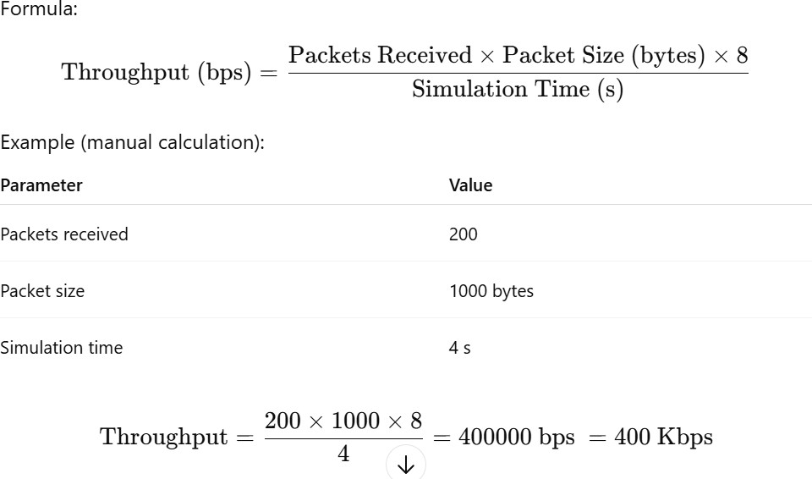
Example (manual calculation):
Parameter | Value
Packets received | 200
Packet size | 1000 bytes

COMPARISON TABLE:

Parameter | Description | Value
Data Rate | Configured rate at sender | 512 Kbps
Throughput | Actual rate achieved at receiver | 400 Kbps (example)
Loss | Difference (due to delay, congestion, etc.) | 112 Kbps

Simulate to Plot Congestion for Different Source/Destination
Experiment: Simulation to Plot Congestion for Different Source/Destination Nodes PROGRAM CODE — Save file as congestion_diff_nodes.tcl

# =========================================================
# Title: Congestion Simulation for Different Source/Destination
# =========================================================
# Step 1: Create a Simulator object set ns [new Simulator]
# Step 2: Open Trace and NAM files
set tracefile [open congestion_diff_nodes.tr w]
$ns trace-all $tracefile
set namfile [open congestion_diff_nodes.nam w]
$ns namtrace-all $namfile
# Step 3: Define 'finish' procedure proc finish {} {
global ns tracefile namfile
$ns flush-trace close $tracefile close $namfile
exec nam congestion_diff_nodes.nam & exit 0
}
# Step 4: Create network nodes for {set i 0} {$i < 6} {incr i} {
set n($i) [$ns node]
}

# Step 5: Create duplex links between nodes
# Assume n2 and n3 are routers; multiple sources and destinations
$ns duplex-link $n(0) $n(2) 1Mb 10ms DropTail
$ns duplex-link $n(1) $n(2) 1Mb 10ms DropTail
$ns duplex-link $n(2) $n(3) 0.5Mb 20ms DropTail ;# Bottleneck link
$ns duplex-link $n(3) $n(4) 1Mb 10ms DropTail
$ns duplex-link $n(3) $n(5) 1Mb 10ms DropTail
# Step 6: Limit queue size (to induce congestion)
$ns queue-limit $n(2) $n(3) 5
# Step 7: Define sources and destinations # Source 1 (TCP)

set tcp1 [new Agent/TCP]
$ns attach-agent $n(0) $tcp1 set sink1 [new Agent/TCPSink]
$ns attach-agent $n(4) $sink1
$ns connect $tcp1 $sink1
set ftp1 [new Application/FTP]
$ftp1 attach-agent $tcp1
# Source 2 (UDP)
set udp2 [new Agent/UDP]
$ns attach-agent $n(1) $udp2 set null2 [new Agent/Null]
$ns attach-agent $n(5) $null2
$ns connect $udp2 $null2
set cbr2 [new Application/Traffic/CBR]
$cbr2 set packetSize_ 1000
$cbr2 set rate_ 1Mb
$cbr2 attach-agent $udp2
# Step 8: Schedule events
$ns at 0.5 "$ftp1 start"
$ns at 1.0 "$cbr2 start"
$ns at 4.5 "$ftp1 stop"
$ns at 5.0 "$cbr2 stop"
$ns at 5.5 "finish"
# Step 9: Run simulation
$ns run

TO RUN THE PROGRAM:
$ ns congestion_diff_nodes.tcl
$ nam congestion_diff_nodes.nam

FILES GENERATED:
  - congestion_diff_nodes.tr → Trace file (records packet send, receive, drop)
  - congestion_diff_nodes.nam → For visualization
TO ANALYZE CONGESTION (PACKET DROPS):

Total packets dropped due to congestion
grep -c "d" congestion_diff_nodes.tr

To see detailed drop information
grep "d" congestion_diff_nodes.tr

To calculate drops for each source
For TCP (source node n0):
grep "d" congestion_diff_nodes.tr | grep "tcp" | wc -l For UDP (source node n1):
grep "d" congestion_diff_nodes.tr | grep "cbr" | wc -l

Simulate to Determine the Performance with respect to Transmission of Packets

Experiment: Simulation to Determine the Performance with respect to Transmission of Packets

PROGRAM CODE — Save file as packet_performance.tcl

# ===========================================================
# Title : Performance Evaluation - Transmission of Packets
# ===========================================================
# Step 1: Create a simulator object set ns [new Simulator]
# Step 2: Open Trace and NAM files
set tracefile [open packet_performance.tr w]
$ns trace-all $tracefile
set namfile [open packet_performance.nam w]
$ns namtrace-all $namfile
# Step 3: Define finish procedure proc finish {} {
global ns tracefile namfile
$ns flush-trace close $tracefile close $namfile
exec nam packet_performance.nam & exit 0
}
# Step 4: Create nodes set n0 [$ns node]
set n1 [$ns node] set n2 [$ns node] set n3 [$ns node]

# Step 5: Create duplex links (n0,n2) and (n1,n2) send to (n3)
$ns duplex-link $n0 $n2 1Mb 10ms DropTail
$ns duplex-link $n1 $n2 1Mb 10ms DropTail
$ns duplex-link $n2 $n3 0.5Mb 20ms DropTail ;# Bottleneck
# Step 6: Limit queue size to induce packet drops
$ns queue-limit $n2 $n3 5

# Step 7: Create TCP and UDP agents for sources set tcp [new Agent/TCP]
$ns attach-agent $n0 $tcp
set sink [new Agent/TCPSink]
$ns attach-agent $n3 $sink
$ns connect $tcp $sink

set ftp [new Application/FTP]
$ftp attach-agent $tcp
set udp [new Agent/UDP]
$ns attach-agent $n1 $udp set null [new Agent/Null]
$ns attach-agent $n3 $null
$ns connect $udp $null
set cbr [new Application/Traffic/CBR]
$cbr set packetSize_ 1000
$cbr set rate_ 512Kb
$cbr attach-agent $udp
# Step 8: Schedule the events
$ns at 0.5 "$ftp start"
$ns at 1.0 "$cbr start"
$ns at 4.5 "$ftp stop"
$ns at 5.0 "$cbr stop"
$ns at 5.5 "finish"
# Step 9: Run the simulation
$ns run

TO RUN THE PROGRAM:
$ ns packet_performance.tcl
$ nam packet_performance.nam

FILES GENERATED:
  - packet_performance.tr → Trace file (record of every event)
  - packet_performance.nam → For visualization

TO ANALYZE PERFORMANCE METRICS

1◻ Packets Sent:
grep "^s" packet_performance.tr | grep "cbr" | wc -l

2◻Packets Received:
grep "^r" packet_performance.tr | grep "cbr" | wc -l

3◻Packets Dropped:
grep "^d" packet_performance.tr | wc -l

PERFORMANCE CALCULATIONS
Let’s assume the following output from the above commands:

Parameter | Value
Packets Sent | 400
Packets Received | 360
Packets Dropped | 40
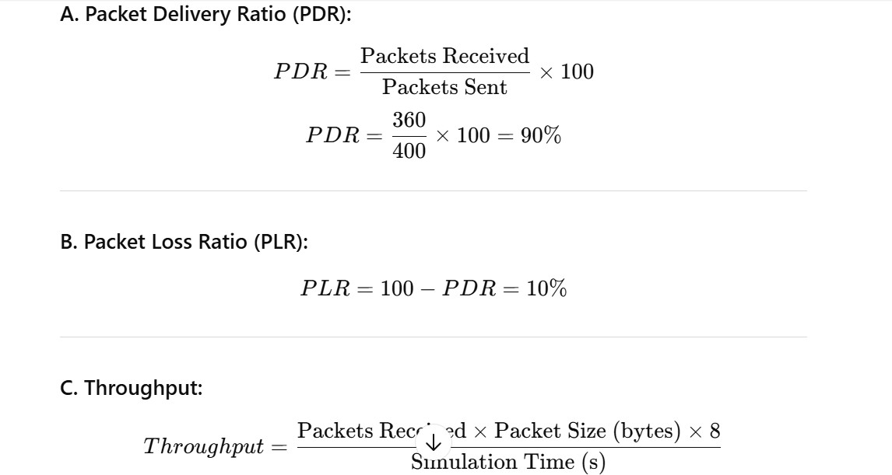

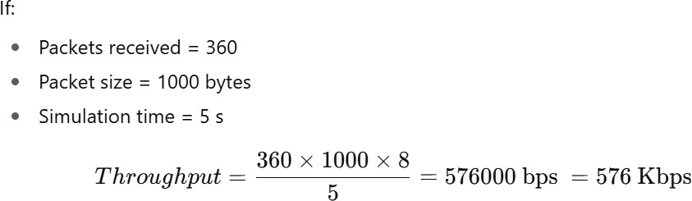

NS2 OUTPUTS
- NS2 Simulator-Introduction
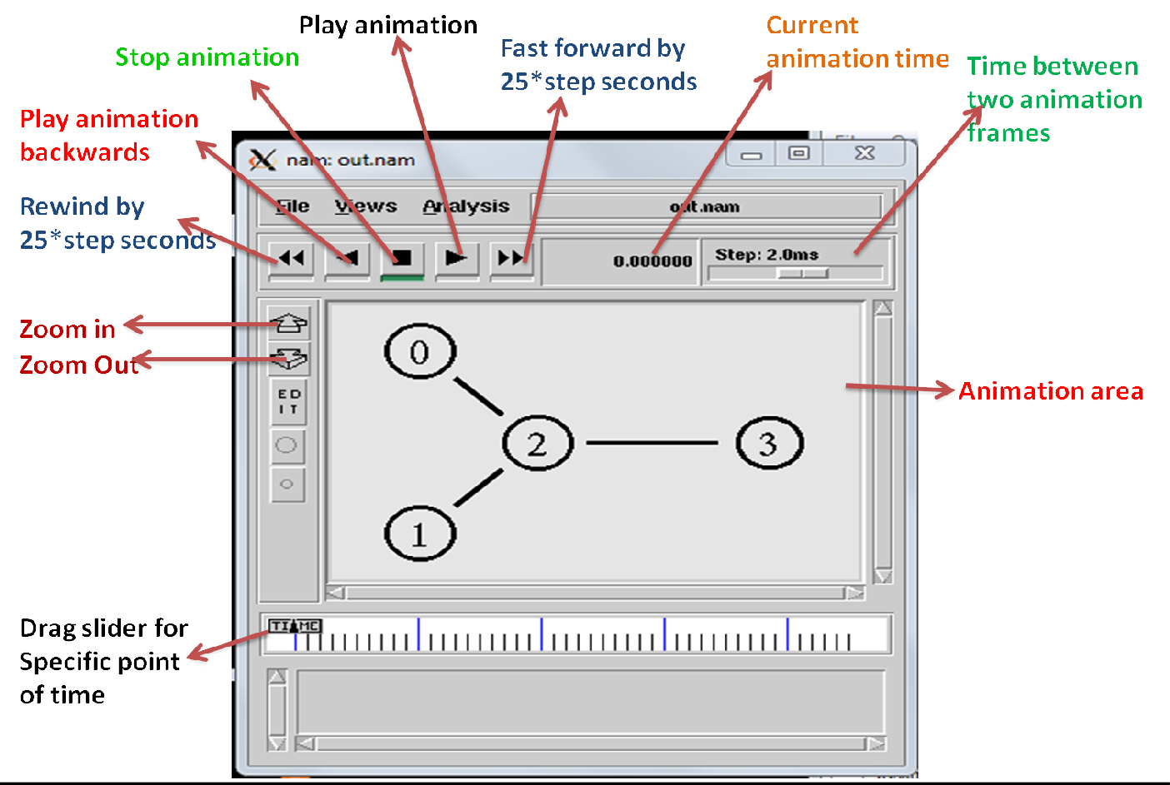
- Simulate to Find the Number of Packets Dropped
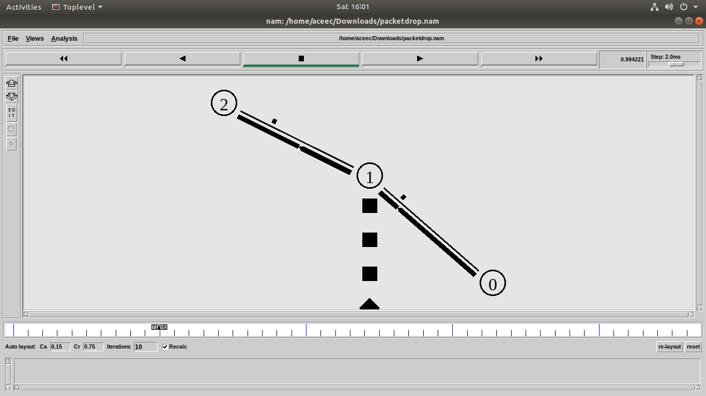
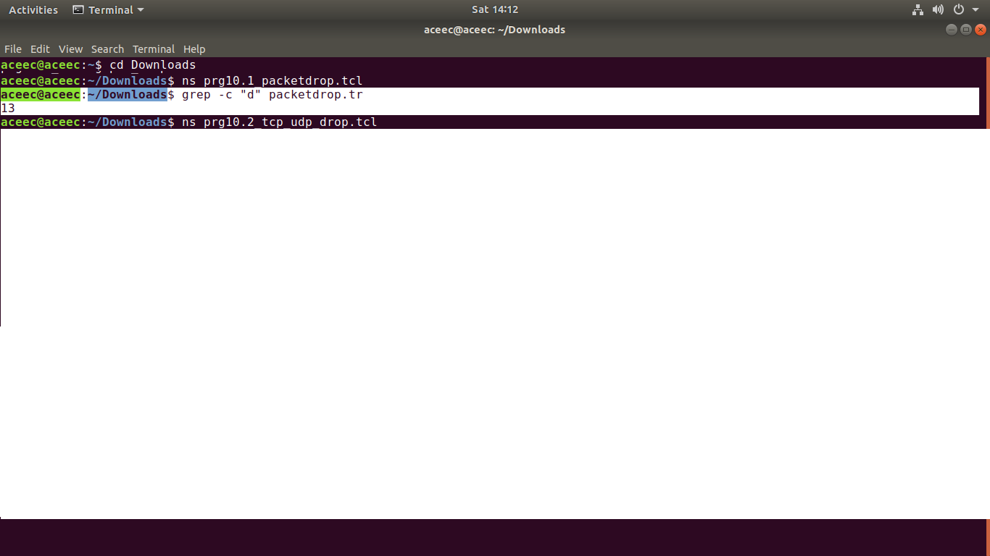
- Simulate to Find the Number of Packets Dropped by TCP/UDP
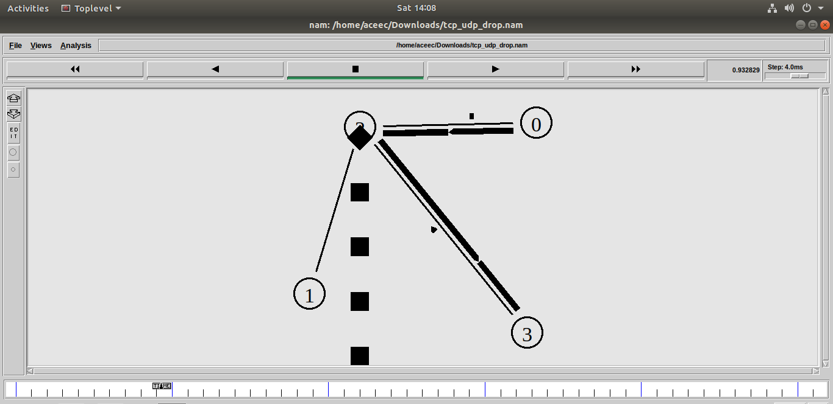

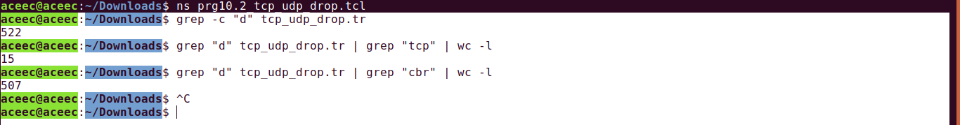
- Simulate to Find the Number of Packets Dropped due to Congestion
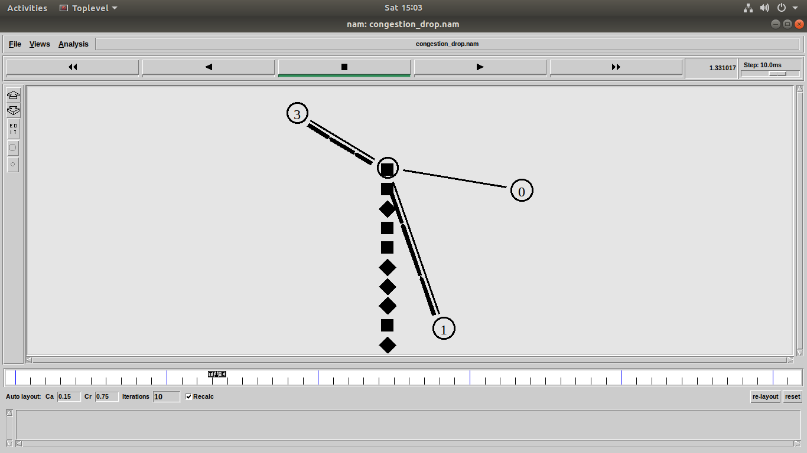

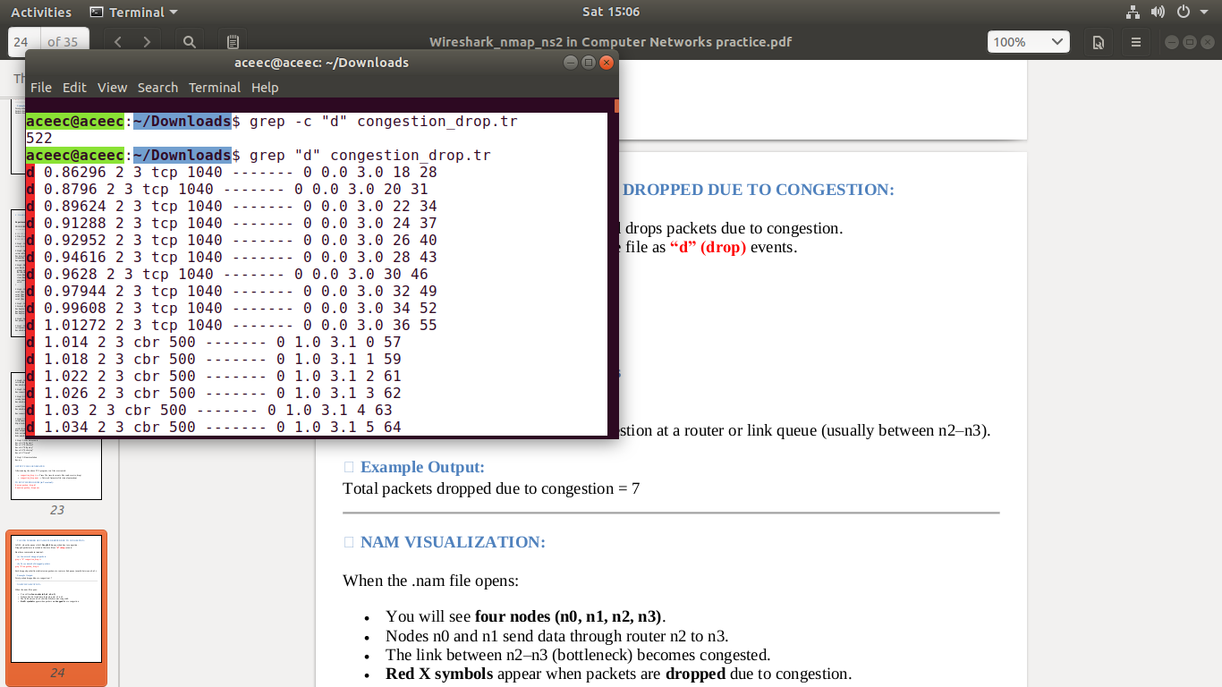

Simulate to Compare Data Rate & Throughput.
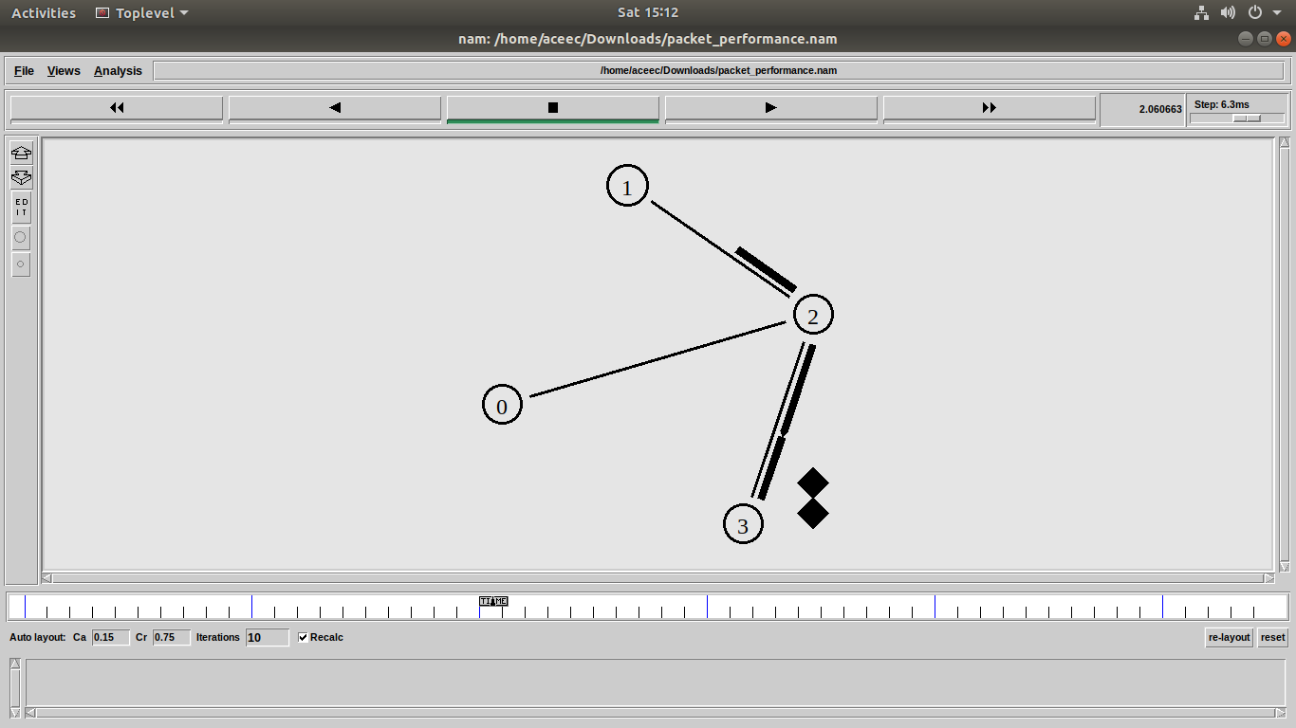

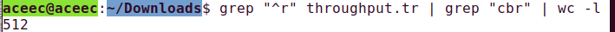

Simulate to Plot Congestion for Different Source/Destination
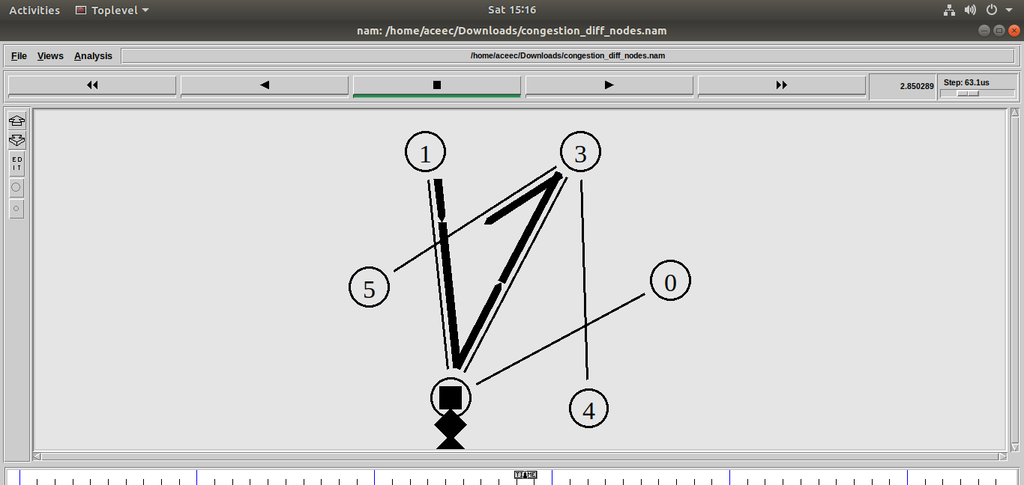

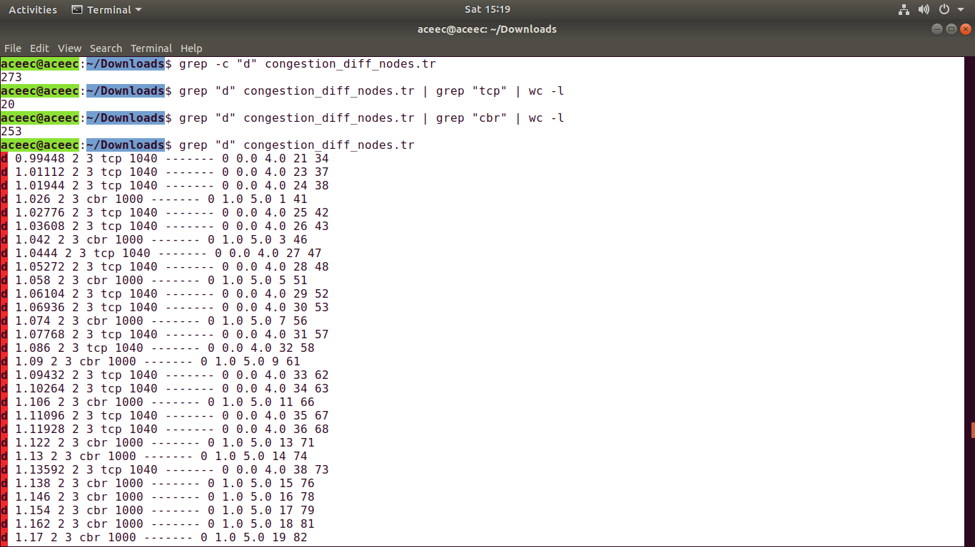

Simulate to Determine the Performance with respect to Transmission of Packets
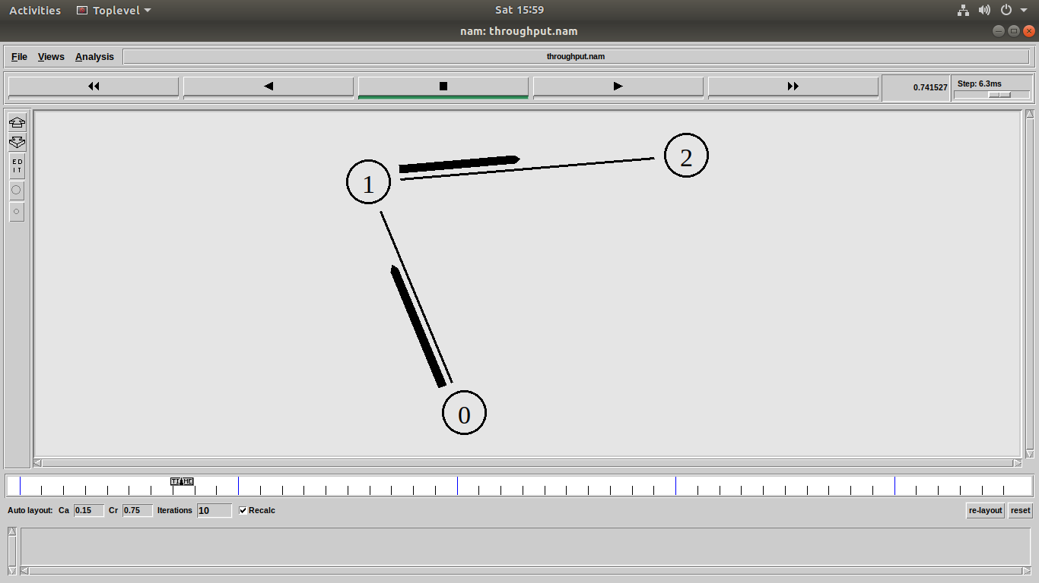

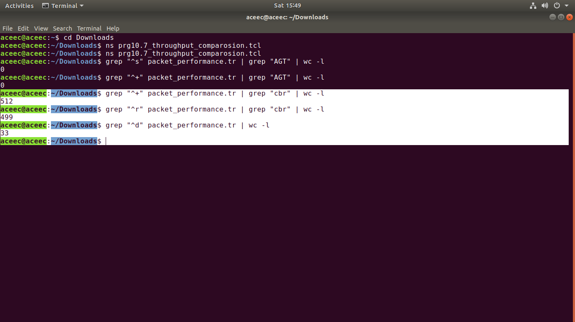

Sheme of Evaluation:

Internal Assessment

S. No. | Assessment of work | Evaluation in Marks
1 | Lab observation-day to day work | 10
2 | Record  +  Observ ation | 10
3 | Internal laboratory Test | 10
Total Marks |  | 25

External Assessment

S. No. | Assessment of work | Evaluation in Marks
1 | Write up | 20
2 | Execution / Experimentation | 20
3 | Results | 15
4 | Viva | 15
Total Marks |  | 70

TEXTBOOKS:
- Computer Networks, Andrew S Tanenbaum, David. j. Wetherall, 5th Edition. Pearson Education/PHI.

REFERENCE BOOKS:

- An Engineering Approach to Computer Networks, S. Keshav, 2nd Edition, Pearson Education
- Data Communications and Networking – Behrouz A. Forouzan. 3rd Edition, TMH.

